Alternative to Purifying Bacteriophage DNA for PCR
Objective: To use plaques or phage lysate instead of pure DNA samples for PCR.
_________________________________________________________________________________________________
Rationale: Traditionally, pure DNA samples are required to conduct PCR. Purifying bacteriophage DNA is tedious and time consuming. As an alternative to using pure DNA, this procedure will utilize plaques or lysate to extract DNA for PCR.
_________________________________________________________________________________________________
Supplies:
- Phage sample (either from a plaque or collected lysate)
- Heat Block
- Phage Buffer
- Microcentrifuge tubes
- Pipette tips
- Microcentrifuge
_________________________________________________________________________________________________
Procedure:
- For phage sample collected from plaque (done aseptically)
- Prepare a sterile microcentrifuge tube and fill it with 20uL of phage buffer.
- Pick a plaque of choice and mark it.
- Using a sterile tip on a p200 micropipettor or an inoculation loop, gently rub the surface of the top agar, making sure to get the plaque and avoid touching the bacteria surrounding the plaque.
- Submerge the tip or inoculation loop into the 20uL of phage buffer and swirl inside the tube.
- Vortex to mix well.
- For phage sample using previously collected lysate (done aseptically)
- Aliquot 16uL of phage buffer into a microcentrifuge tube.
- Pipette 4uL of lysate into the 16uL of phage buffer.
- Vortex to mix well.
- Boiling
- Turn on the heat block to 100 °C.
- Place the centrifuge tubes with the diluted phage samples into the heat block.
- Leave the samples for 10 minutes to boil.
- Centrifuge for 30 seconds.
- The samples are ready for PCR work and can be stored in -20 °C until it’s ready to be used.

PCR Condition:
94°C, 5 minutes; 1 cycle
94°C, 30 seconds, 55°C, 30 seconds, 72°C 45 seconds; 35 cycles
72°C, 5 minutes; 1 cycle
4° C, indefinite time (holding temperature)
PCR Example
Master Mix Example

Reagent | Amount
DNA Sample | 5uL
50mM MgCl2 | 1uL
5x PCR Buffer | 10uL
Taq | 0.3uL
ddH20 | 31.7uL
Forward Primer | 1uL
Reverse Primer | 1uL
Total | 50uL
The same primer was used for each DNA sample (plaque or lysate). Specific banding in the gel electrophoresis provides evidence that the procedure works with low-medium titer lysates, and also works by directly picking phage plaques.
 | Content | Times Boiled | Amount used for PCR
M | Ladder 1kb | ----------- | -------------
1 | SL lysate | 1 | 5uL
2 | SL lysate | 1 | 10uL
3 | SL plaque | 1 | 5uL
4 | SL plaque | 2 | 5uL
5 | SL plaque | 1 | 5uL
6 | SL plaque | 1 | 2uL
7 | SL plaque | 1 | 5uL

Note: All the plaque and lysate samples were taken out from the original 20uL dilutions from either step A or step B.

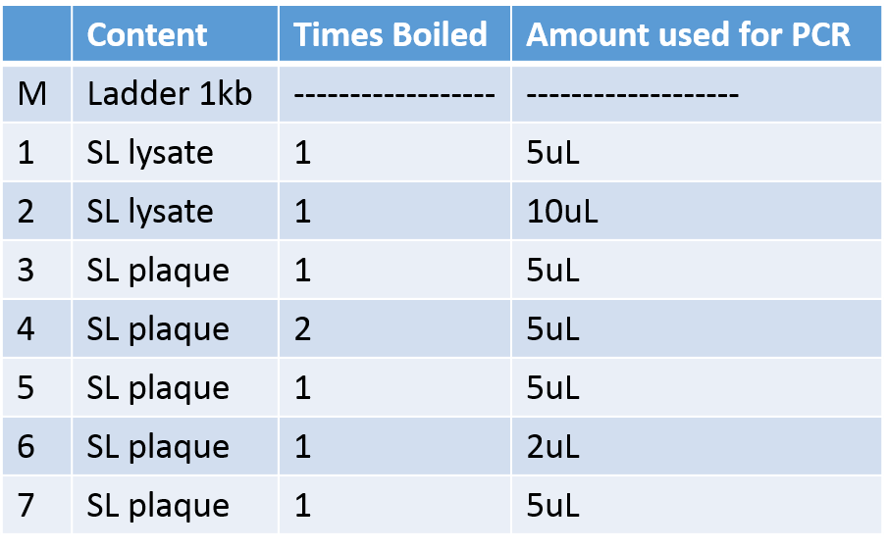
Tips and Tricks
- This protocol is especially useful for low to medium titer lysate. Thus, a 1:5 dilution was used.
- After the samples are boiled, they do not have to be boiled again if they are stored in -20 °C.

