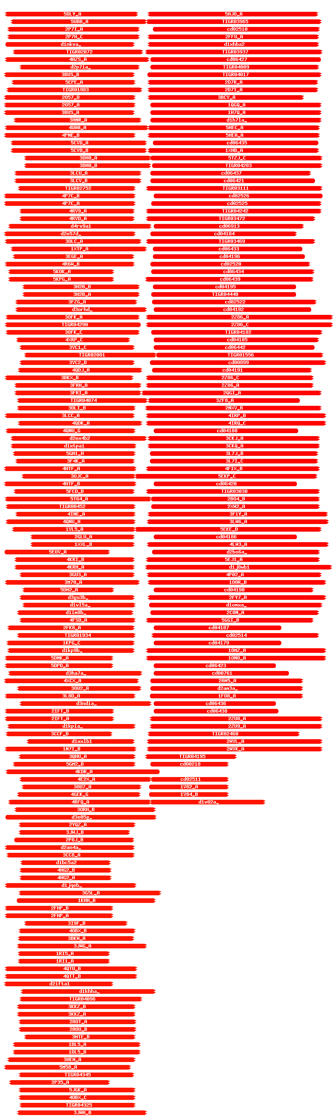

Hitlist
Show entries
Nr | Hit | Name | Probability | E-value | SS | Cols | Target Length
1 | 5AJO_A | POLYPEPTIDE N-ACETYLGALACTOSAMINYLTRANSFERASE 2 (E.C.2.4.1.41), MUCIN; TRANSFERASE, AFM, SAXS, LECTIN DOMAIN; HET: SO4, A2G; 1.48A {HOMO SAPIENS} | 99.74 | 6e-19 | 21.3 | 208 | 571
2 | TIGR03965 | mycofact_glyco; mycofactocin system glycosyltransferase. Members of this protein family are putative glycosyltransferases, members of pfam00535 (glycosyl transferase family 2). | 99.74 | 4.8e-19 | 19.9 | 212 | 466
3 | cd02510 | pp-GalNAc-T; pp-GalNAc-T initiates the formation of mucin-type O-linked glycans. UDP-GalNAc: polypeptide alpha-N-acetylgalactosaminyltransferases  (pp-GalNAc-T) initiate the formation of mucin-type, O-linked glycans by catalyzing the transfer of alpha-N-acetylgalactosamine (GalNAc) from UDP-GalNAc to hydroxyl groups of Ser or Thr residues of core proteins to form the Tn antigen (GalNAc-a-1-O-Ser/Thr). | 99.73 | 6e-19 | 19.1 | 204 | 299
4 | 2FFU_A | Polypeptide N-acetylgalactosaminyltransferase 2 (E.C.2.4.1.41)/13-Peptide EA2; ppGalNAcT mucin glycosyltransferase; HET: UDP; 1.64A {Homo sapiens} | 99.73 | 5e-19 | 19.9 | 209 | 501
5 | d1xhba2 | c.68.1.17 (A:95-422) Polypeptide N-acetylgalactosaminyltransferase 1, N-terminal domain {Mouse (Mus musculus) [TaxId: 10090]} | 99.73 | 2.2e-18 | 22.5 | 209 | 328
6 | TIGR03937 | PgaC_IcaA; poly-beta-1,6 N-acetyl-D-glucosamine synthase. Members of this protein family are biofilm-forming enzymes that polymerize N-acetyl-D-glucosamine residues in beta(1,6) linkage. | 99.73 | 9.8e-19 | 20.4 | 212 | 4

