Gene 53 eq (37271)

2.2 HHPRED
Evidence Description | Evidence
Results are aligned well, with over 90% probabilities indicating the gene’s function to be Hfq RNA Binding Protein, rather than a hypothetical protein or just an RNA Binding Protein. | 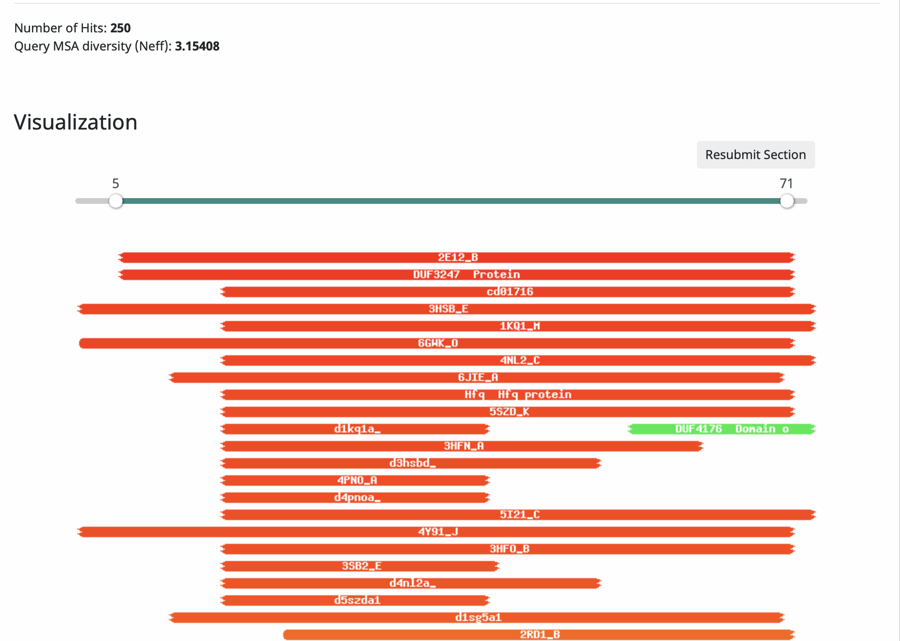  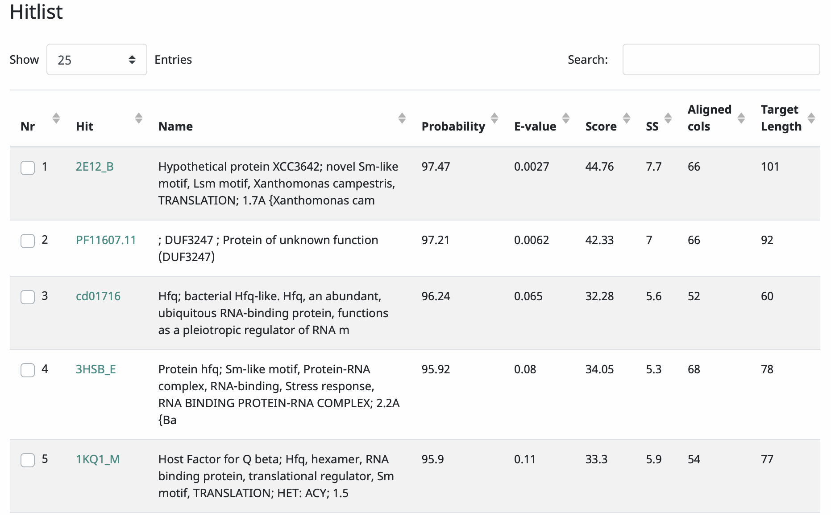

Hfq-Sm-Lsm protein family are a unique class of RNA binding proteins that were originally discovered as being required for replication of the RNA bacteriophage Qβ. It is distinct from other annotated phage RNA binding proteins.

Some info from (https://www.ncbi.nlm.nih.gov/pmc/articles/PMC4615618/):
Research on Hfq commenced in the late 1960s, when the protein was identified in Escherichia coli as an essential host factor of the RNA bacteriophage Qβ (from which the name Hfq was derived)¹³⁴; the protein probably improves the replication efficiency of the viral genome by melting a secondary structure at the 3′ end of the RNA¹³⁵. Early biochemical characterization defined E. coli Hfq as a remarkably heat-resistant and abundant nucleic acid-binding protein with strong preferences for AU-rich single-stranded RNA^{86,136–140}.
The 1990s brought the first clues as to the potential benefits that Hfq could provide to the bacterium itself, rather than to its phage predator. Loss of Hfq was found to reduce fitness and impair the stress response, and (in pathogenic bacteria such as Brucella abortus) to diminish virulence^{141,142}. In addition, it was discovered that the translation or turnover of numerous cellular mRNAs is regulated by Hfq^{76,143,144}.
About a decade ago, structural and bioinformatic studies showed that Hfq is part of the much wider Sm family, highlighting that its origins date back to the last common ancestor of eukaryotic, bacterial and archaeal lineages^{50,67}. It also became clear that Hfq associates with small regulatory RNAs (sRNAs) to promote their base-pairing with cognate target mRNAs^{8,50,67,145}. The sRNA–mRNA pairing affects the translation rate and lifetime of the targeted transcript. The connection of Hfq as a facilitator of the trans-actions of sRNAs could account for many of the complex phenotypic effects that are observed in the early gene knockout studies^{9,141}. Hfq proteins have been predicted to be present in at least 50% of all bacterial species². In addition, unusual functional homologues with weak homology to E. coli Hfq are still being discovered^{126,146,147}, suggesting that Hfq or Hfq-like proteins operate as a hub for post-transcriptional regulation in many diverse bacteria.

