Here is a weird one for phage MrMiyagi. Not autocalled, no Coding potential seen in GeneMark (smeg), S, or TB. But seen as in phamerator, sharing the same pharm 9086 with gene 31 in phage Fowlmouth. When inserted, shows poor RBS scores (z= 1.353, F =-6.153), but surprisingly, TmHMM & SOSUI analysis clearly shows that this is a membrane protein! (See figures below). Blastp yields q11:s1 with Cuke; q11:s1 with Fowlmouth. HHPred yields no hits above 90% probability [The highest hit, at 83.65% probability (4IMM_B; PDBe ), hits the "Outer membrane assembly lipoprotein YfgL; 8-bladed beta-propeller, Protein-protein interactions, chaperone; 2.33A {Moraxella catarrhalis}]. What’s your take?
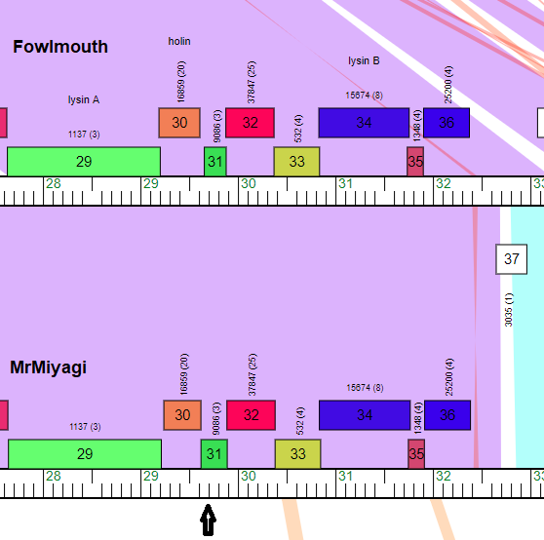
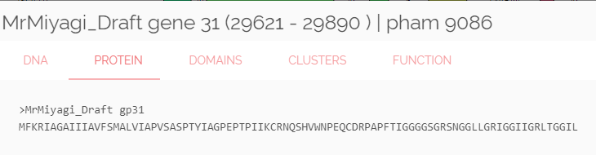
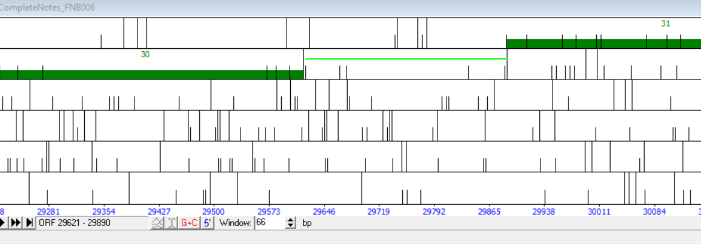
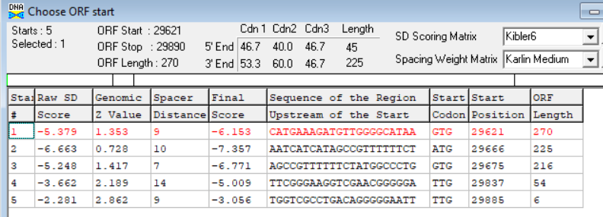
http://www.cbs.dtu.dk/cgi-bin/webface2.fcgi?jobid=5EB03BD600001A3DC2CEA551&wait=20
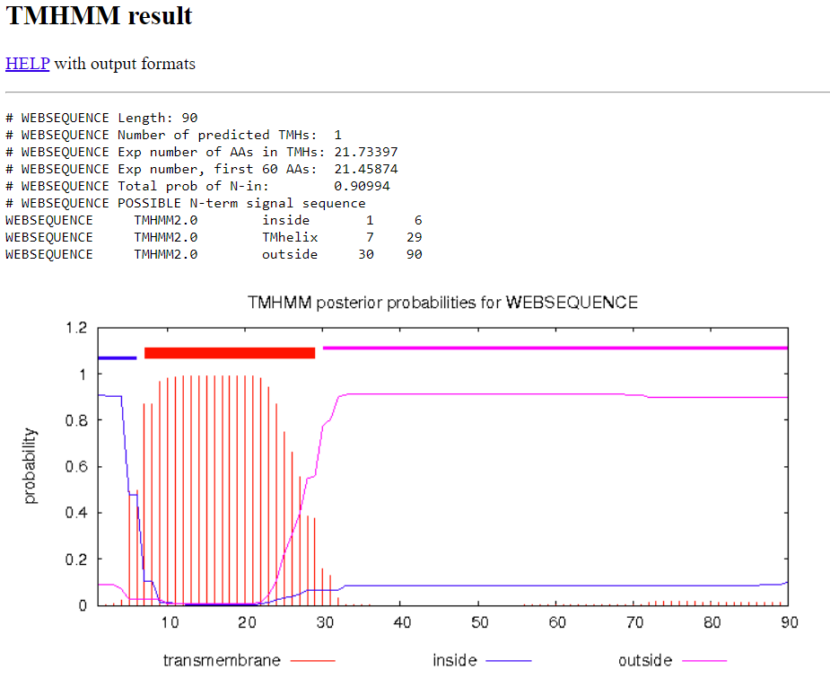
http://harrier.nagahama-i-bio.ac.jp/sosui/cgi-bin/adv_sosui.cgi
