Morty007

GeneMark Tb for Morty007 at gene 68 – strong coding potential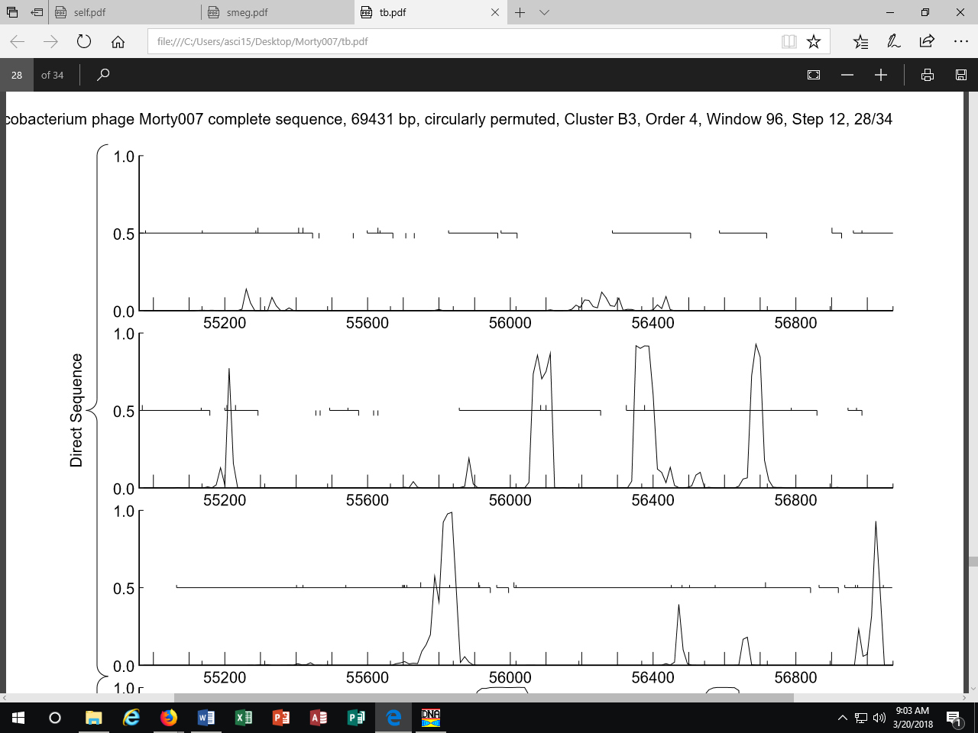

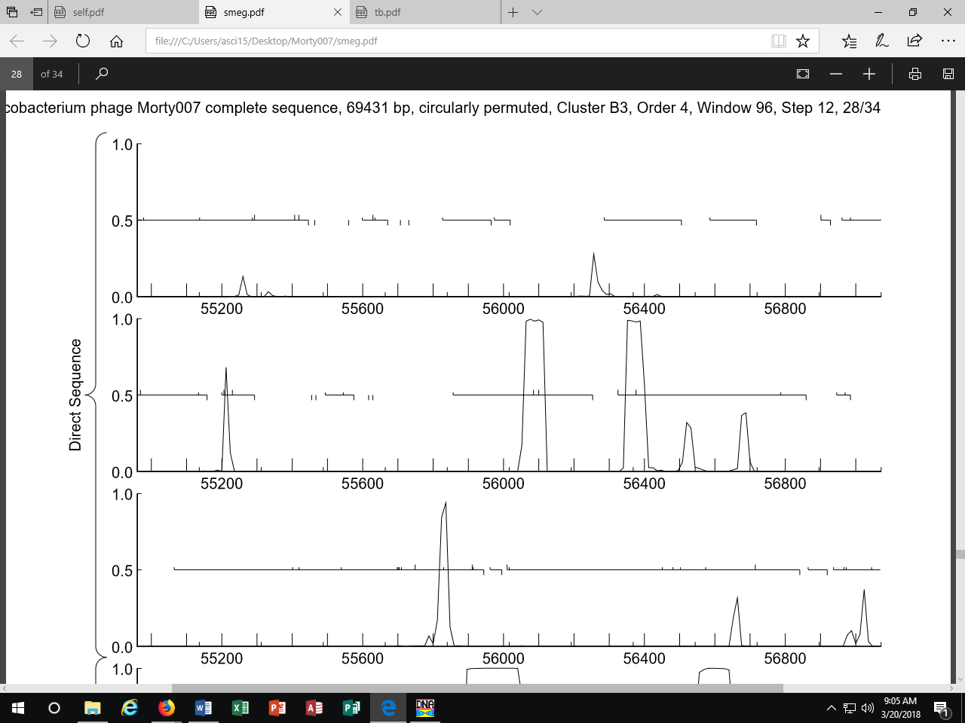
GeneMark Smeg for gene 68 – some coding potential

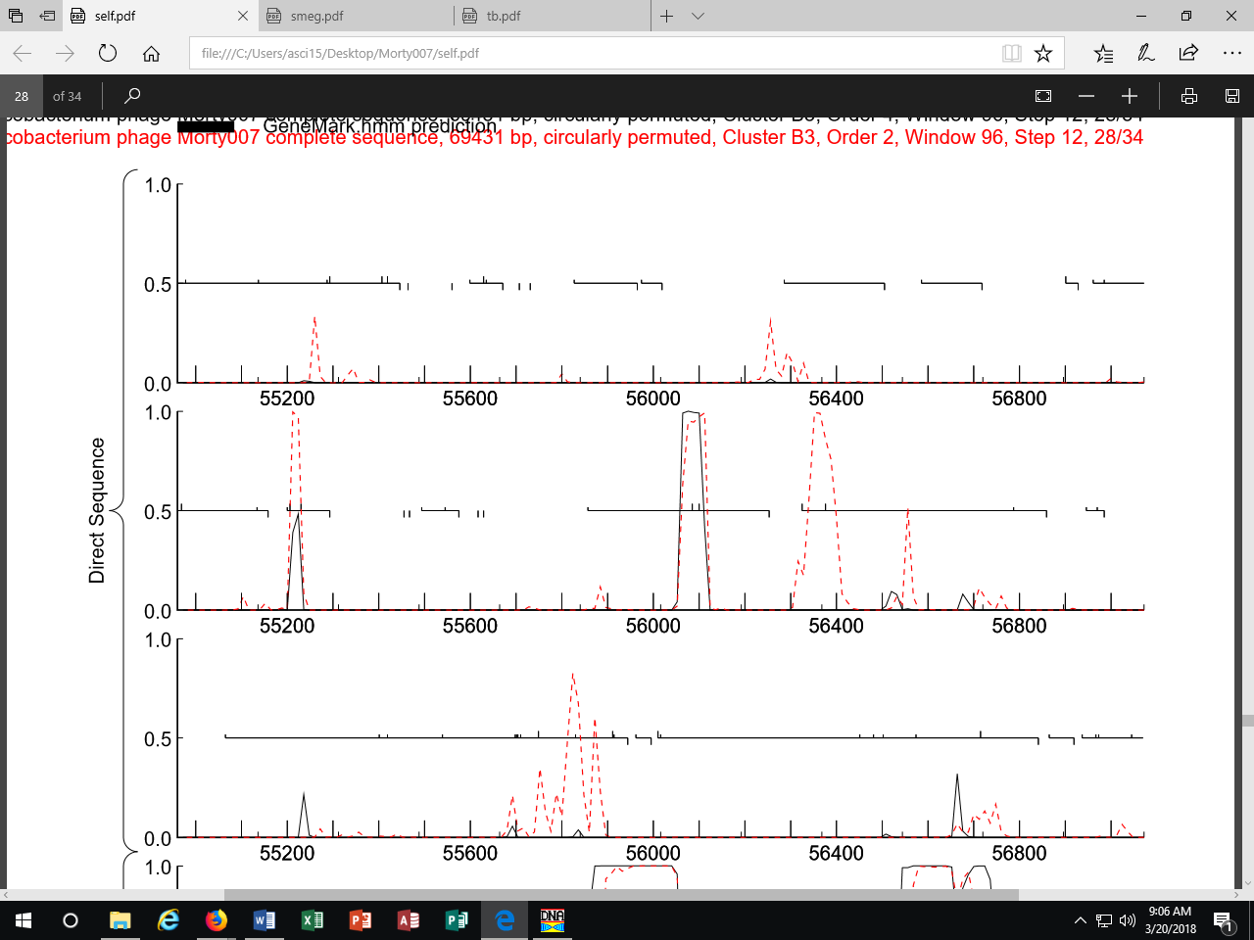
GeneMark Self – basically no coding potential – but according to DNA Master – GeneMark does not call the gene.

PhagesDb blast for the protein at 68 – shows only Morty007
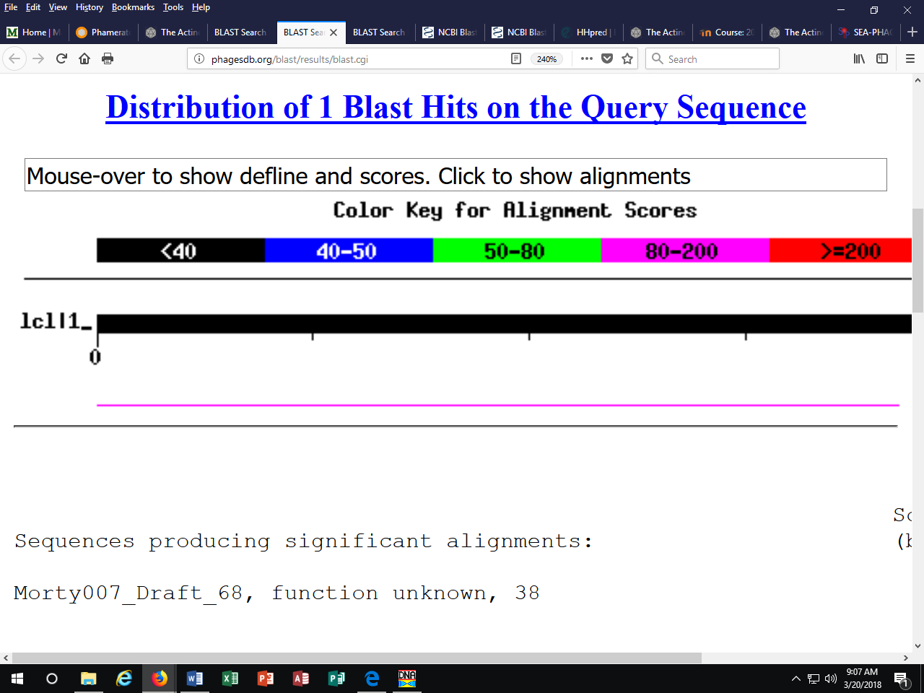
But the nucleotide blast includes our twin Marley1013
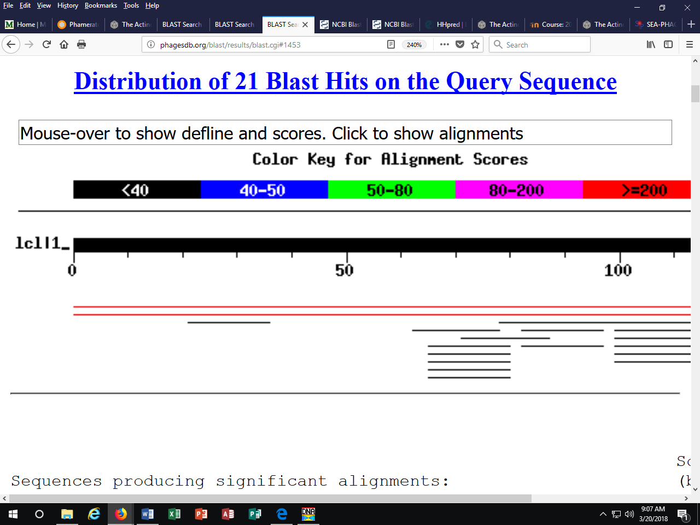
Morty007 calls the gene but Marley1013 doesn’t. They are conserved at the range, but most other phages are different in the region.
NCBI comes up without results for both protein and nucleotide blasts.
HHPred comes up with a 23% match to a mushroom species, which might be present in our region.
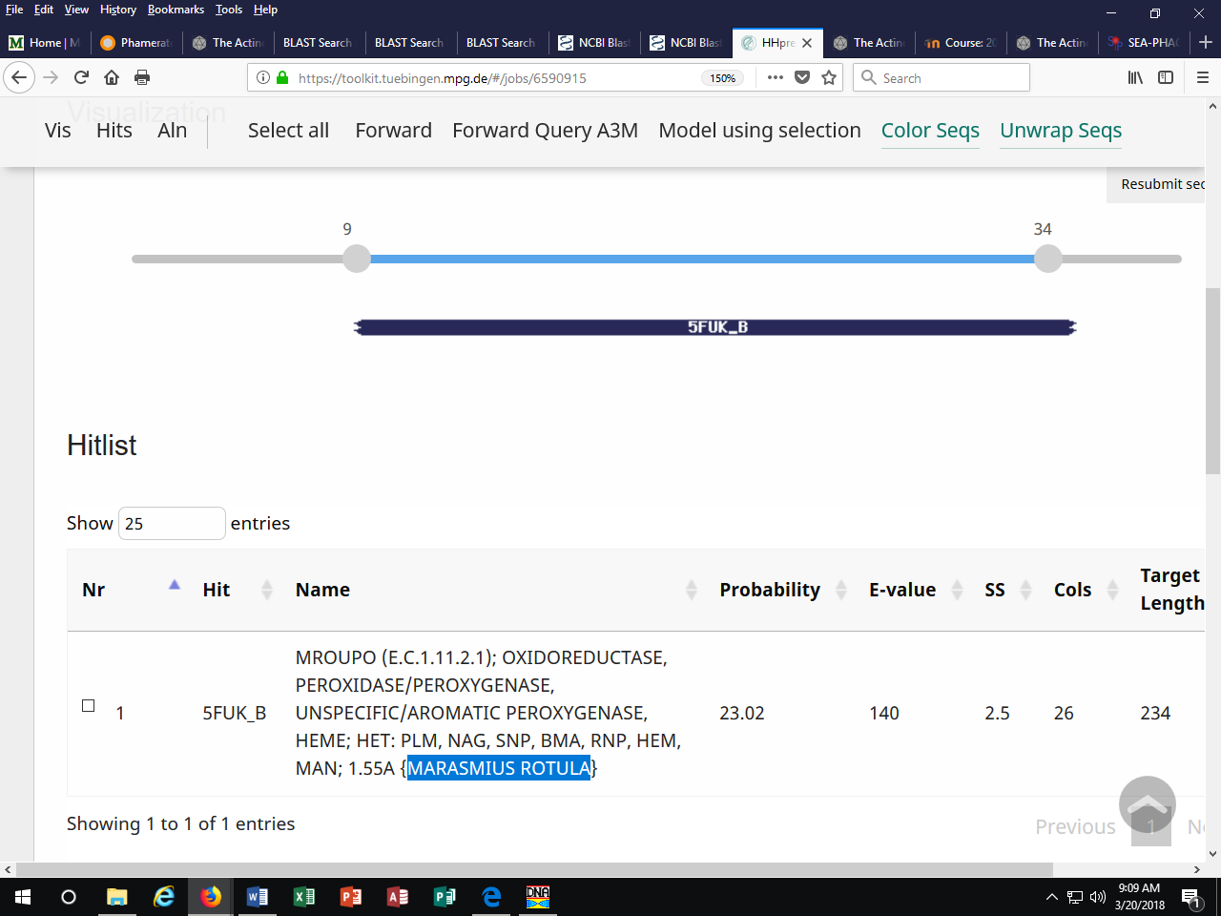
There is no Starterator map for the Pham.
So, we’re just not sure and want some outside thoughts.

