Skinny gene at 63560-63949 bp hits several LAGLIDADG endonuclease, homing endonuclease, HNH endonuclease, with low similarity (less than 60%). Wondering whether to call it with the general “Hydrolase” or “NKF”? Below are the relevant BLASTp and HHPred data:
The hit in PDB is (LAGLIDADG endonuclease):
https://www.rcsb.org/structure/1m5x
The amino acid sequence is:
MDLAYLGGFFDGEGNVGLYKSGGESPRLRVQVFQNHGASQDRLMHEIHDTFGGTLHDRGTGYLYSASGSRAVDLLTQLRPHLRLKLEQADEALEWWRNRTAERFRSRTAEEVAYDESAMTRLKELKRAGZ
BLASTp results from phagesDB
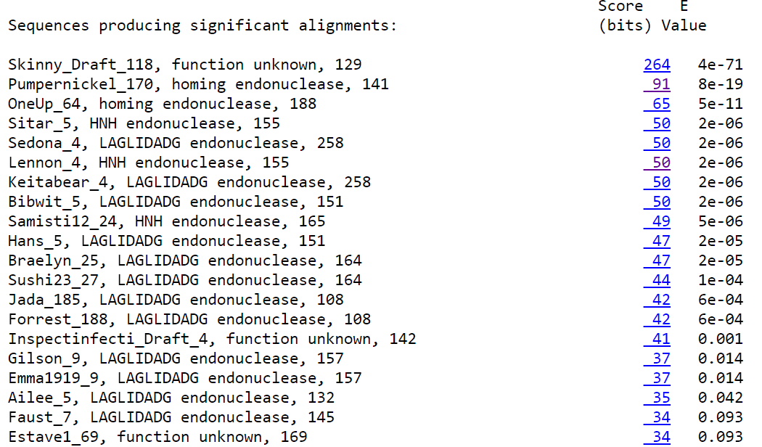
HHPred data: https://toolkit.tuebingen.mpg.de/jobs/4283447
