From Setting Preferences: https://seaphagesbioinformatics.helpdocsonline.com/article-66

Step 2.

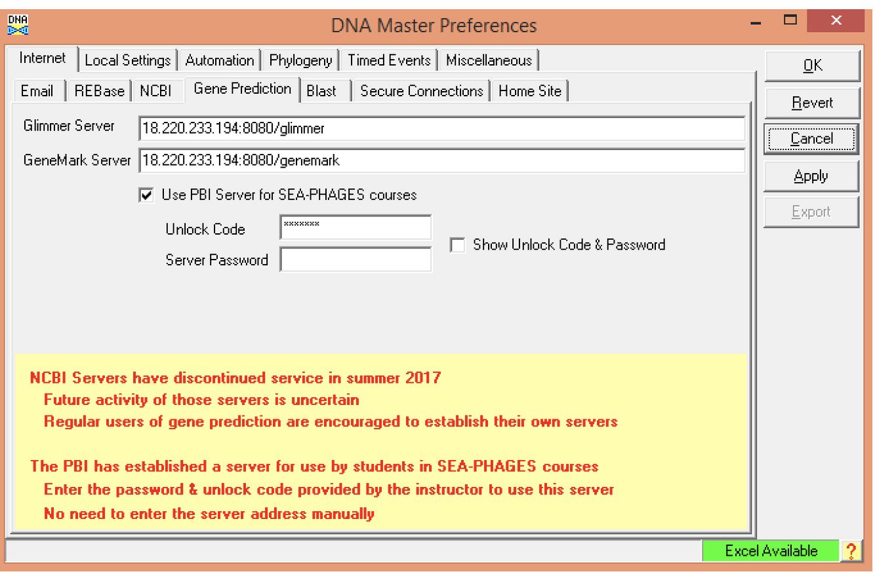

Unlock code: Hatfull
Step 6:

