Gene 16 Typha
Product: MPVFREVHPIRHYPFIPDPNGLTDTHGNVIGTVSTDPVPRKVIAIYPNGTPFEANHSIDYVERDVSFLIMLVRKPELYHAQDEVEINGRRFQVQGEGEDLDYRRSPWPNVTKAFGGQVLIRRVGZ
Query information from HHPred
https://toolkit.tuebingen.mpg.de/#/jobs/8725072_41

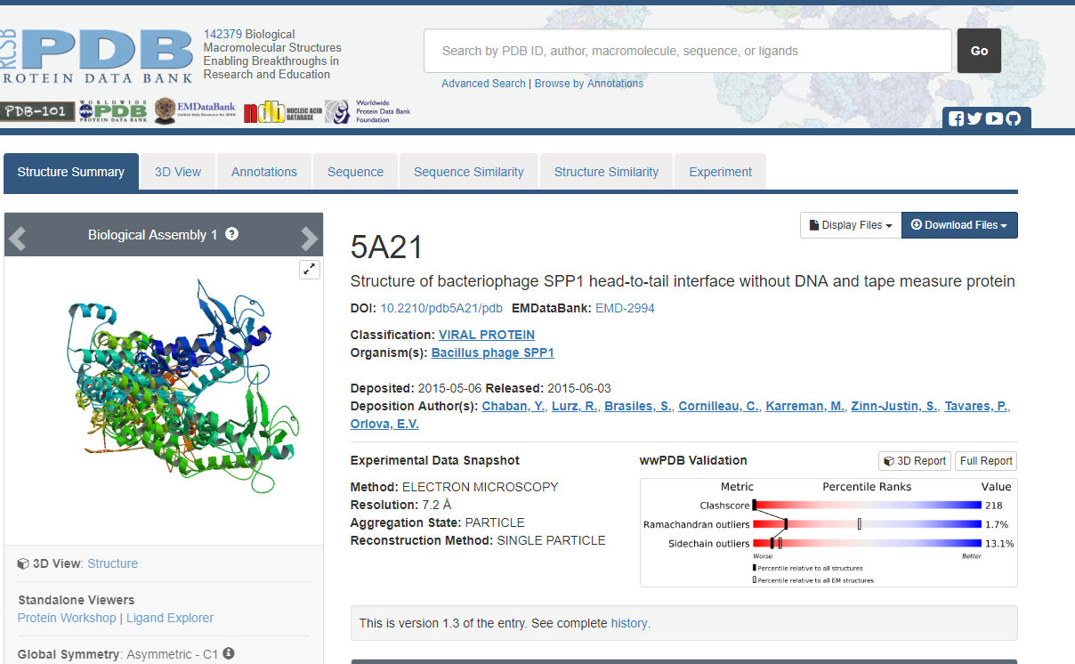
Hits that are coming up below on the page

Gene 18 Typha
Product:
MMVDVAGESIYPPILPPDLEELSVNYLMLKMAVAMGTRLPKTPAGQSLPDPFVRVQFGGGVQVNPIEFDIDTIIHSYHADETLASLNCRTAFAHMVAARGLTVDGWFISGTRGTSLPHRMSDPQVPLPRYRAMVCWRVQGQLITPQZ
Query information from HHPred:
https://toolkit.tuebingen.mpg.de/#/jobs/8725072_42

