Alphafold webserver: https://alphafoldserver.com/
Paste your sequence into the input textbox,
Set Molecule to Protein
Set Copies to 6.
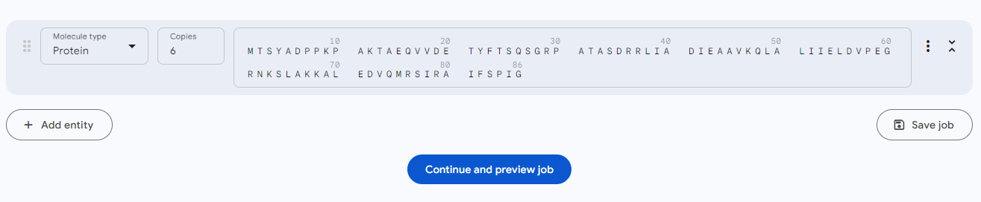

When the prediction completes, you can rotate the molecule to examine for hexamer structure. Alphafold should produce a hexamer model something like this, with low expected position error.
