GalacticEye_6 (stop site 6295)

Function: terminase, small subunit?

Evidence For:
- Downstream gene is terminase, large subunit. (Synteny)
- A few other genes in this pham have called terminase, small subunit (all CS phages); they have e-value of 0 on PhagesDB BLAST.
- PCOILS appears to predict some coil-coil (I’m not sure if I’m interpreting this correctly
- DNABIND predicts DNA-binding function

Evidence Against:
- NO HHpred hits of significance for this gene when searching thru PECAAN (SCOPE, PDB, PFam).
- NO evidence of HTH-binding function

Relevant SEA-PHAGES forum posts:
https://seaphages.org/forums/topic/4736/
https://seaphages.org/forums/topic/4735/ (case study by Debbie)
https://seaphages.org/forums/topic/4942/?page=1#post-7410

PCOILS results (below)
https://toolkit.tuebingen.mpg.de/jobs/GalacticEye_6

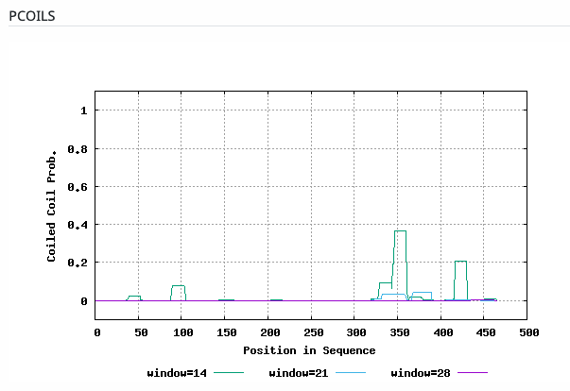
Positive control: Posted by washj in forums, t4 gp16 small terminase:
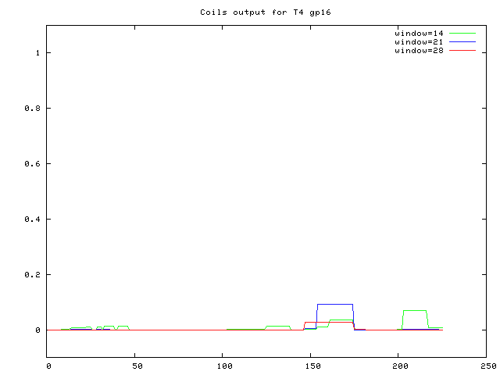

GalacticEye_6 DNABIND prediction:

