Clarification Question About HNH Endonuclease Function Determination in view of hits to the Ref Sequences
In view phagesDB & HHPred data, we are seeking clarification of the HNH function status of the following five draft Glaske16 genes at positions: 44853-45341 bp (gp 70), 51656-52198 bp (gp 83), 54100-54426 bp (gp 91), 56773-57150 bp (gp 98), and 60940-61320 bp (gp 117). There respective sequences are provided, along with background information.
>Glaske16_gp70_(44853-45341 bp)
MPDGNQPACKYGACNDPVLARGFCKLHYYRNRDGKPMDGPRRSYSTGPRAWTYERLASVPITSTGAHQRVRRLWGSASLYPCATCGGPAKDWAYDGTDPTHYYEQGRKAWSHFSRWPEFYMPMCKPCHSNHDRRAAADELREYRQWKMRNPGKTLEDLEGVAZ
>Glaske16_gp83_(51656-52198 bp)
MDTIWKPIPQDPTGLYLASQDGRILRKEYVIEKLQSHGHLYRRVMPEKIVKQCIKDRAPSHGVHPIIQMRSSTQYASTVERRVSSLIAAAWHGLPYEAGDRTAQNDWRIGFIDGDPSNVHADNLEWVSNQGVNTHHSHDFYYENLKAYRAQAAVETAESFLARYYSPDEIDWSTAERIAAZ

>Glaske16_gp91_( 54100-54426 bp)
MPTNSKNGPRSRGRTGGKFERAKWRVLKANQICAHPDCRQLIDLDLKWPDPMSPTVNHIIPVKDLAWDDPLTYSVENLEPMHLVCNQRLGAGPRKKKPKHPQSRNWREZ

>Glaske16_gp98_(56773-57150 bp)
MALAGEAKREYQRQWRANRRAAWFAGKACVRCGSDEDLELDHVDPTLKVTNAVWSWSQERRDVELAKCQVLCNACHKAKTISQTVITIGLKAYRHGTCSMYEHHRCRCGLCRLWARNKKRRQRAAZ

>Glaske16_gp117_(60940-61320 bp)
MQREYMRRWVANRRSAFFASKQCAMCGAGEELELDHIDPTKKVDHRIWSWTDARRSEELAKCQVLCASCHKKKTGEQWYANRSVSENAHHGTSRRYRKMKCRCGLCRLGNTNRSRALRQRHRVPVEZ

HNH is expected to have a typical ββα-metal fold and Zn-finger motif (which would need protein modeling software to decipher; DOI: https://doi.org/10.1038/srep42542), and the Official Function List simply states that it “Must have H-N-H over a 30 aa span.” It would help students if there was an easy way to make this determination since it may not always be obvious in HHPred. Besides just considering the percent probability, should we also consider the e-values (and probably have an e-value cut-off)? Additionally, must it always hit chain A as well as the Zn-finger motif, could it hit other chains such as chain D, with non-zinc motifs such as for Manganese or strontium ions?
Reference sequences for HNH endonuclease are Sisi gp 99 and Arianna gp 54. Both match Geobacillus virus E2 hit 5H0M_A in PDB, with Sisi having a 93.5% alignment, 98.7% probability, and E-value: 1e-7, while Arianna has 67.3% alignment, 98.7% probability, and E-value: 2.2e-7.
>Sisi_gp99 MPRAPKVCRHAGCTTLTTTGTCPQHTTHRWGNHQGRKVPHRLQQATFRRDNWTCQSCGHTATPGSGQLHADHIQPRSRGGADTLDNMRTLCKACHAPKSRAEARGSNT
> Arianna_gp54
MAWSNGSSRTSSKHWQALRASAKKQLGYYCCAVCGITPAGGARLELDHIIPVAEGGSDEMANLQWLCARHHAIKTRAESRRGAQRRAARRRLPQRPHPGLR

HHPred for Arianna is: PDB, Geobacillus virus E2, hit # 5H0M_A, 67.3% alignment, Probability: 98.67%, E-value: 2.2e-7.
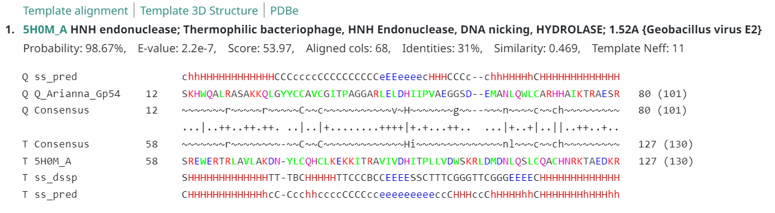
The PDB hit for Arianna (https://www.rcsb.org/structure/5H0M) is below
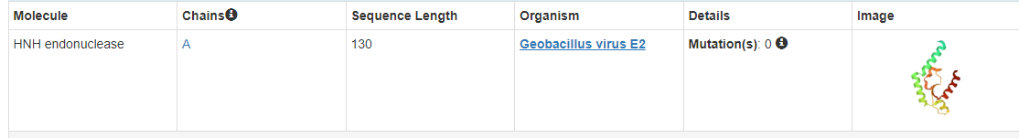
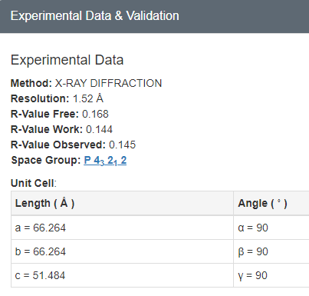
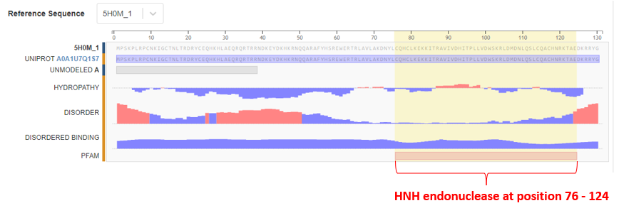
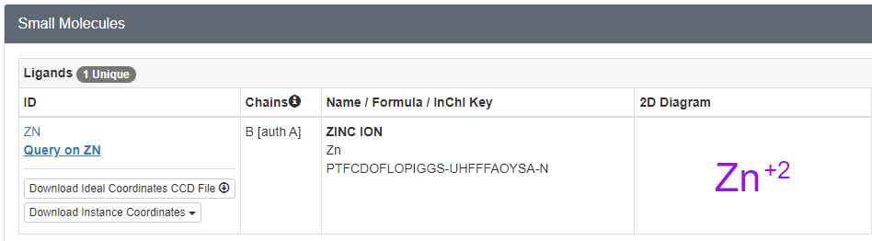
In view of the above, we can now specifically ask about the following five draft Glaske16 genes at positions: 44853-45341 bp (gp 70), 51656-52198 bp (gp 83), 54100-54426 bp (gp 91), 56773-57150 bp (gp 98), and 60940-61320 bp (gp 117).
Glaske16 gp 70 (44853-45341 bp has the top PhagesDb hit as Skinny gp 71 which is called Hypothetical Protein, yet it is 100% identical, q1:s1, but has >10 hits to HNH endonuclease). I am inclined to call this an HNH endonuclease, except if the forum suggests otherwise. Again, below is its aa sequence:
MPDGNQPACKYGACNDPVLARGFCKLHYYRNRDGKPMDGPRRSYSTGPRAWTYERLASVPITSTGAHQRVRRLWGSASLYPCATCGGPAKDWAYDGTDPTHYYEQGRKAWSHFSRWPEFYMPMCKPCHSNHDRRAAADELREYRQWKMRNPGKTLEDLEGVAZ
However, this gene, like the two reference sequences, hits HNH chain A of the same Geobacillus virus E2 hit 5H0M_A in PDB, with 75.5% alignment, 99.19% probability, and E-value: 2.5e-11, with everything exactly as seen above for the two reference sequences, including the HNH endonuclease at position 76-124 (https://www.rcsb.org/structure/5H0M).
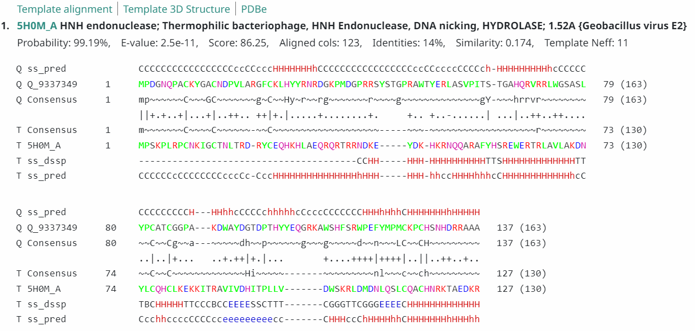
Notably, Skinny gp 93 which is called HNH has got poor e-values
Next is Glaske16 gene at 51656-52198 bp (draft gp 83); its sequence is below:
MDTIWKPIPQDPTGLYLASQDGRILRKEYVIEKLQSHGHLYRRVMPEKIVKQCIKDRAPSHGVHPIIQMRSSTQYASTVERRVSSLIAAAWHGLPYEAGDRTAQNDWRIGFIDGDPSNVHADNLEWVSNQGVNTHHSHDFYYENLKAYRAQAAVETAESFLARYYSPDEIDWSTAERIAAZ
This one too hits HNH endonuclease in phagesDB. HHPred shows it in PDB with 54.1% alignment, Probability: 99.76%, E-value: 6.2e-18, but notably, it does not hit the same chain as the ref chain (it hits 1U3E_M; https://www.rcsb.org/structure/1U3E) and no Zn⁺² motif, but instead Mn⁺² and Sr⁺², but it also has the βα. See below:
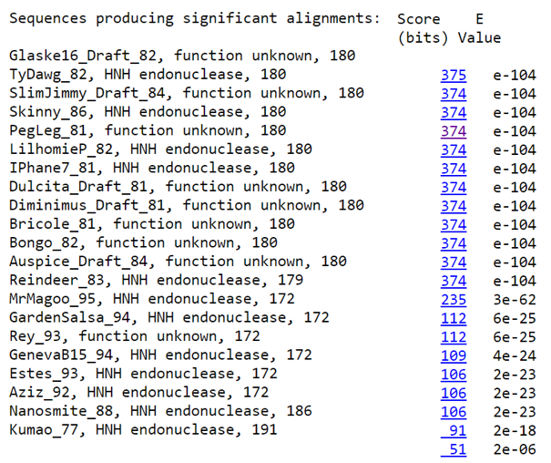
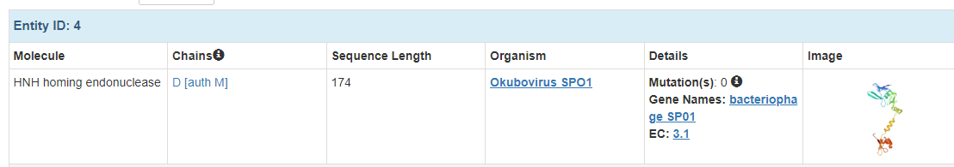
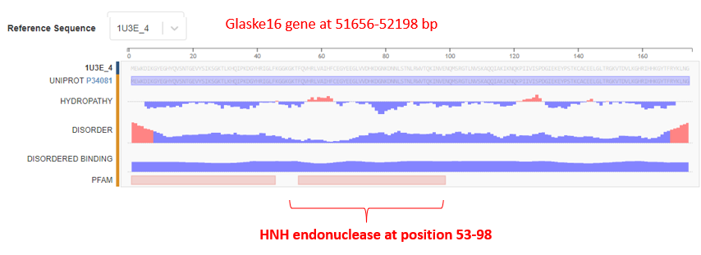

What is your verdict on this gene in Glaske16 at 51656-52198 bp in view of the above? I am inclined to call it HNH endonuclease, except if the forum suggests otherwise.
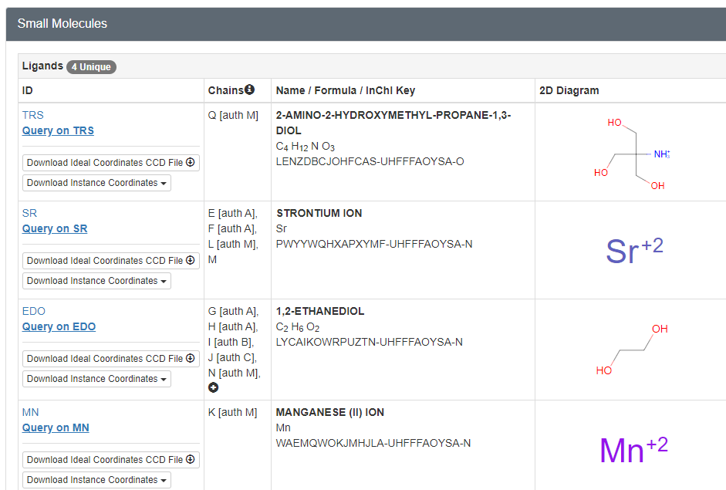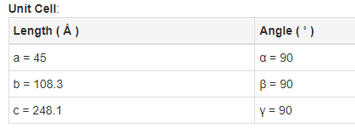

Next is Glaske16 gp 91 at position 54100-54426 bp. Has several hits to HNH in phagesDB.
MPTNSKNGPRSRGRTGGKFERAKWRVLKANQICAHPDCRQLIDLDLKWPDPMSPTVNHIIPVKDLAWDDPLTYSVENLEPMHLVCNQRLGAGPRKKKPKHPQSRNWREZ
This has a low e-value but hits the same chain as the ref sequence, and the zinc motif (https://www.rcsb.org/structure/5H0M ), and is called HNH endonuclease, and another hit at 4H9D_A (https://www.rcsb.org/structure/4H9D).
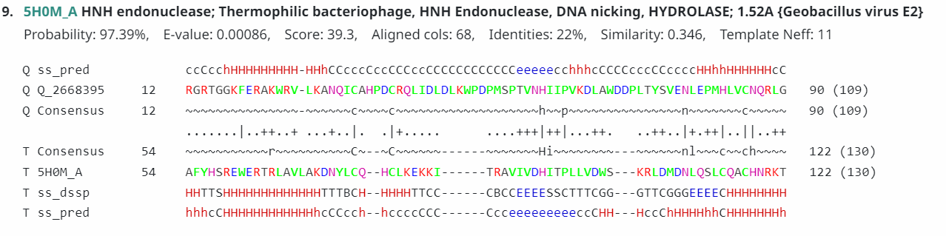
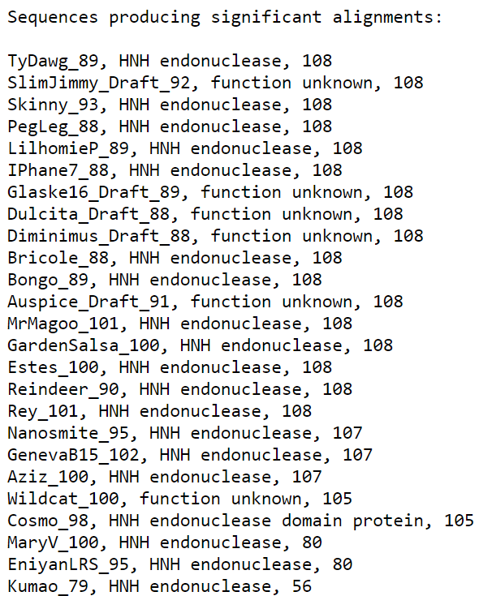
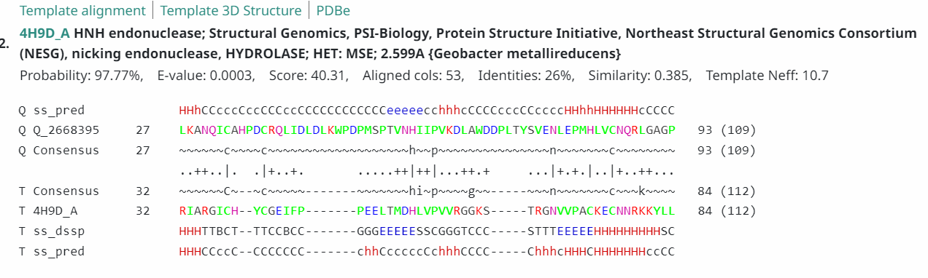
What is your verdict on this gene in Glaske16 gp91 at 54100-54426 bp in view of the above? I am inclined but wary to call it HNH endonuclease because of the e-values, but again, it hits are the same as the Ref sequences; any suggestions?

The next question is about the Glaske16 gp98 at position 56773-57150 bp. It has more than 60 hits to HNH endonuclease in phagesDB. Its sequence is below:
MALAGEAKREYQRQWRANRRAAWFAGKACVRCGSDEDLELDHVDPTLKVTNAVWSWSQERRDVELAKCQVLCNACHKAKTISQTVITIGLKAYRHGTCSMYEHHRCRCGLCRLWARNKKRRQRAAZ
It also hits the same hit 5H0M_A in PDB with the same everything as the reference sequences, and high probability (98%), alignment 52.4%, but with not as great an e value (0.000029). What is your verdict on this one? See data below:
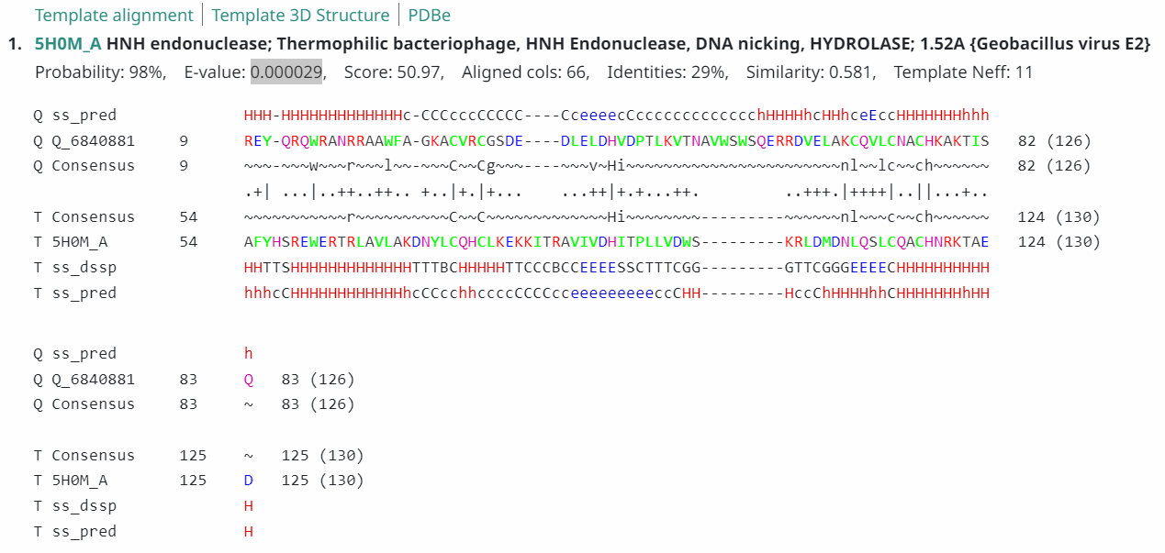
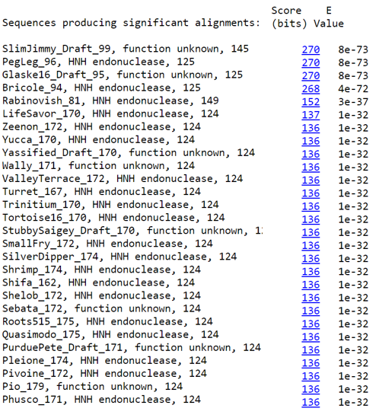

Finally, the Glaske16 gp117 at 60940-61320 bp. This gene has more than 70 hits to HNH endonuclease in phagesDB. What is your verdict on this one? Its sequence is:
MQREYMRRWVANRRSAFFASKQCAMCGAGEELELDHIDPTKKVDHRIWSWTDARRSEELAKCQVLCASCHKKKTGEQWYANRSVSENAHHGTSRRYRKMKCRCGLCRLGNTNRSRALRQRHRVPVEZ
It also hits the same hit 5H0M_A in PDB (https://www.rcsb.org/structure/5H0M) with the same everything as the reference sequences Sisi gp 99 and Arianna gp 54, and high probability (98.05%), alignment 49.6%, but with not as great an e-value (0.000017). What is your verdict on this one? See data below.
