BlastN results: JalFarm20_36

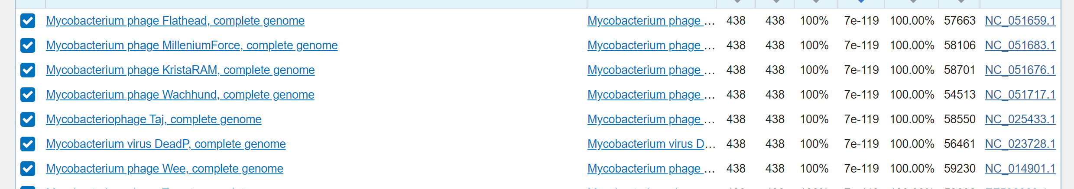
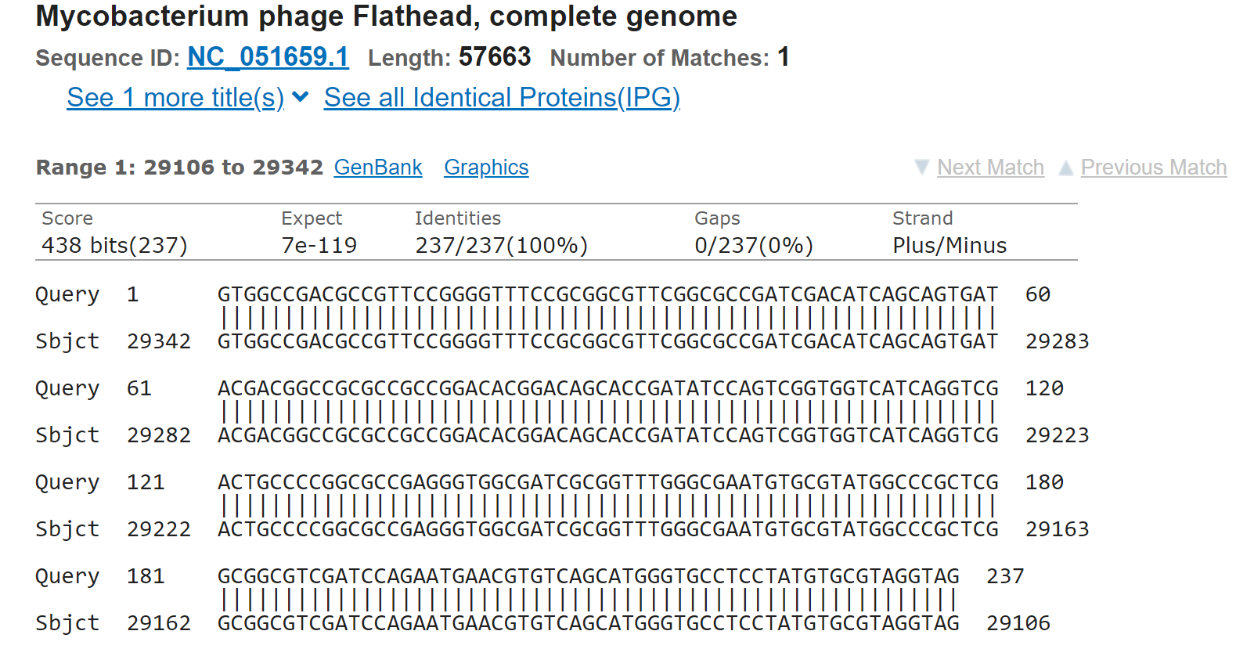
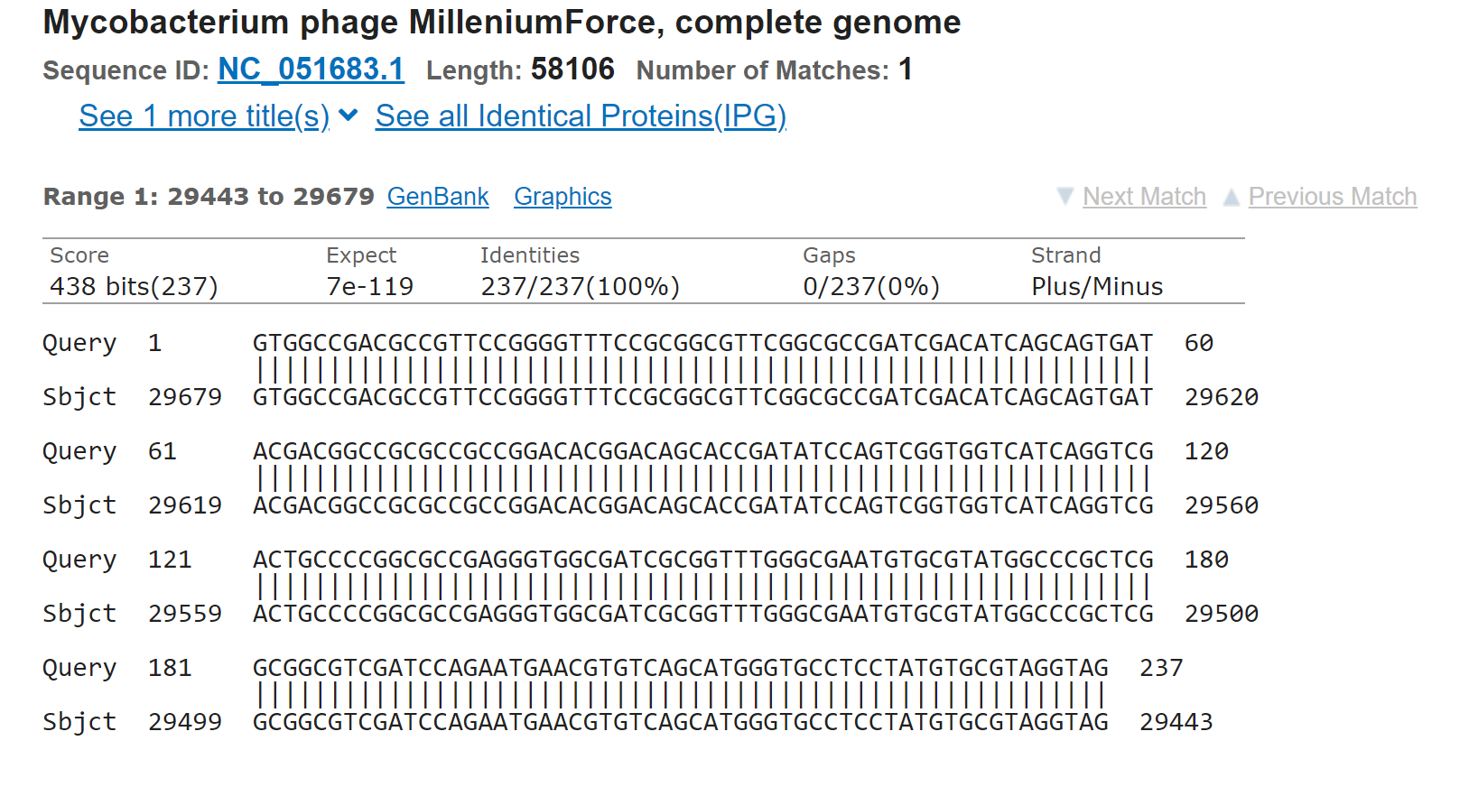

We have more than 4 bp overlaps.
Gap between 36 and 37 is -211.
