Follow-up Clarifying Question about tRNA and protein genes not overlapping.
In my previous post entitled “Is there any recent evidence of a tRNA overlapping a protein gene, even by a few bp?” (https://seaphages.org/forums/topic/5365/) I thought this question was settled. I want to delete the gene in phage Glaske16 at position 60940-61320 bp, but because several recent annotations have kept it, and it has more than 70 hits to the HNH endonuclease in phagesDB, I am seeking a second opinion on this. Its sequence is MQREYMRRWVANRRSAFFASKQCAMCGAGEELELDHIDPTKKVDHRIWSWTDARRSEELAKCQVLCASCHKKKTGEQWYANRSVSENAHHGTSRRYRKMKCRCGLCRLGNTNRSRALRQRHRVPVE
Despite more than 70 hits to HNH endonuclease in phagesDB, this gene has low (<50%) coding potential in Genemark_S, and entirely no CP in Genemark_smeg, and TB. THIS GENE OVERLAPS 15bp WITH A tRNA CALLED BY ARAGORN v1.2.41 AND tRNA-SE v. 2.0. WITH AN INFERNAL SCORE OF 55.5.
I am asking this question because of the statement from the Resource Guide entitled, “Predicting tRNA and tmRNA genes” (https://seaphagesbioinformatics.helpdocsonline.com/article-40):
“It is highly unusual that a phage tRNA will:(i) Be encoded within an ORF called by Glimmer and GeneMark that has high coding potential, (ii) Be encoded on the opposite strand as a number of other phage tRNAs found in the same genome, (iii) Be encoded at a genomically distant location from the other tRNA genes in a genome. In general, violation of any of the three preceding conditions is sufficient for exclusion of a potential tRNA from an annotation (we have found a single high scoring tRNA that is not part of the rest of the large cluster, however this situation is very rare).”
Whereas I am inclined to delete the protein coding gene and keep the tRNA since it is called by ARAGORN and tRNAscan-SE with a high infernal score (55.5), I also note that this tRNA is distant from other tRNAs, being 387 bp apart, which seems to violate caveat iii above.
According to the forum post, “How close can one pack protein and tRNA's genes” of Feb 24, 2016, Dr Pope stated that, “We tend to steer clear of a tRNA and a protein occupying the same space, but there are definitely genomes where they get pretty close.”
I realize that there may be exceptions though but wanted to be sure. Some M1 phages such as Reindeer & Iphrane7 do not have this gene but have the “Glu” tRNA (61306-61380 bp in Glaske16; see fig below), and we know that tRNAs tend to be conserved.

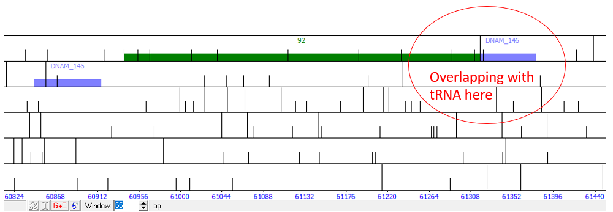
Phamerator map
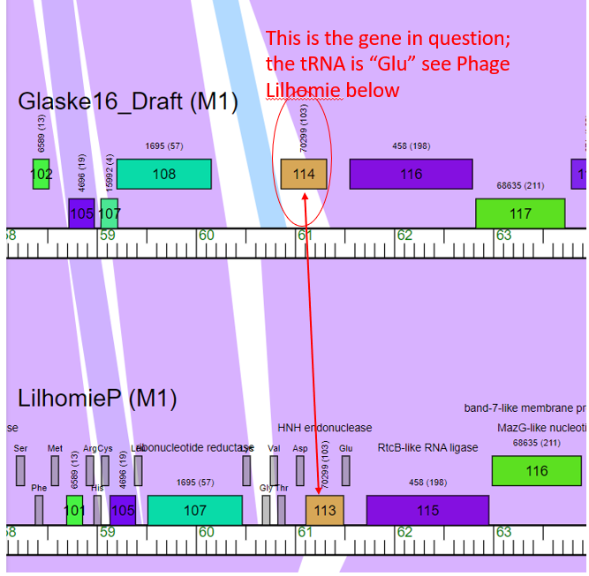
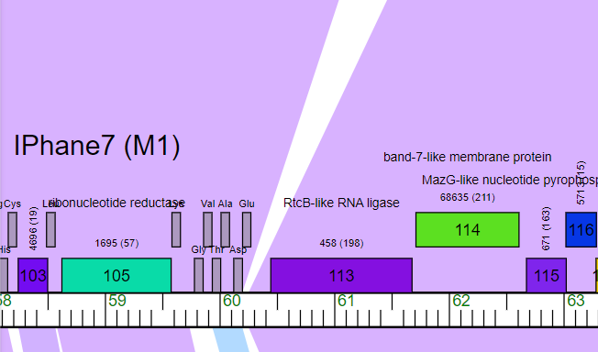

Sample phagesDB hits
