BIOS 252 Science Research
Annotation Template
Panagakis 4/20/21

List most closely related phages to JalFarm20 by BLAST in phagesdb.org:

Annotation for Gene # ___36 in DNAMaster_____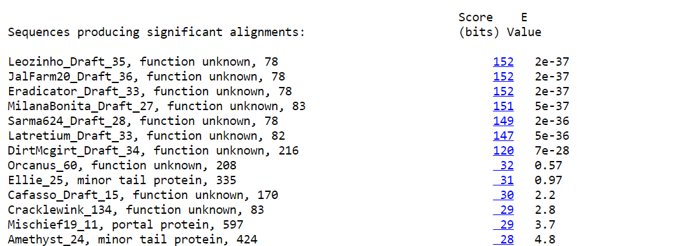

Glimmer predicted nucleotide start 29,586-29,822 (reverse); DNAMaster, phagesdb, Phamerator. BUT this is #37 in PECAAN.

Glimmer predicted nucleotide stop __29,822_____

1. Is the ORF a protein coding gene?

a. Do the Glimmer and GeneMark gene calls in the auto-annotation agree? ____NO; not called by GeneMark.___

b. Does the ORF have high coding potential based on the GeneMark output? Mostly atypical.
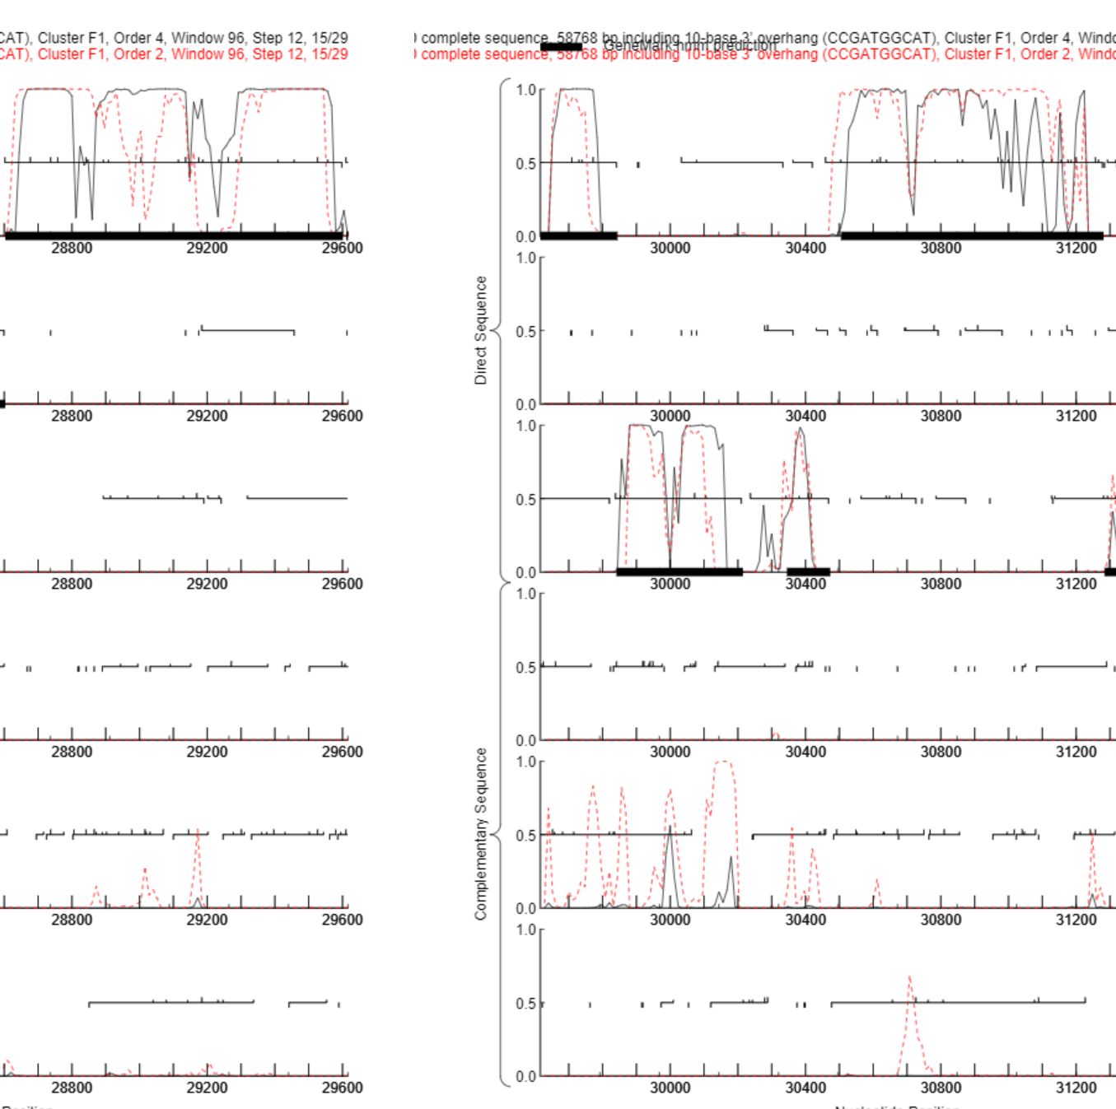
Lysin B
28,603-29,601

#35: 28,603-29,601 +3 (Lysin B)
#36: 29,822-29,586 -1 (reverse)
#37: 29,611-29,844 +3 (Holin)
#38: 29,841-30,215 +2
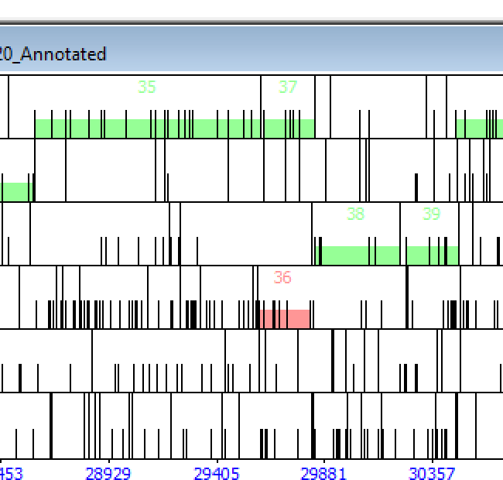

c. Do we see this ORF in phage of the same subcluster using a Phamerator gene map? ___Just drafts____ If so, what is the Pham number? 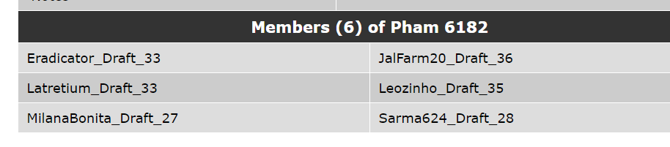
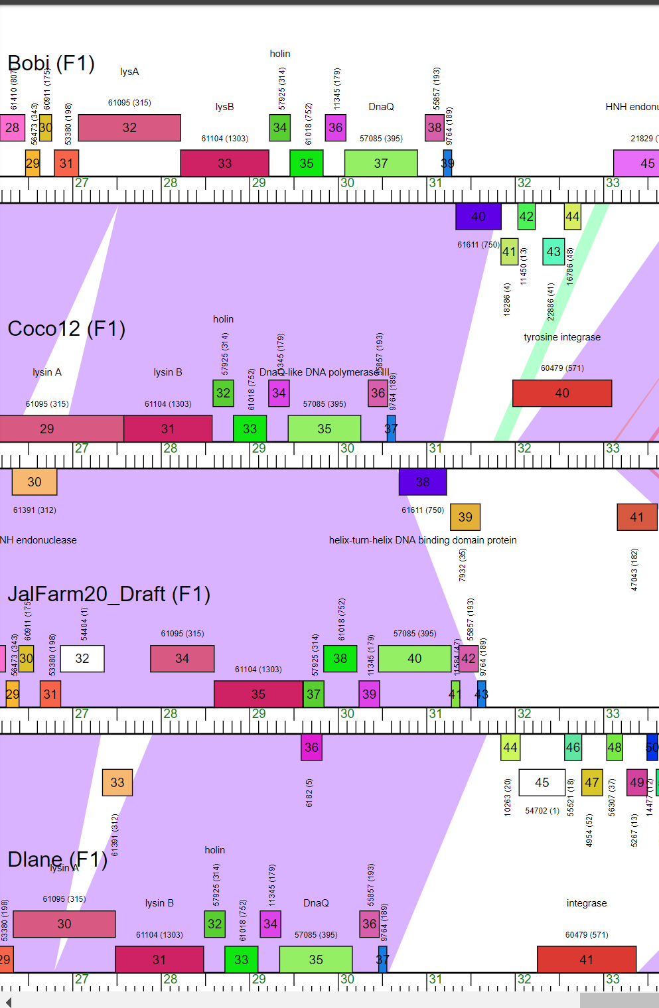

d. Does a protein BLAST (from either phagesdb.org BLAST, or from NCBI BLAST) produce any matched alignments to proteins with well-known functions? NO
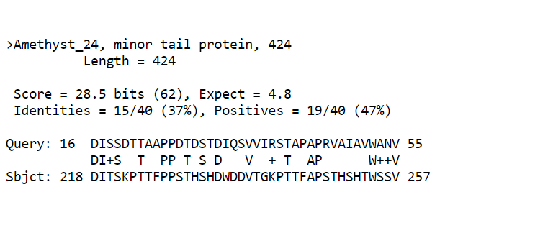Conclusion: Is the ORF a gene? NO?
Rationale for the decision:
1. GeneMark did not call this as a gene
2. Coding potential is mostly atypical
3. Starterator was not informative; only draft genomes in Pham #6182
4. In DNAMaster: Forward genes 35 and 37; this gene, 36, is a reverse gene that overlaps: 29,822-29,586 (reverse)
5. No synteny evident

2. If it is a gene, where does it start?

a. Is this start conserved among all members of the pham in Starterator? ___No____
(phagesdb.org/Phage/Phams/enter phamily number/get starterator report) to evaluate gene starts.
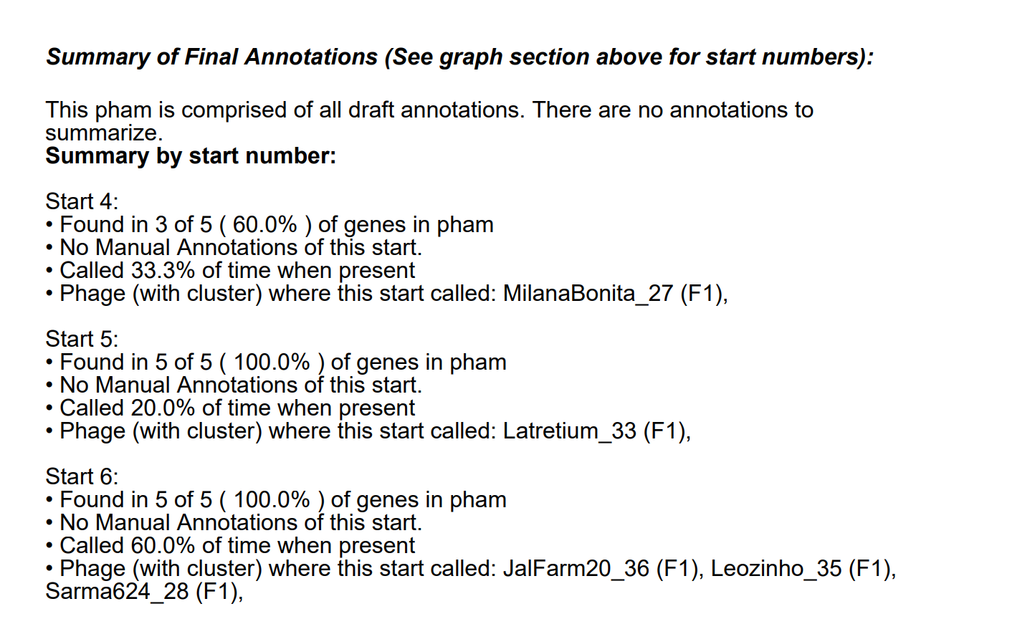

b. Does the currently predicted start site include all of the coding potential in the GeneMark output? ___Yes; BUT atypical____

c. Did Glimmer and GeneMark agree on the start? NO

d. Is the predicted start codon the longest possible for the ORF without causing excessive overlaps? Check DNA Master DNA/Frames. Yes

e. For genes with functional predictions from BLAST, does the start choice include the full-length protein? ___N/A_

f. Does the start site match other starts for similar genes in NCBI BLAST and the phagesdb.org BLAST? ___Yes, but only drafts

g. Does the predicted start have an associated ribosome binding site (RBS, i.e. Shine-Dalgarno sequence) with a high score or recognizable sequence? ____
Use RBS Sequence Finder in DNA Master.

Conclusion: At which nucleotide does the gene start? ____

Rationale for the decision:

3. What is the gene's function?

a. BLASTP: Does this protein align with a protein with a functional assignment in NCBI or phagesdb.org? ____Only small portion-minor tail protein_

b. HHPred: Does this protein align with a protein with a functional assignment in the PDB? ___
Use https://toolkit.tuebingen.mpg.de/#/tools/hhpred and paste protein sequence into the box.

c. Synteny: Is this gene located adjacent to other genes of known function, in a region of the genome that shows high conservation of gene order? ______NO

d. Official function from the current SEA-PHAGES FUNCTIONAL ASSIGNMENTS list found at https://seaphagesbioinformatics.helpdocsonline.com/article-96.

Conclusion: What is the gene function? _

Rationale for the decision:

4. Annotation Notes.

This is the short-hand code list in the Features/Notes section of DNA Master for each gene.
SSC: CP: SCS: ST: BLAST-Start: Gap: 40 LO: RBS: F: SIF-BLAST: SIF-HHPred: SIF-Syn
The instructions how to record the notes are found at https://seaphagesbioinformatics.helpdocsonline.com/officialdocumentation

