Phage Name: PermaG

Gene Number: 38
Documenter: Wasique Hasan
Date: 10/21/20

- SSC: 25,816-25,920
- CP: [Yes, appears as if all coding potential is covered by start]
Start is a little upstream of where the black bar signalling coding potential ends. Graph for coding potential goes to zero before stop site.
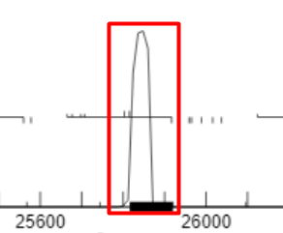
- SCS: [both-gm]
Chosen start is at 25,816

- ST: [NA]
Gene is an orpham
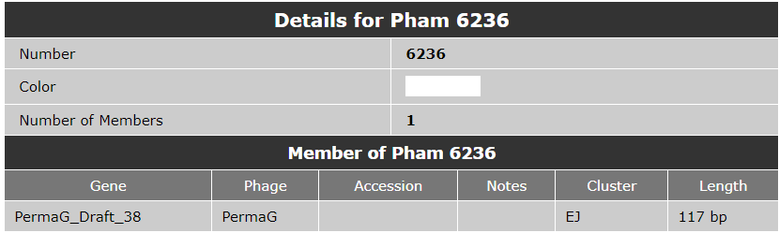
- Blast-Start: [NA, no blast results]
No matches in PhagesDB BLAST data.
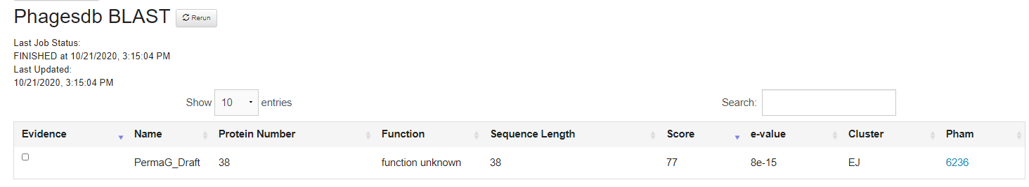

- Gap: [1bp overlap for start at 25,816]
For Start 25,804, 13 bp overlap
For Start 25,816, 1 bp overlap
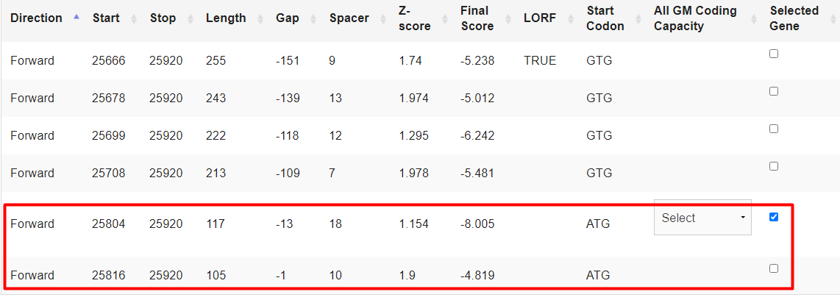
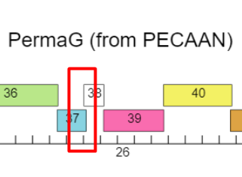

- LO: [No, there is overlap]
- RBS: [1.9, -4.819, best score between the two potential starts we are considering at 25,804 and 25,816]
For the start at 25,816: It was called by GeneMark as the start, it has the higher RBS score compared to the other potential start, and it has the smallest overlap among the potential starts. Because of these reasons, we have decided on 25,816 as the start.
- F: [NKF]
- SIF-BLAST: [NA]
No NCBI BLAST data.
Phagesdb BLAST does not give function information.
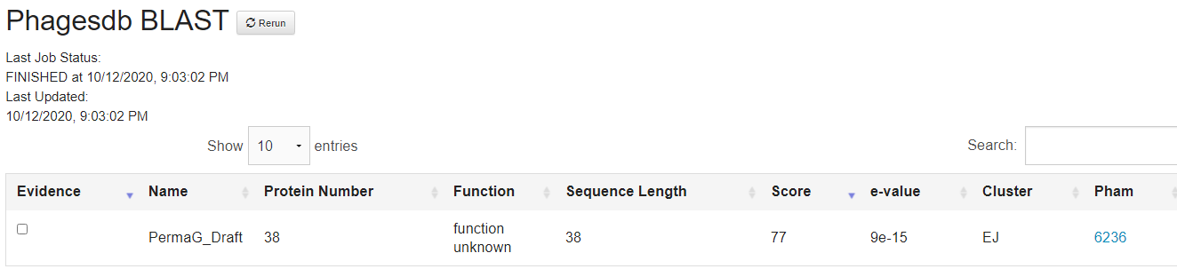
- SIF-HHPred: [NKF- no matches with proteins present in phages]
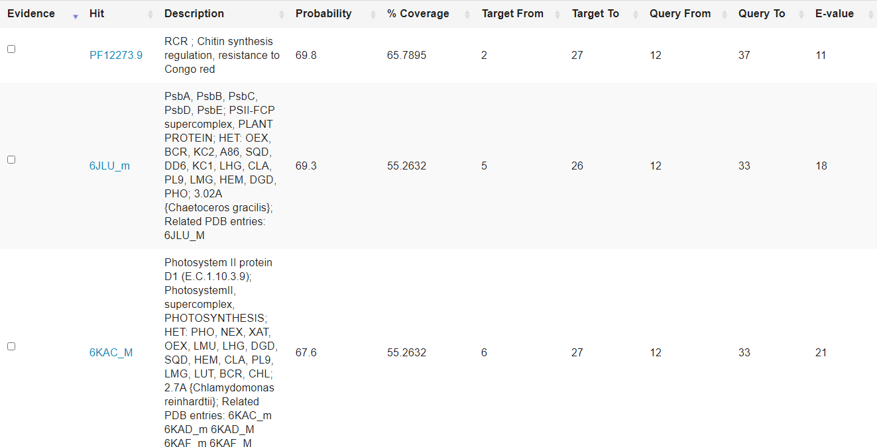
- SIF-Synteny: [NKF- no positional similarity with related phages in the same cluster]
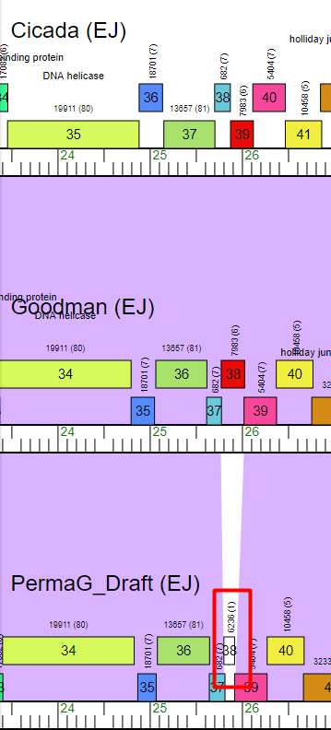
- Notes: Changed the start site from the Glimmer start site at 25,804 to the GeneMark start at 25,816

