Query about Function assignment for MrMiyagi gene 97
Need help deciding on the function of MrMiyagi gene 97 (gene 100 in phamerator). It is an Orpham.
BLASTp in NCBI & phagesDb hits holliday junction resolvase with phage Fowlmouth, q59: s7, coverage 52%, pecent identity 96.97%, e-value 1e-25 (https://blast.ncbi.nlm.nih.gov/Blast.cgi).
However, HHPred data hits at DNA Helicase, PDBe, Thermus thermophilus, d1ixsa_, 28.92%, 92.41% as well as RNA POLYMERASE SIGMA FACTOR CNRH; TRANSCRIPTION, ECF-TYPE SIGMA and on RuvA_C ; RuvA, C-terminal domain. The hit at Holliday junction DNA helicase ruvA/RuvB(E.C.3.6.1.3) has a probability of 78.61%. I am therefore conflicted on what function to settle for: holliday junction resolvase, DNA Helicase or RNA polymerase sigma factor?
https://toolkit.tuebingen.mpg.de/jobs/MrMiyagi_gp97
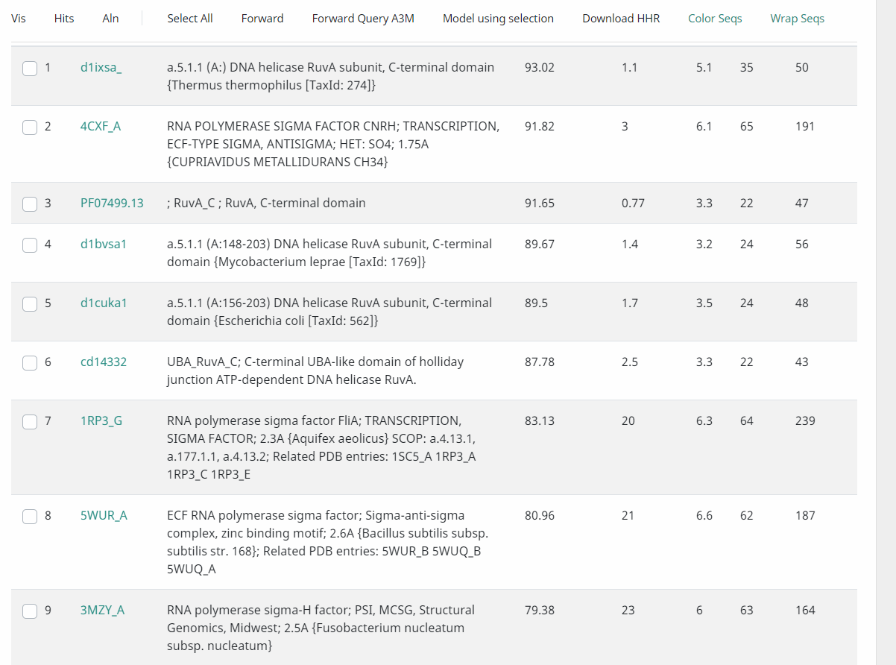
https://www.rcsb.org/structure/4CXF
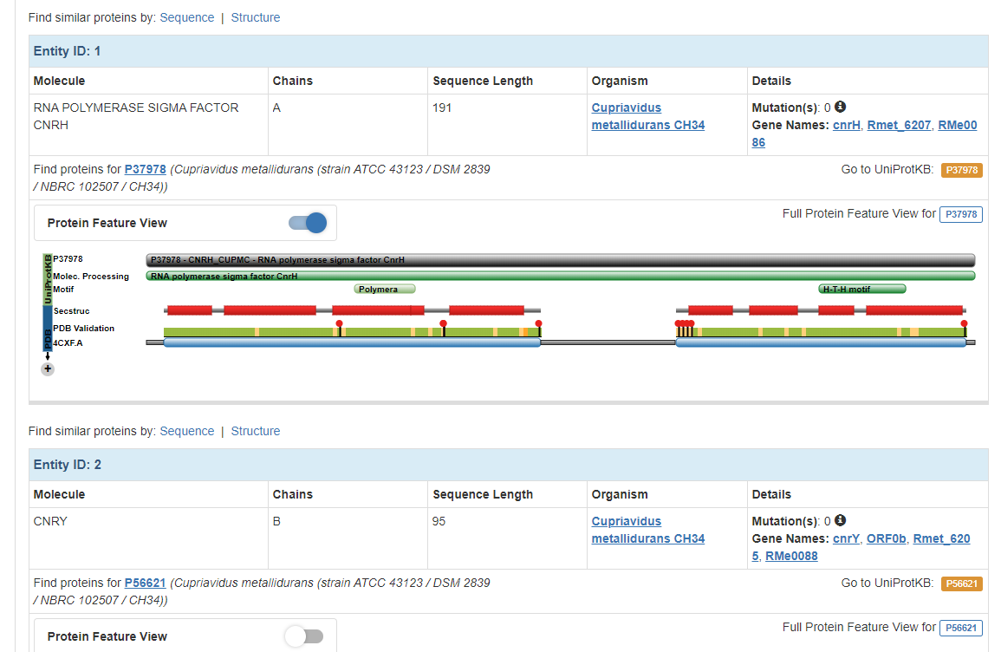

This is the HHPRED link to the Sigma factor reference sequence
https://toolkit.tuebingen.mpg.de/jobs/Nurujay_Gp52

