DNA Master Gene Prediction Settings.

- Go to File --> Preferences [Internet] [[Gene Prediction]]
- Check the box labeled ‘Use PBI server for SEA-PHAGES courses.’
- Enter the code ‘Hatfull’ in the field ‘Unlock Code’ This code is case-specific. You may want to check the box marked "show Unlock Code and Password" to assure yourself you have entered the correct code in the correct case.
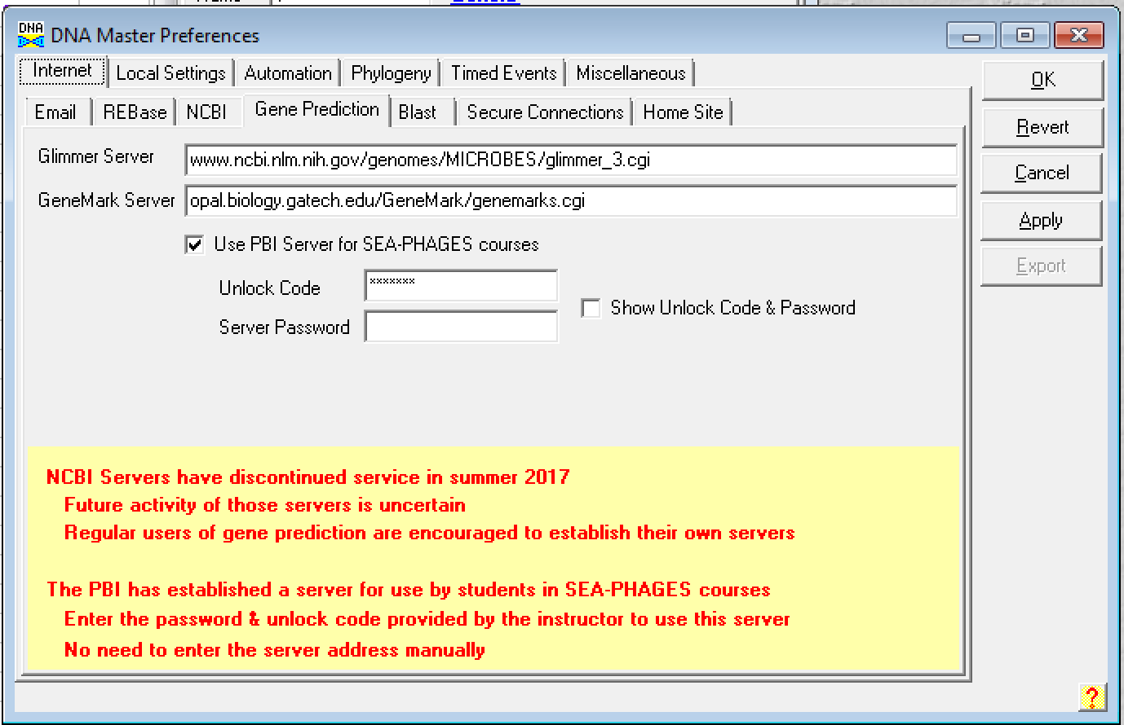

- Go to File --> Preferences [Internet] [[Secure Connections]]
- Uncheck the box labeled ‘Secure Connection (HTTPS) to GeneMark Server’.’
- Uncheck the box labeled ‘Secure Connection (HTTPS) to Glimmer Server’.
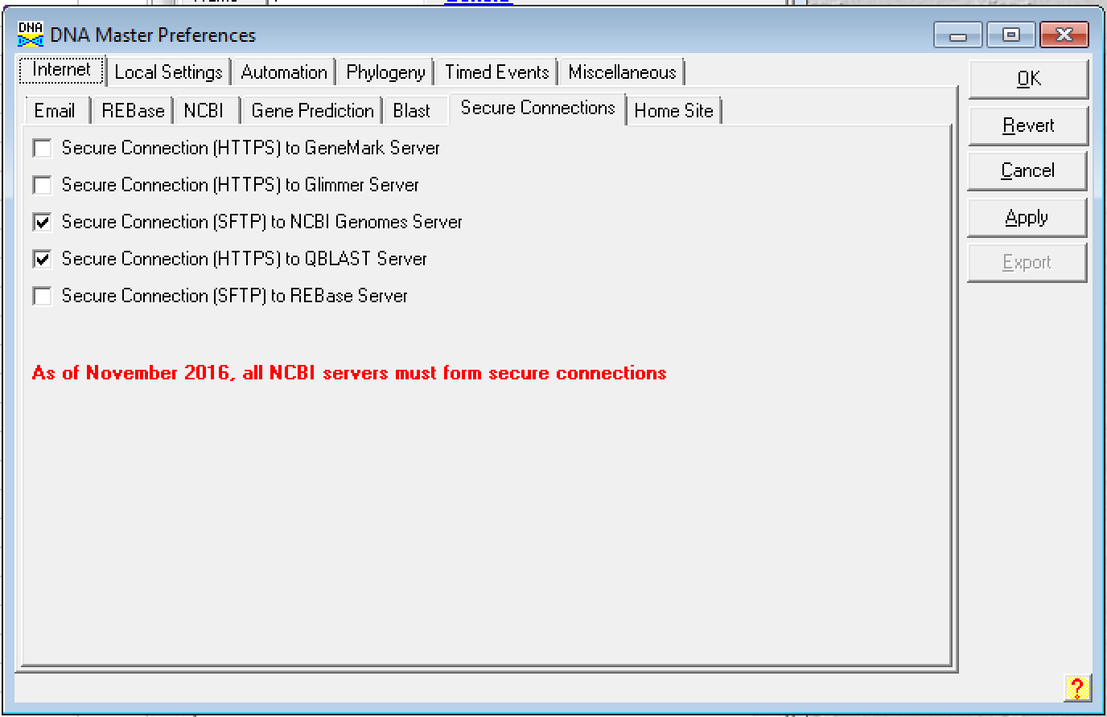
- Click ‘Apply’.

