Case Study: Cluster A tyrosine integrase

Phage Genome: IronMan

Genome Coordinates: 26928-28090

Objective: Determine where the integrase of IronMan starts

1. Collect Evidence: insert screenshots relevant to THIS REGION of the genome as indicated below. of GeneMark, BLAST results, Aragorn, Phamerator, HHPred, choose start window, frames window, etc. Make sure that your evidence is readable and complete.

A: screenshot of BLASTN results on phagesdb.org

B: screenshot of phagesdb.org pham page with functions

C: Autoannotation results for this region (what do the DNA Master notes say are the Glimmer and GeneMark results?)

D: screenshot of the DNA Master frames window

E: screenshot of GeneMarkS output. If no coding potential in region, add GeneMark-host output(s)

F: screenshot of regional Phamerator map, with relevant phages

G: screenshot of DNA Master “Choose Start” window

H: screenshot(s) of DNA Master BLAST results, including alignment tab(s)

I: screenshot(s) of Starterator report

J: screenshots of HHPred results

K: screenshot of Aragorn results

L: screenshot of tRNAscanSE results

M: screenshot of Phamerator map of entire genome

N: other

2A. Is this a gene? __Y;
Rationale: Write a one-sentence explanation for each piece evidence above and how it supports your answer to 1, or write NI for not informative or n/a for not applicable.

This case study isn’t really about is it a gene-
A
B:

C:

D:

E:

F:

G:

H:

I:

J:

K:
L:

2B. Rank the evidence from most-to-least compelling. include a one -to -two sentence rationale to support your order or write NI for not informative or n/a for not applicable.

If your answer to 2 is “no”, you are done with this case study.

If not:

3. What is the start coordinate for your gene? ________
Refer to evidence in part 1.
Rationale: Write a one-sentence explanation for each piece evidence you’ve included and how it supports your answer to 3 or write NI for not informative or n/a for not applicable.
A:
B:
C:
D:
E:
F:
G:
H:
I:

J:
K:
L:

3.B Rank the evidence from most-to-least compelling, include a one-to-two sentence rationale to support your order or write NI for not informative or n/a for not applicable..

4A. What is the function of this gene? (choose from approved list): (ie terminase, large subunit)
integrase (Y-int)
4B: Rationale for evidence:
Rationale: Write a one-sentence explanation for each piece evidence you’ve included and how it supports your answer to 4A or write NI for not informative or n/a for not applicable.
A:
B: most members of the pham are labeled integrase
C:
D:
E:
F:
G:
H:
I:
J:
K:
L:

4C: Rank the evidence from most-to-least compelling. Include a one-to-two sentence rationale write NI for not informative or n/a for not applicable.

J: :

5. How does this function influence your start choice or gene/not a gene decisions?
a. confirms
b. required adjustment of start or gene prediction
c. not informative

6. Does this function make sense in the context of the genome as a whole? Refer to the list of common phage functions, their most common genome locations, and the number of times they usually appear in a genome.

yes. integrases are frequently found in the central area of the genome.

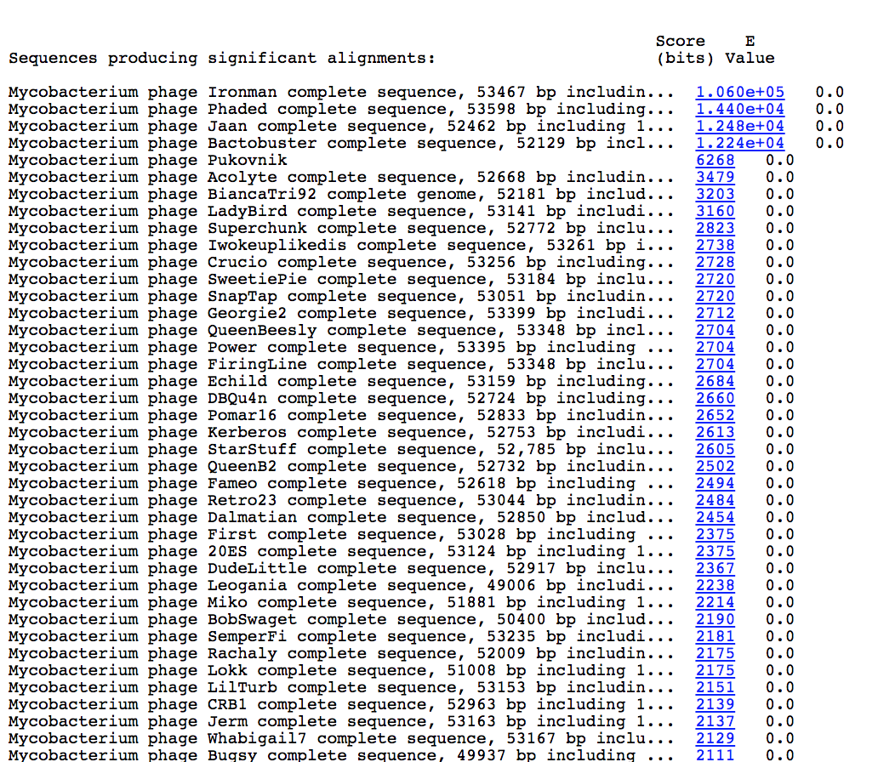

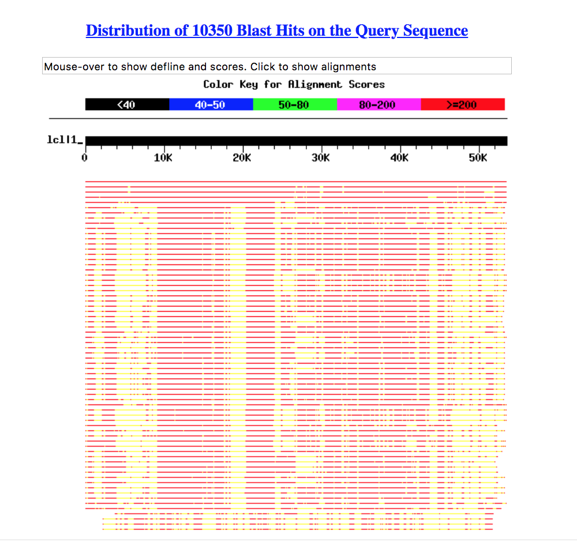

B.

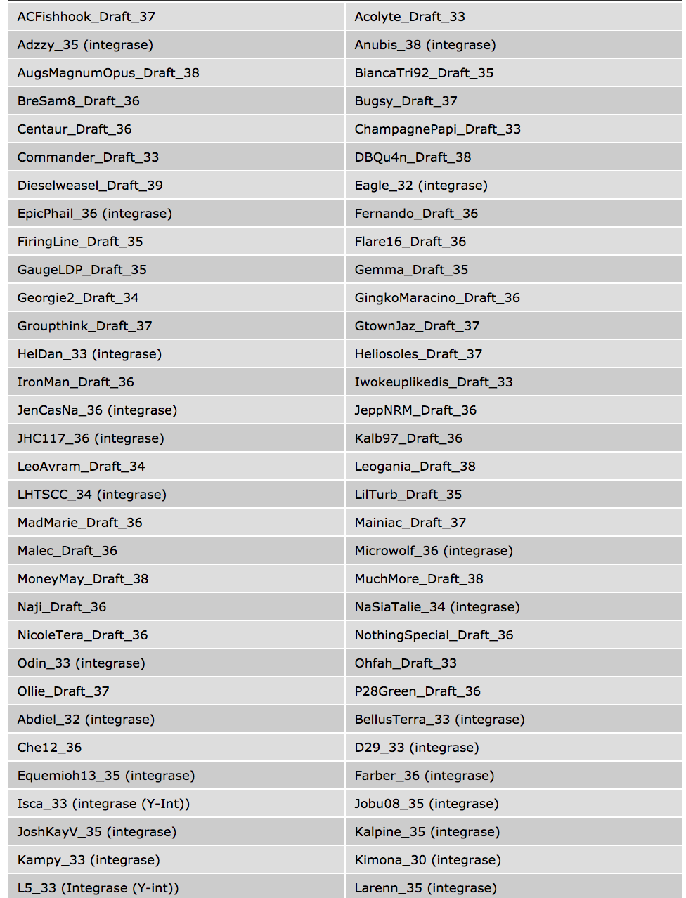
C.

﻿Original Glimmer call @bp 28052 has strength 10.22
D.
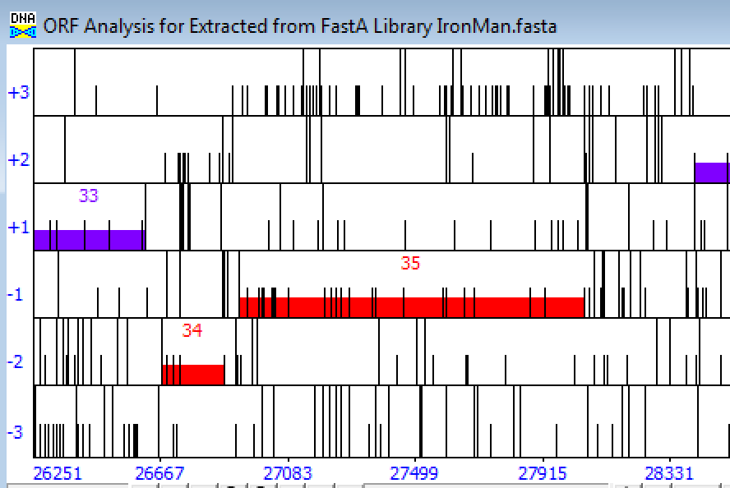

E.
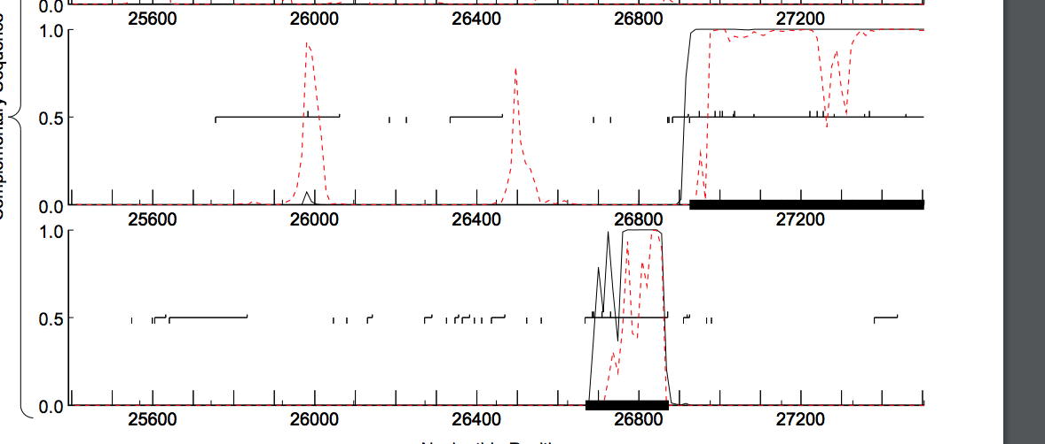
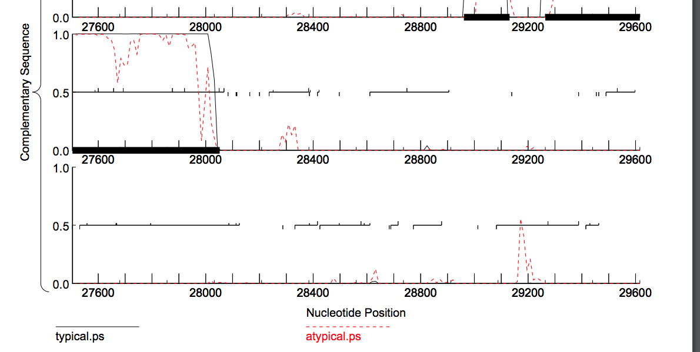
F:
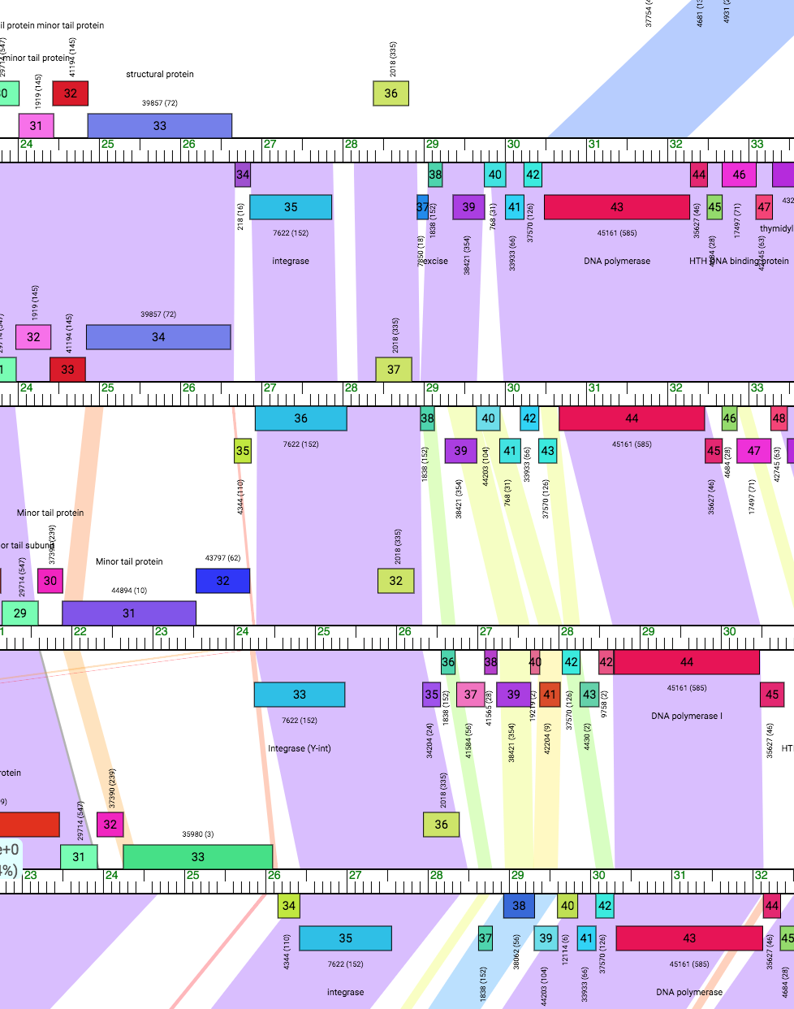

G:

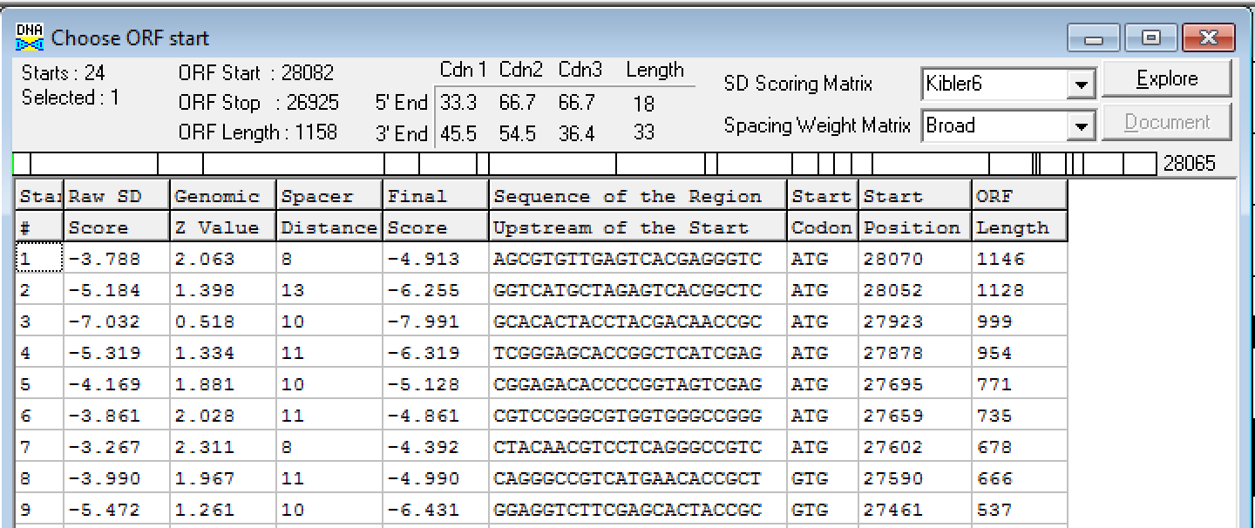

H.

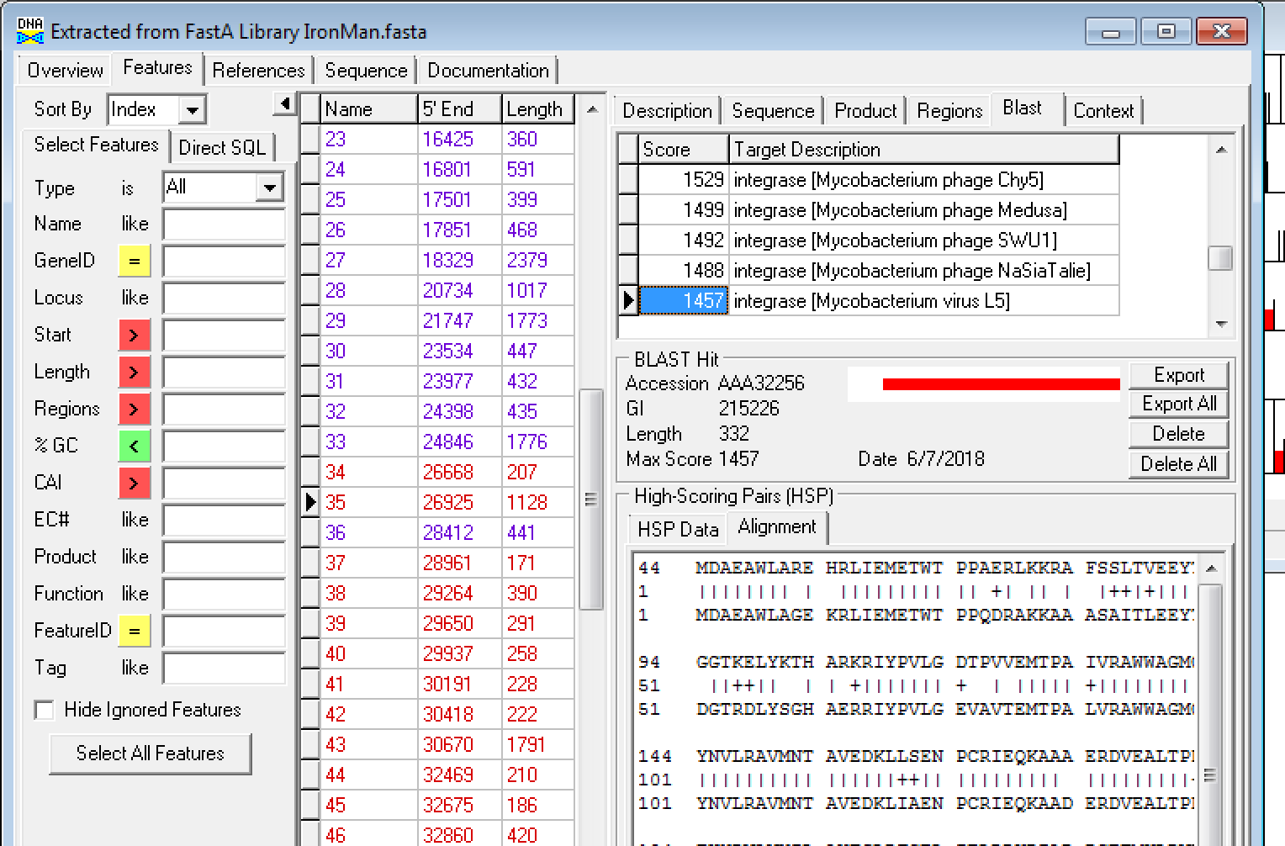

I.
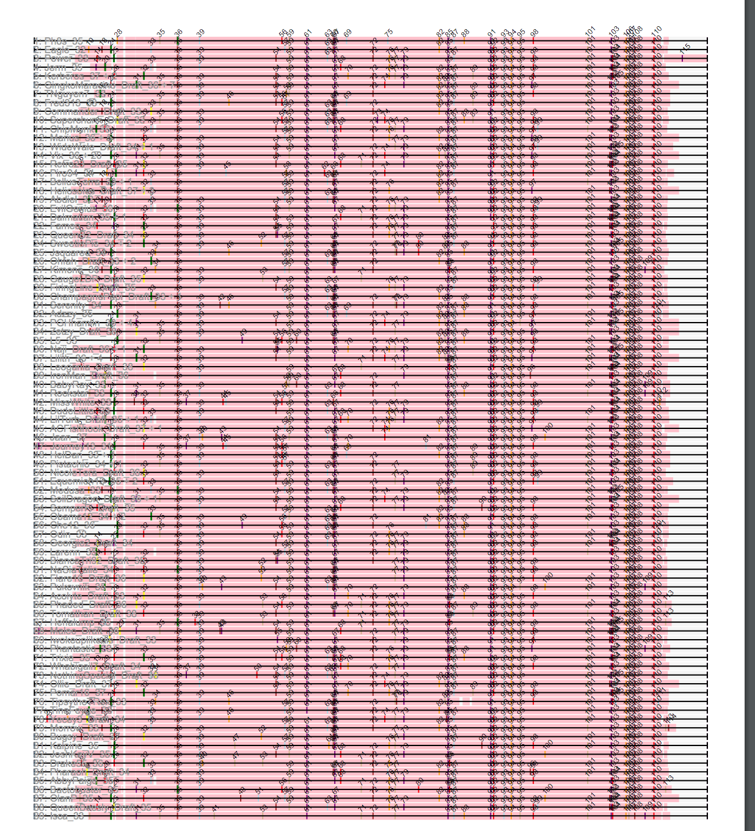

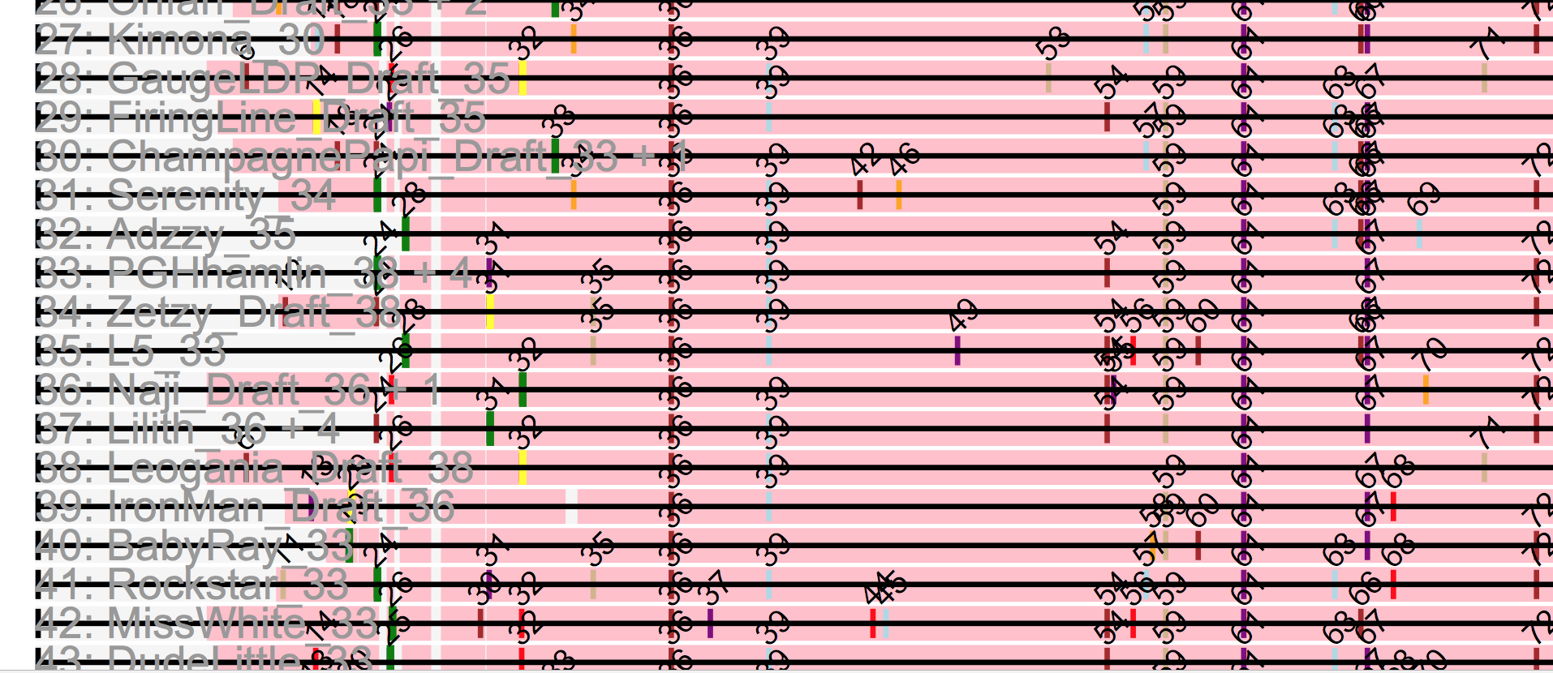
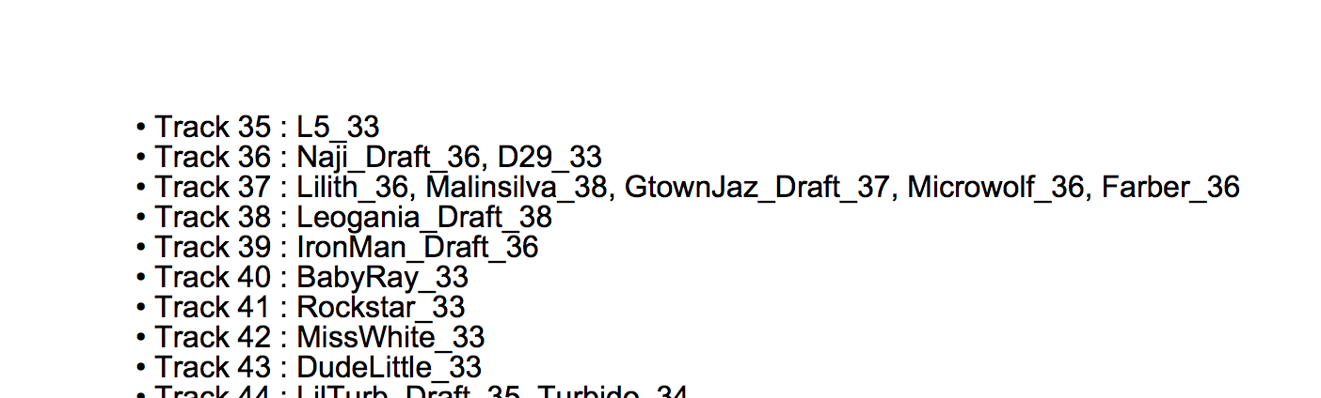
J.

