Case study: Calling tRNAs in Phage Genome CrystalP

Objectives:
Genome annotator will be able to:
- Evaluate predicted tRNAs using Aragorn 1.1, Aragorn 1.2.38 and tRNAscanSE v2.
- Determine the ends of each tRNA using Aragorn 1.2.38.
- Document the appropriate data for each tRNA in the DNA Master file.

Bioinformatics Guide Resources: All tRNA information is linked to https://seaphagesbioinformatics.helpdocsonline.com/article-40

- Collect Evidence

  - Auto-annotation (Aragorn 1.1). This program is out-of-date, but because it is the only program that we can integrate into DNA Master, it is valuable to use. It should NEVER be the only way you evaluate tRNAs.

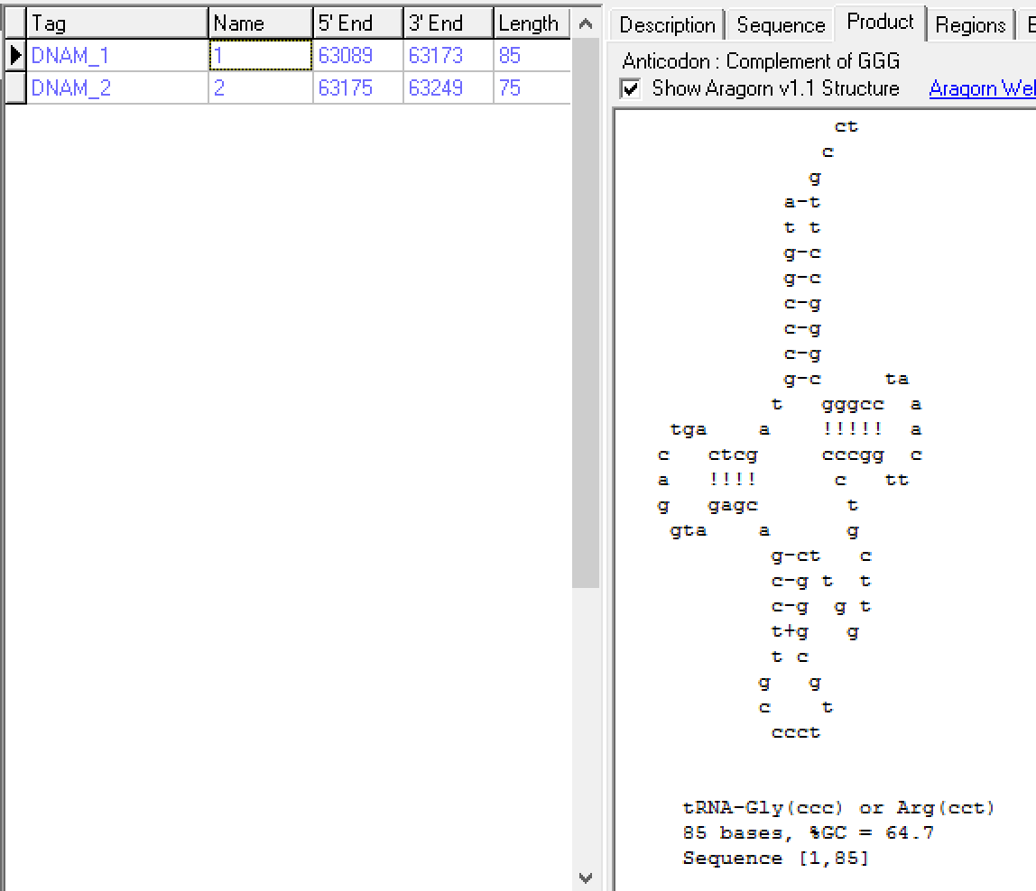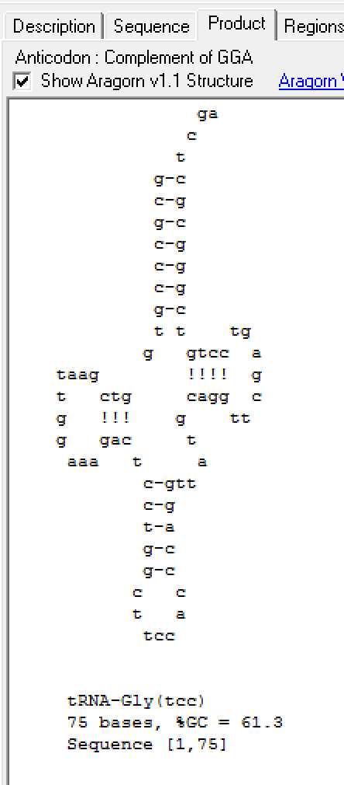

Note: The 3’ end is not cut correctly for either tRNA

  - Aragorn 1.2.38. This program is the current version of Aragorn. The program predicts the ends of the tRNAs to reflect our best understanding of tRNA annotation. The acceptor stem is typically 7 bases in length and the 3’ end can include a discriminator base, followed by the extension C C A. The 3’ end is trimmed to include only [discriminator base] C C A. This end is cut once the sequence deviates from that motif.

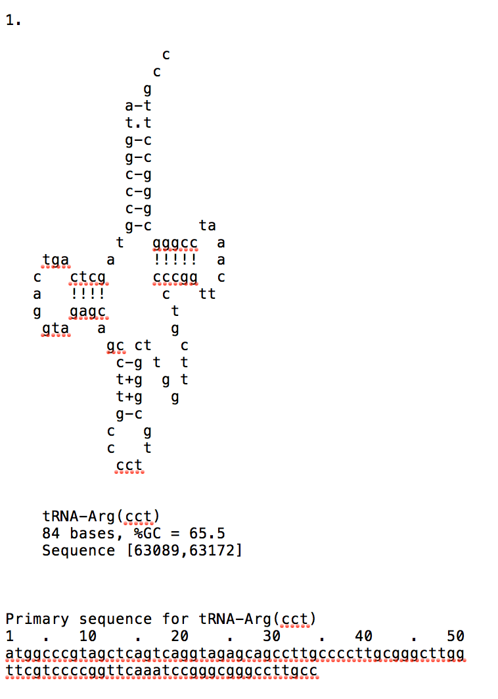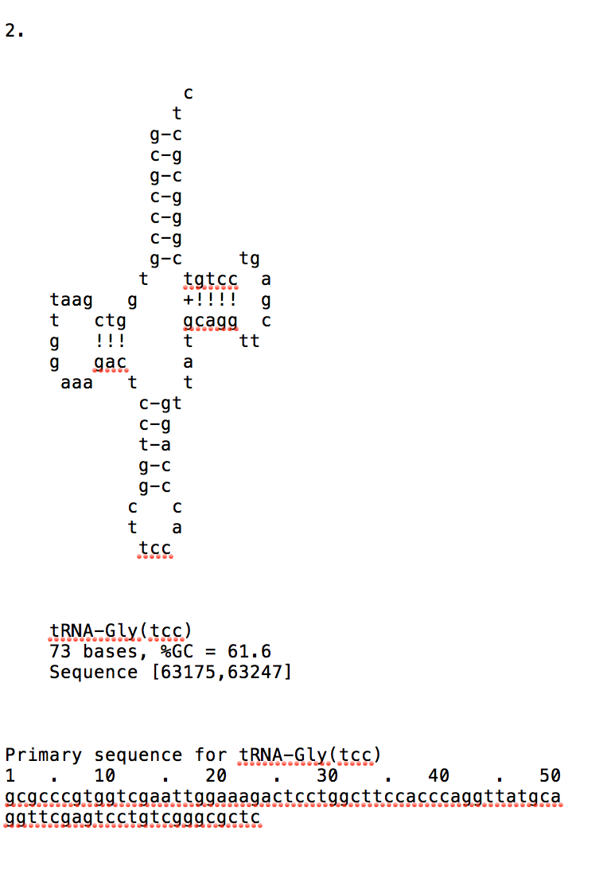
Note: Ends are trimmed correctly and should be recorded as shown from this output.

  - tRNAscanSE v2. This program allows you to relax the search parameters, so that less than ‘stellar’ tRNAs can be detected. It provides a numerical score to aid in the evaluation. Any score > 35 should be included.

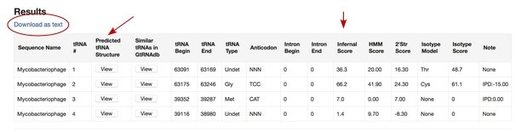

If you would like to save the tRNA scanSE data, you can download as text.
One of the arrows is pointing to the infernal scores: the first two have acceptable scores, the second two do not.

The other arrow is pointing to a predicted structure. Compare the structure of the first tRNA to the one predicted by Aragorn 1.2.38 and the canonical diagram found in “Predicting tRNA and tmRNA genes” in the Bioinformatics Guide.

Here is the visual representation of the predicted tRNA structure:
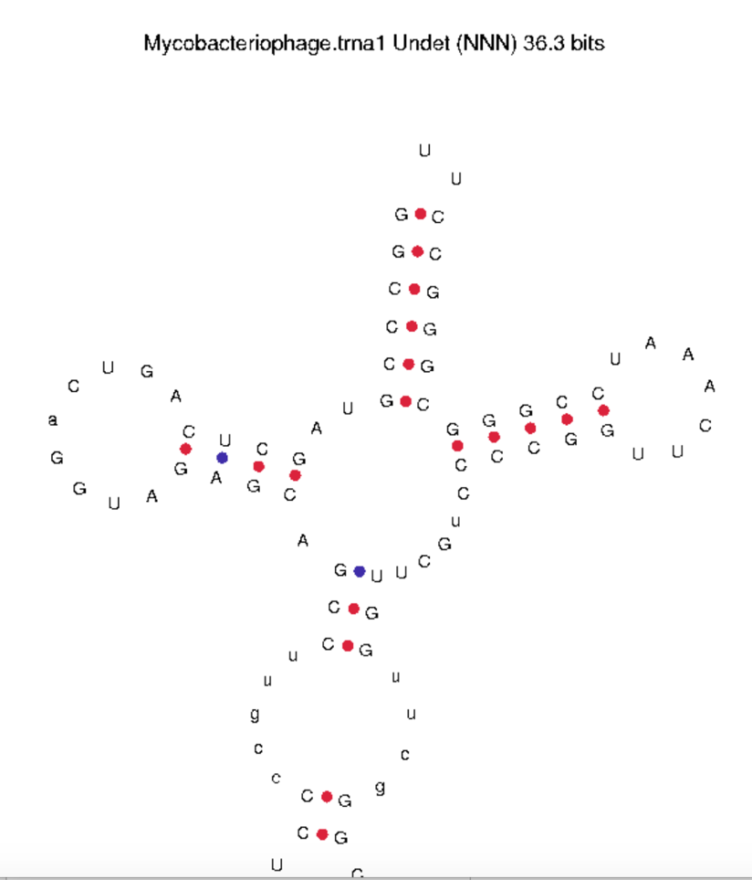

- Evaluate the Data

Are the common features identified in the canonical diagram present in each tRNA that you evaluate? When you compare the diagram of the tRNAscanSE for this tRNA to the Aragorn predicted structure, there are number of significant differences. What are they?
In this case, the Aragorn version of this tRNA is much more believable.

- Document tRNA(s) in your annotation

Refer to “Documenting tRNAs and tmRNAs in DNA Master” to enter the annotation for each tRNA.
- Be sure that the feature type is “tRNA” and not “CDS”.
- Modify the end coordinates as designated by Aragorn 1.2.38.
- In the function field, record the tRNA in the following format: tRNA-Arg (ccc)
- In the notes field: Record that your tRNA was found by (if applicable): Aragorn 1.2.38 and tRNAscanSE. Record the infernal score found at tRNAscanSE.

Example:

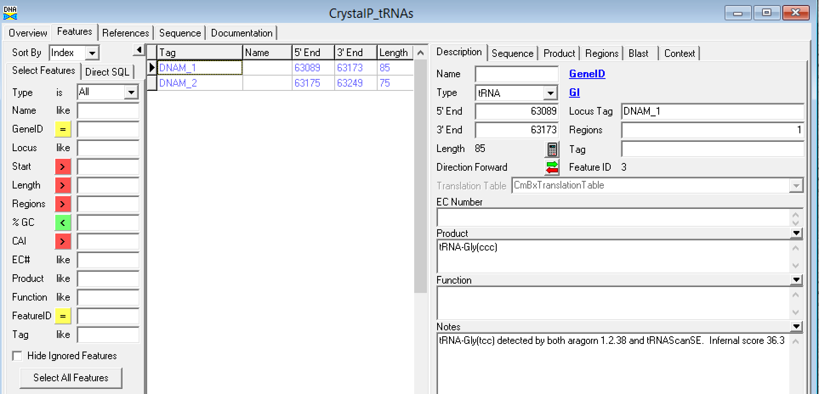

Evaluation of the tRNAs in CrystalP

First, look at the second tRNA of CrystalP.

Compare the tRNA schematic of Canonical tRNA to the Aragorn diagram of the second tRNA of CrystalP.
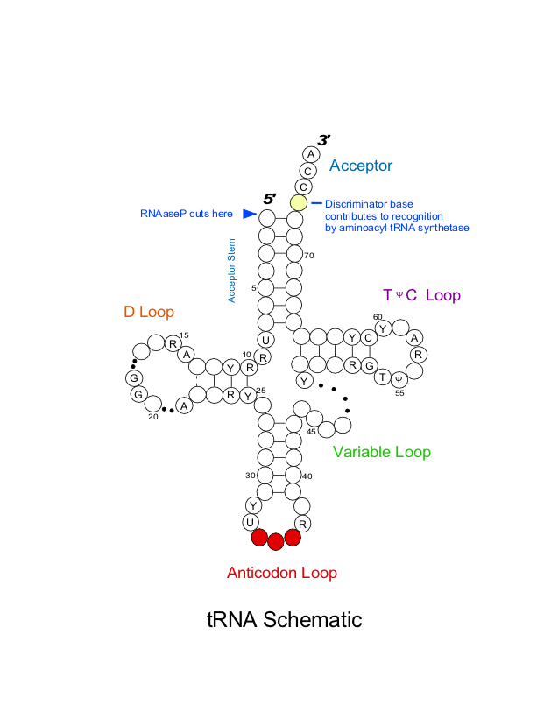

Aragorn 1.2.38 output of the second tRNA of Crystal P:
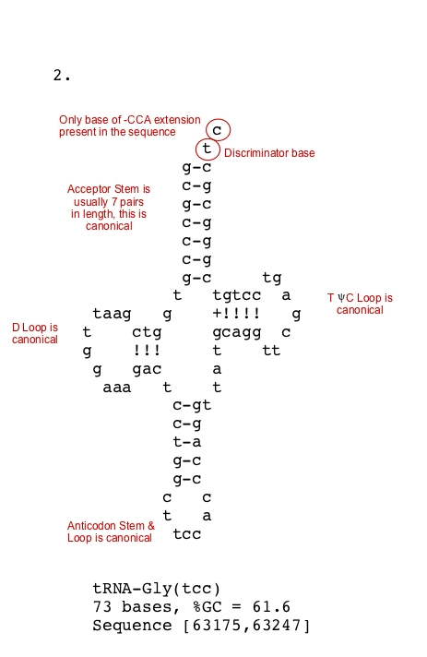

Each feature of the second tRNA in Crystal P appears to be canonical. With an infernal score of 66.2 from tRNAscanSE 1.2.38, it meets the criteria to include this annotation.

Aragorn 1.2.38 output of the first tRNA of Crystal P:

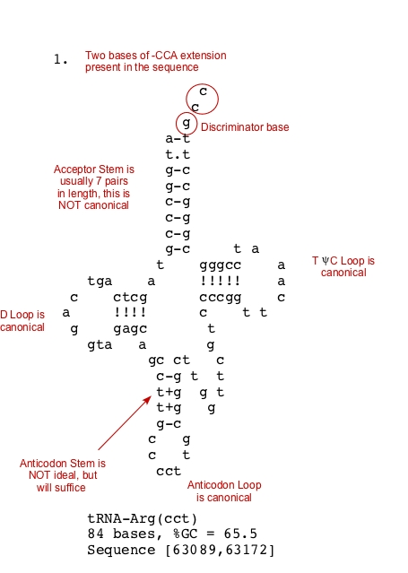

Each feature of the first tRNA in Crystal P appears to be canonical except for the acceptor stem. With an infernal score of 36.3 from tRNAscanSE 1.2.38, it meets the criteria to include this annotation.

