DO NOT CONSIDER FOR TALK
2023 SEA Symposium Abstract
Winthrop University
Rock Hill SC
Corresponding Faculty Member: Victoria Frost (frostv@winthrop.edu)
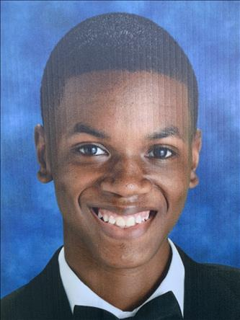
Ryan N Harris
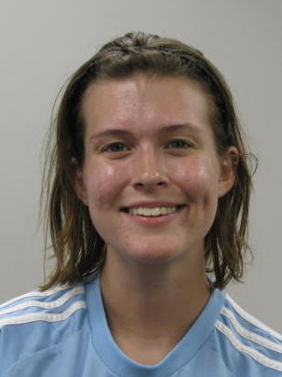
Brooke Jewell
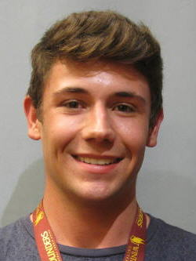
Alex B Lee
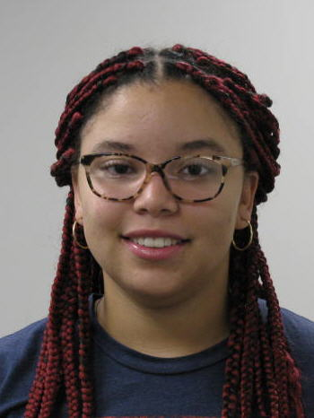
Kierra R McCall
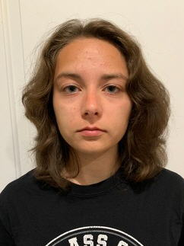
Kaylee E Mills
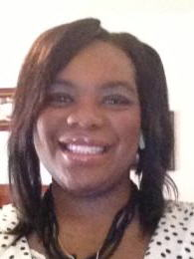
Jaquelle’ A Memminger
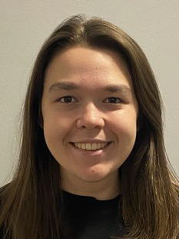
Jessica E Morgan
Valentine Savioz
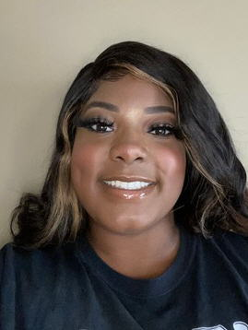
Taegan A Smith
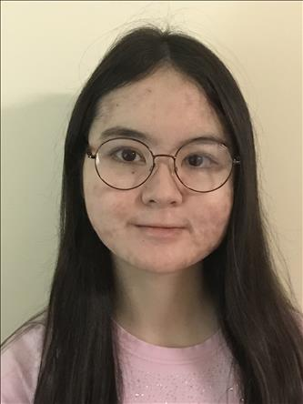
Emi Umemoto
Characterizing the Effect of Bacteriophage ExplosioNervosa Gene Expression on Mycobacterium smegmatis
Ryan N Harris, Brooke Jewell, Alex B Lee, Kierra R McCall, Kaylee E Mills, Jaquelle’ A Memminger, Jessica E Morgan, Valentine Savioz, Taegan A Smith, Emi Umemoto, Kathryn Kohl, Victoria Frost
The GENES portion of the SEA program extends our knowledge of phage biology by attempting to characterize the function of each annotated gene within phage genomes. SEA-GENES students at Winthrop University have been investigating mycobacteriophage ExplosioNervosa; an A9 subcluster bacteriophage discovered in Winthrop University’s campus soil. ExplosioNervosa has 96 putative genes of which only 36 are predicted to have a known function. Using molecular cloning protocols, students isolated and amplified each of ExplosioNervosa’s genes. Gel electrophoresis confirmed that the correct amplicon size was generated. The amplicons were then individually assembled into a pExTra plasmid in preparation for transformation into Escherichia coli. Resulting colonies were clone verified to ensure that the pExTra plasmids contained the gene insert of interest. Plasmid DNA was extracted, and an additional procedure in the workflow will sequence verify every cloned gene. The next step is to perform a cytotoxicity assay, the results of which will be presented here. The cytotoxicity assay is a technique that allows for the visualization of how the expression of each of ExplosioNervosa’s genes affects the growth of its host bacterial cell, Mycobacterium smegmatis. A phage gene product that causes a host phenotypic change warrants further investigation to help reveal its function in phage biology. These are initial steps towards increasing our knowledge of the dynamic, and ancient, relationship between bacteriophages and their bacterial hosts.

