DO NOT CONSIDER FOR TALK
2023 SEA Symposium Abstract
Winthrop University
Rock Hill SC
Corresponding Faculty Member: Kristi Westover (westoverk@winthrop.edu)
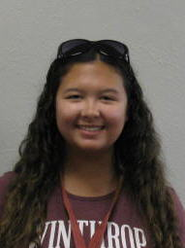
Alexis R Atkinson
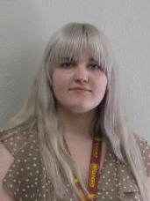
Abby Bowers
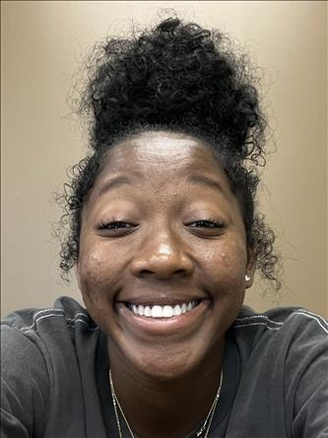
Amaya Brown
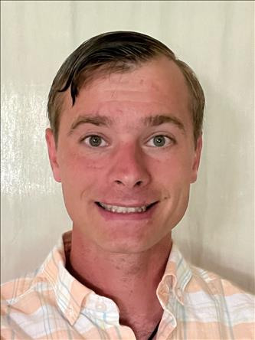
James C Ferebee IV
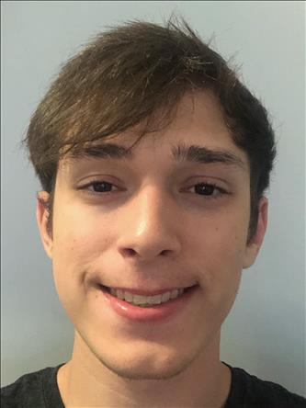
Chase A Keisler
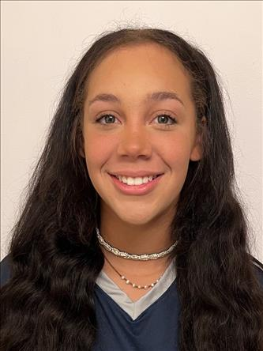
Kaylyn Little
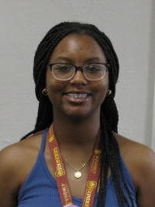
Amaya Payton
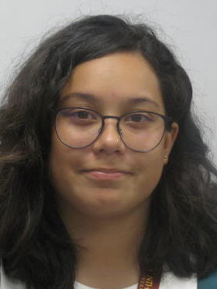
Lidia A Peralta
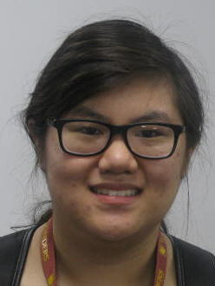
Julianne V Phu
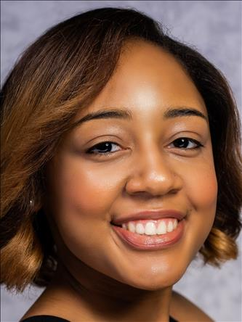
Khamryn Pollock
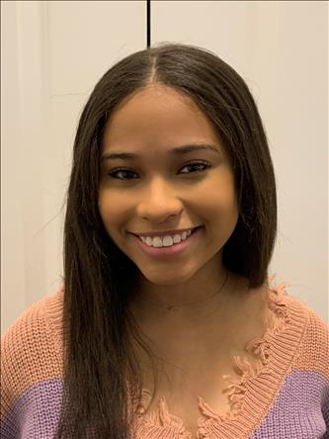
Maya G Scott
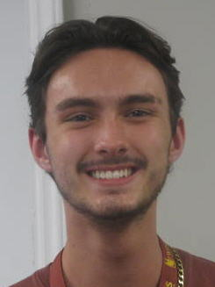
Bryson E Vaughan
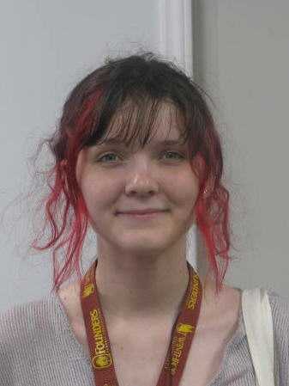
Karissa M Wilczak
From Soil to SEA - Discovery and Characterization of Novel Bacteriophages Ashballer and Bombitas
Alexis R Atkinson, Abby Bowers, Amaya Brown, James C Ferebee IV, Chase A Keisler, Kaylyn Little, Amaya Payton, Lidia A Peralta, Julianne V Phu, Khamryn Pollock, Maya G Scott, Bryson E Vaughan, Karissa M Wilczak, Kristi M Westover, Victoria J Frost
The SEA program at Winthrop University began last year with the discovery and initial characterization of bacteriophages found in our campus soil. Each freshman student isolated and characterized a soil-found bacteriophage using host bacteria Mycobacterium smegmatis mc2155. Bacteriophages were purified and amplified to provide high titer lysates for genomic DNA extraction. Purified phage DNA was then characterized using molecular and microscopic techniques. Transmission electron microscopy (TEM), revealed that 12 of the phages had a Siphoviridae morphology, while one displayed a Myoviridae morphology (Jinnie). Unique restriction fragment banding patterns were used to determine which phage DNA samples should be sequenced. Bacteriophages Ashballer (52,231 bp) and Bombitas (110,129 bp) were consequently determined to be in sub-clusters A1 and cluster J, respectively. DNA Master, used for initial manual annotation of Ashballer, provided putative start site locations of open reading frames as well as statistics associated with the ribosomal binding assessment for these starts. Evaluating whether the open reading frames have biological functions was based on homology comparisons at the protein level with HHPred, NCBI’s BLASTp, and Phamerator. Bombitas was annotated using PECAAN, a software program which auto-implements all of the above described evidence. Both phages showed synteny (shared genes in similar locations and relative position on their genomes) with other phages in their clusters. Mosaicism, due to recombination events, sequence loss and gain, was also evident. 61% of Ashballer’s rightward-transcribed genes have predicted functions, while only 17% of the leftwards-transcribed genes do. Annotation of Bombitas displayed a similar trend. It is noticeable that a higher percentage of rightward-transcribed genes often code for structural proteins in phages genomes. Determining the putative function of each phage gene can provide further insight into possible interactions with host bacteria. The third component of the SEA-program is SEA-GENES. This next step will help characterize those genes with putative functions as well as those where homology comparisons provided no evidence of function.

