CONSIDER FOR TALK
2022 SEA Symposium Abstract
George Mason University
Fairfax VA
Corresponding Faculty Member: Anne Scherer (aschere2@gmu.edu)
Parker Niccum
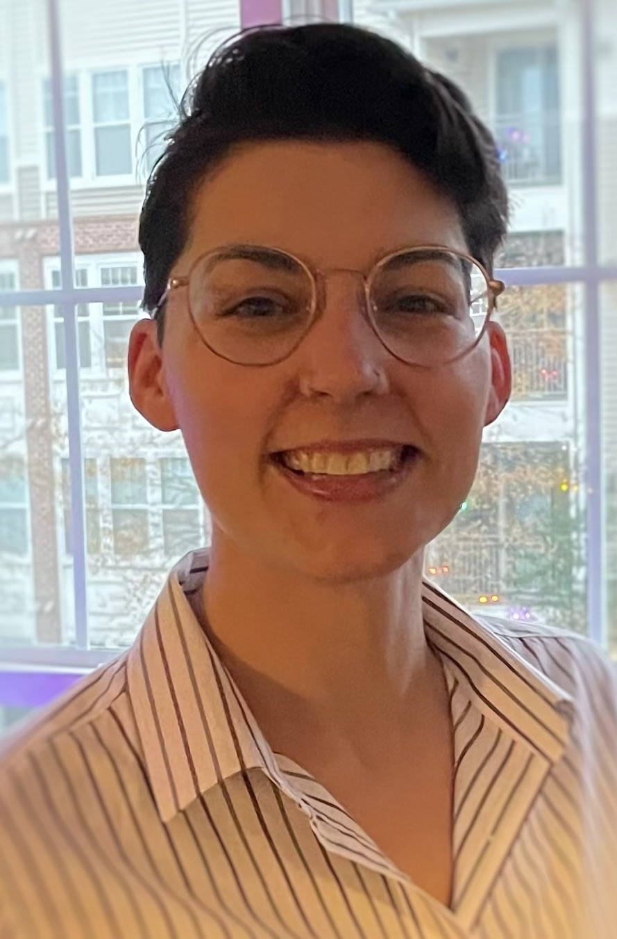
Sarah A Raburn
Exploration of subcluster A4 DNA Methylation
Parker Niccum, Sarah A Raburn, Anne E Scherer
The goal of this project is to determine the cause of certain methyltransferase genes in subcluster A4 phages behaving differently in other closely related phages. Specifically, some of the phages were protected by the restriction enzyme EcoRI, while other very similar phages were not. This was completed using BLAST tools to find similar phages, restriction gel images from phagesDB to determine enzyme susceptibility, and multiple sequence alignment to determine the difference in sequence. We discovered that the amino acid in the second position of the second methyltransferase genes of the A4 phages cut by EcoRI had switched from serine to threonine. This was caused by a transition from guanine to cytosine in the nucleotide sequences.
Restriction digest pictures of phages in other subclusters are cut with different restriction enzymes. Future research conducted would include more subclusters in order to compare their relatedness and determine possible causes for susceptibility to other restriction enzymes. We would also like to learn more about how different methylases protect against different enzymes. Regarding restriction gel reading, we’d also like to know if there is a reason that some of the phages have smears on HaeIII and some have bands.

