DO NOT CONSIDER FOR TALK
2022 SEA Symposium Abstract
University of Ottawa
Ottawa
Corresponding Faculty Member: Adam Rudner (arudner@uottawa.ca)
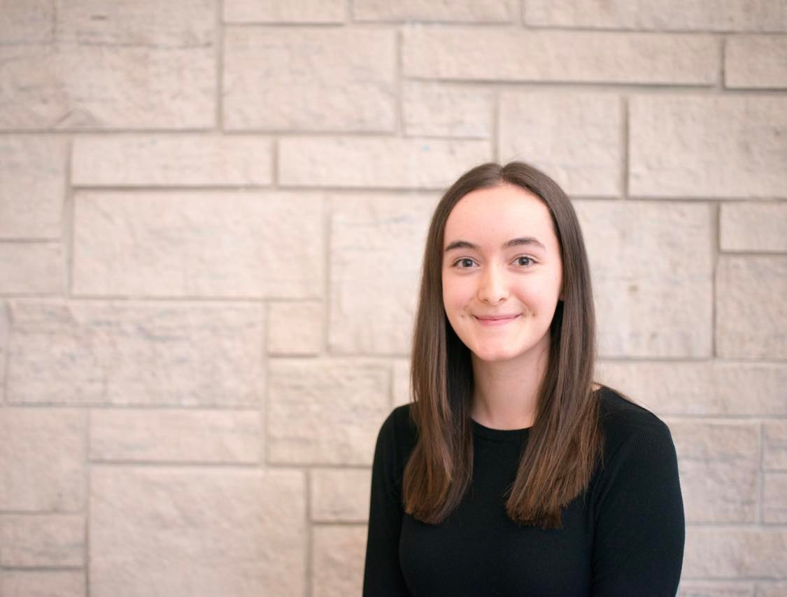
Amanda Featherstone
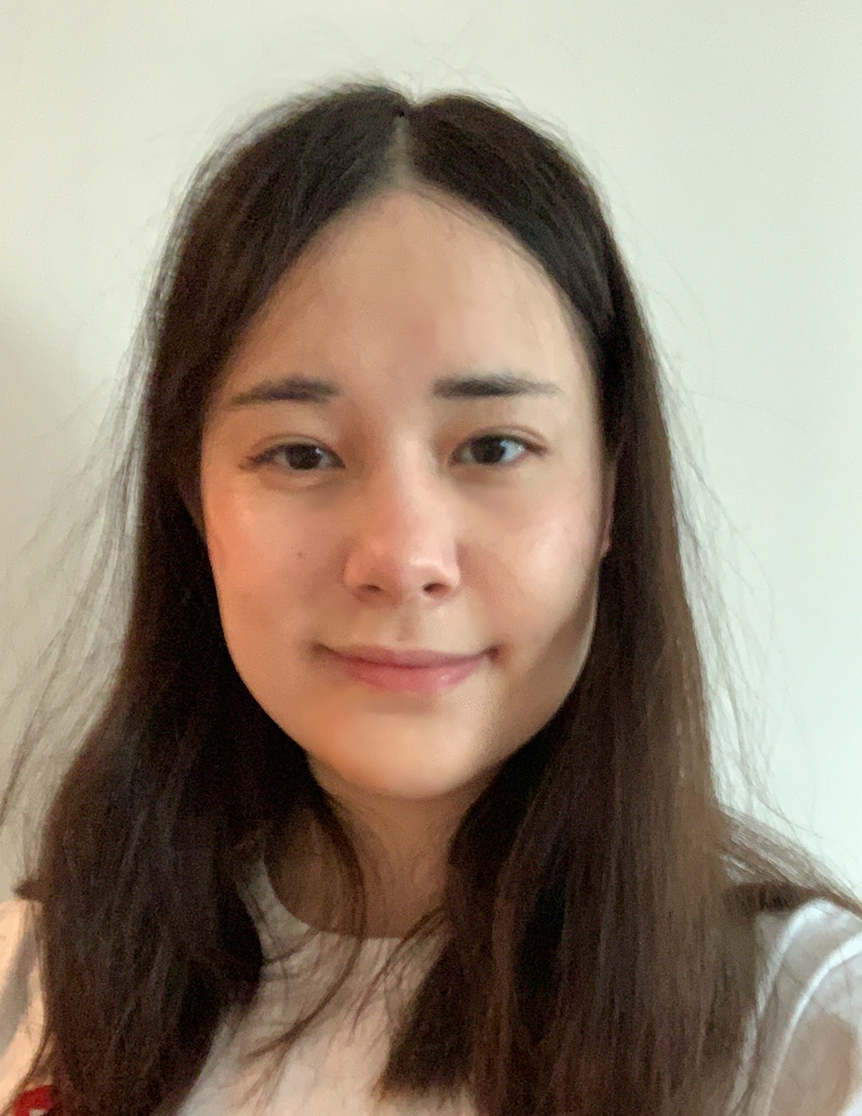
Ana Radar
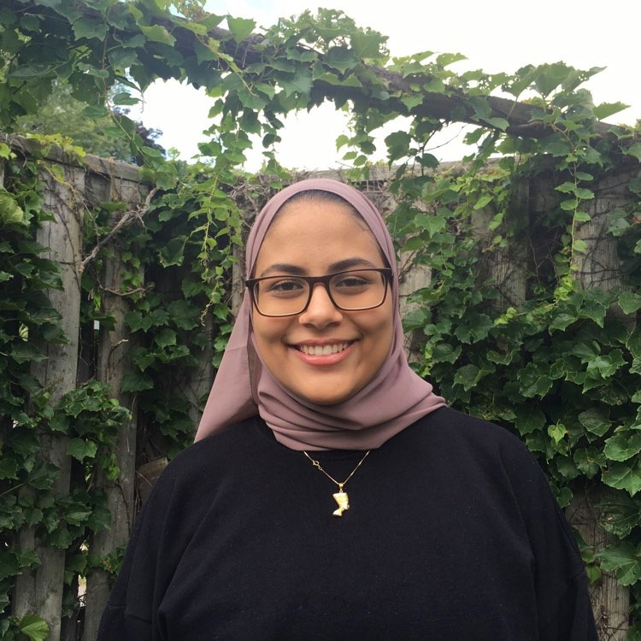
Amanie Salama
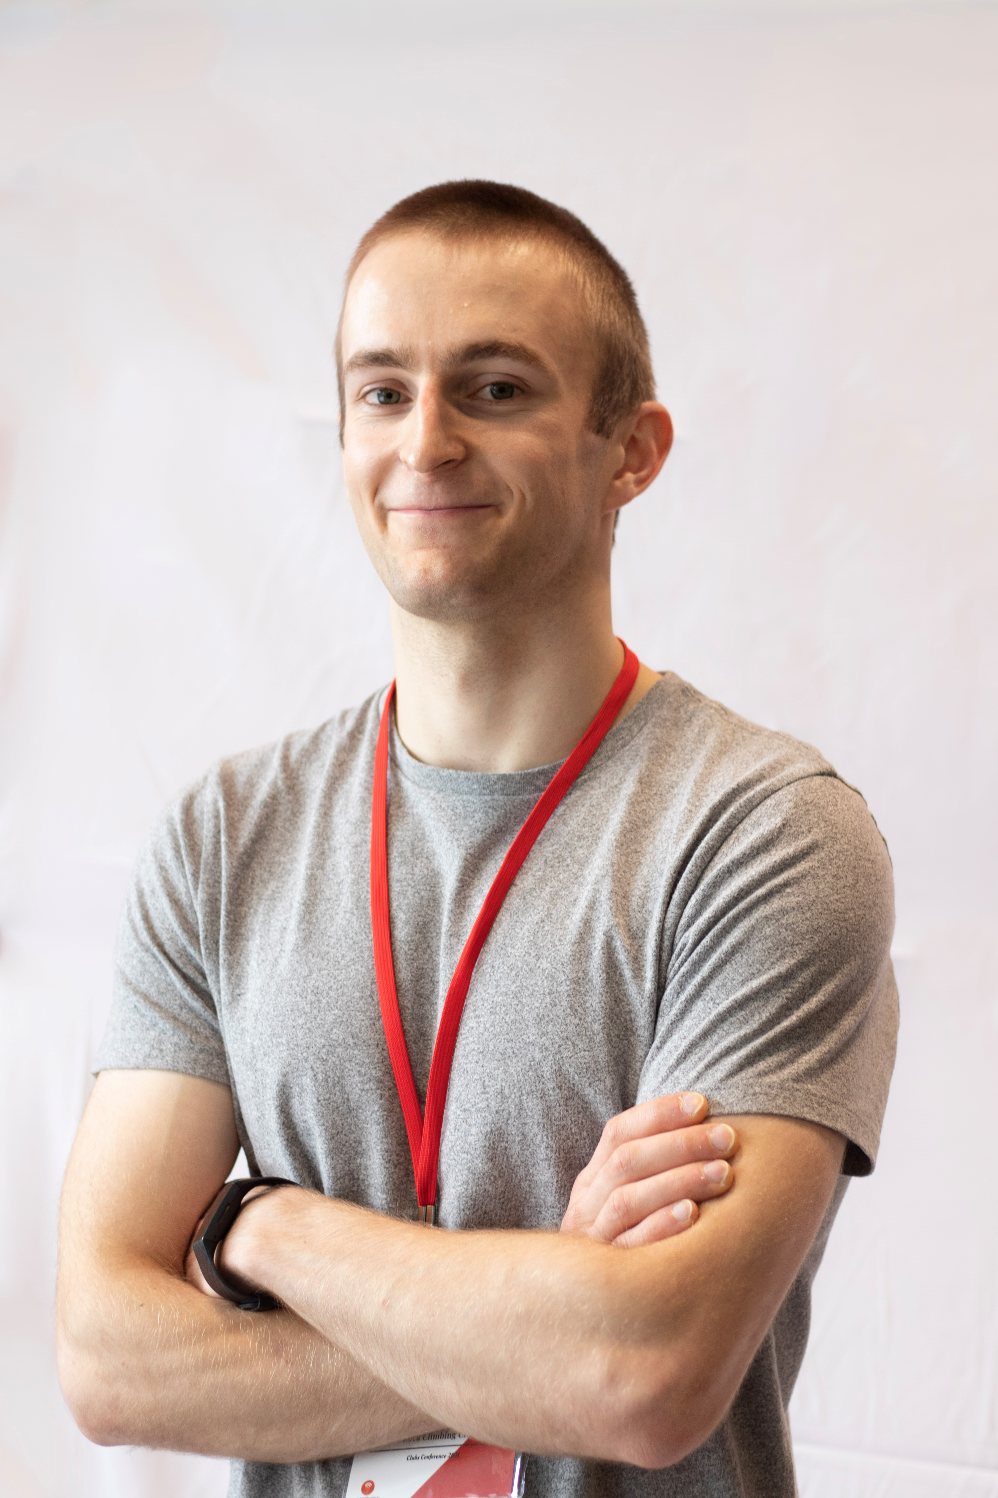
Samuel Tiukuvaara
Omar Ferri
Give Us a Millet of Your Time: Dehusking the Singleton Bacteriophage Arzan
Amanda Featherstone, Ana Radar, Amanie Salama, Samuel Tiukuvaara, Omar Ferri, Arvin Zaker, Shafik Algharbi, Osama Mahdi, Gayatri Setia, Rachel Friesen, Grace Shi Yuan Wang, Jingyuan Li, Ruiyan Gao, David Jung, Gapisha Karunakaran, Erika Znamenski, Milica Ristovski, Rama Sarakbi, Julia Douglas Freitas, Liam McCarthy, Elizabeth C Williams, Lisa D'Ambrosio, Keith Wheaton, Adam D Rudner
Bacteriophages (also known as phages) are viruses that infect and kill bacteria. During the Fall term of 2021, students enrolled in uOttawa phage hunters at the University of Ottawa isolated and characterized bacteriophages from the environment using Arthrobacter globiformis as a host bacterial species. Arzan was one of the identified phages – it is a singleton bacteriophage, meaning it lacks the nucleotide identity and/or shared gene content required for it to be clustered with sequenced genomes of known phages.
Arzan was collected from garden soil near the National Resources Canada building in Ottawa, Ontario. The phage produced small, circular, and clear plaques, and transmission electron microscopy revealed a long, non-contractile tail. These morphological details allowed us to classify Arzan as a siphoviridae. The phage was also characterized genomically through a restriction digest of its isolated genome: it consists of 58,710 base pairs, it has a 47.6% GC content, and at this stage of annotation it has 97 putative genes, 29 of which are orphams (founding members of a pham that share no similarity with known actinobacteriophage genes).
Based on initial annotations and blasting of the full Arzan genome, this phage appears to be most closely related to the FK-cluster phages Qui and Paella. Another phage that appears to be similar to Arzan is the novel AU6-cluster phage Zeina, which was isolated, characterized, and annotated by students at the University of Ottawa in 2020-21. Since we have this phage in our library, it will serve as an interesting comparator phage for our lysogeny studies.
Here, we report on our annotation progress for phage Arzan. We are using PECAAN, Phamerator, PhagesDB, NCBI BLAST, and HHPred to complete our annotation. We will use this information to further investigate aspects of Arzan’s biology including confirming the presence of essential phage genes in Arzan and investigating new gene functions that we identify during our annotation. We are also isolating a lysogen for Arzan. We will test if it has autoimmunity and look for superinfection immunity against other Arthrobacter bacteriophages discovered in our laboratory, including Zeina.

