DO NOT CONSIDER FOR TALK
2022 SEA Symposium Abstract
University of Wisconsin-River Falls
River Falls WI
Corresponding Faculty Member: Karen Klyczek (karen.k.klyczek@uwrf.edu)
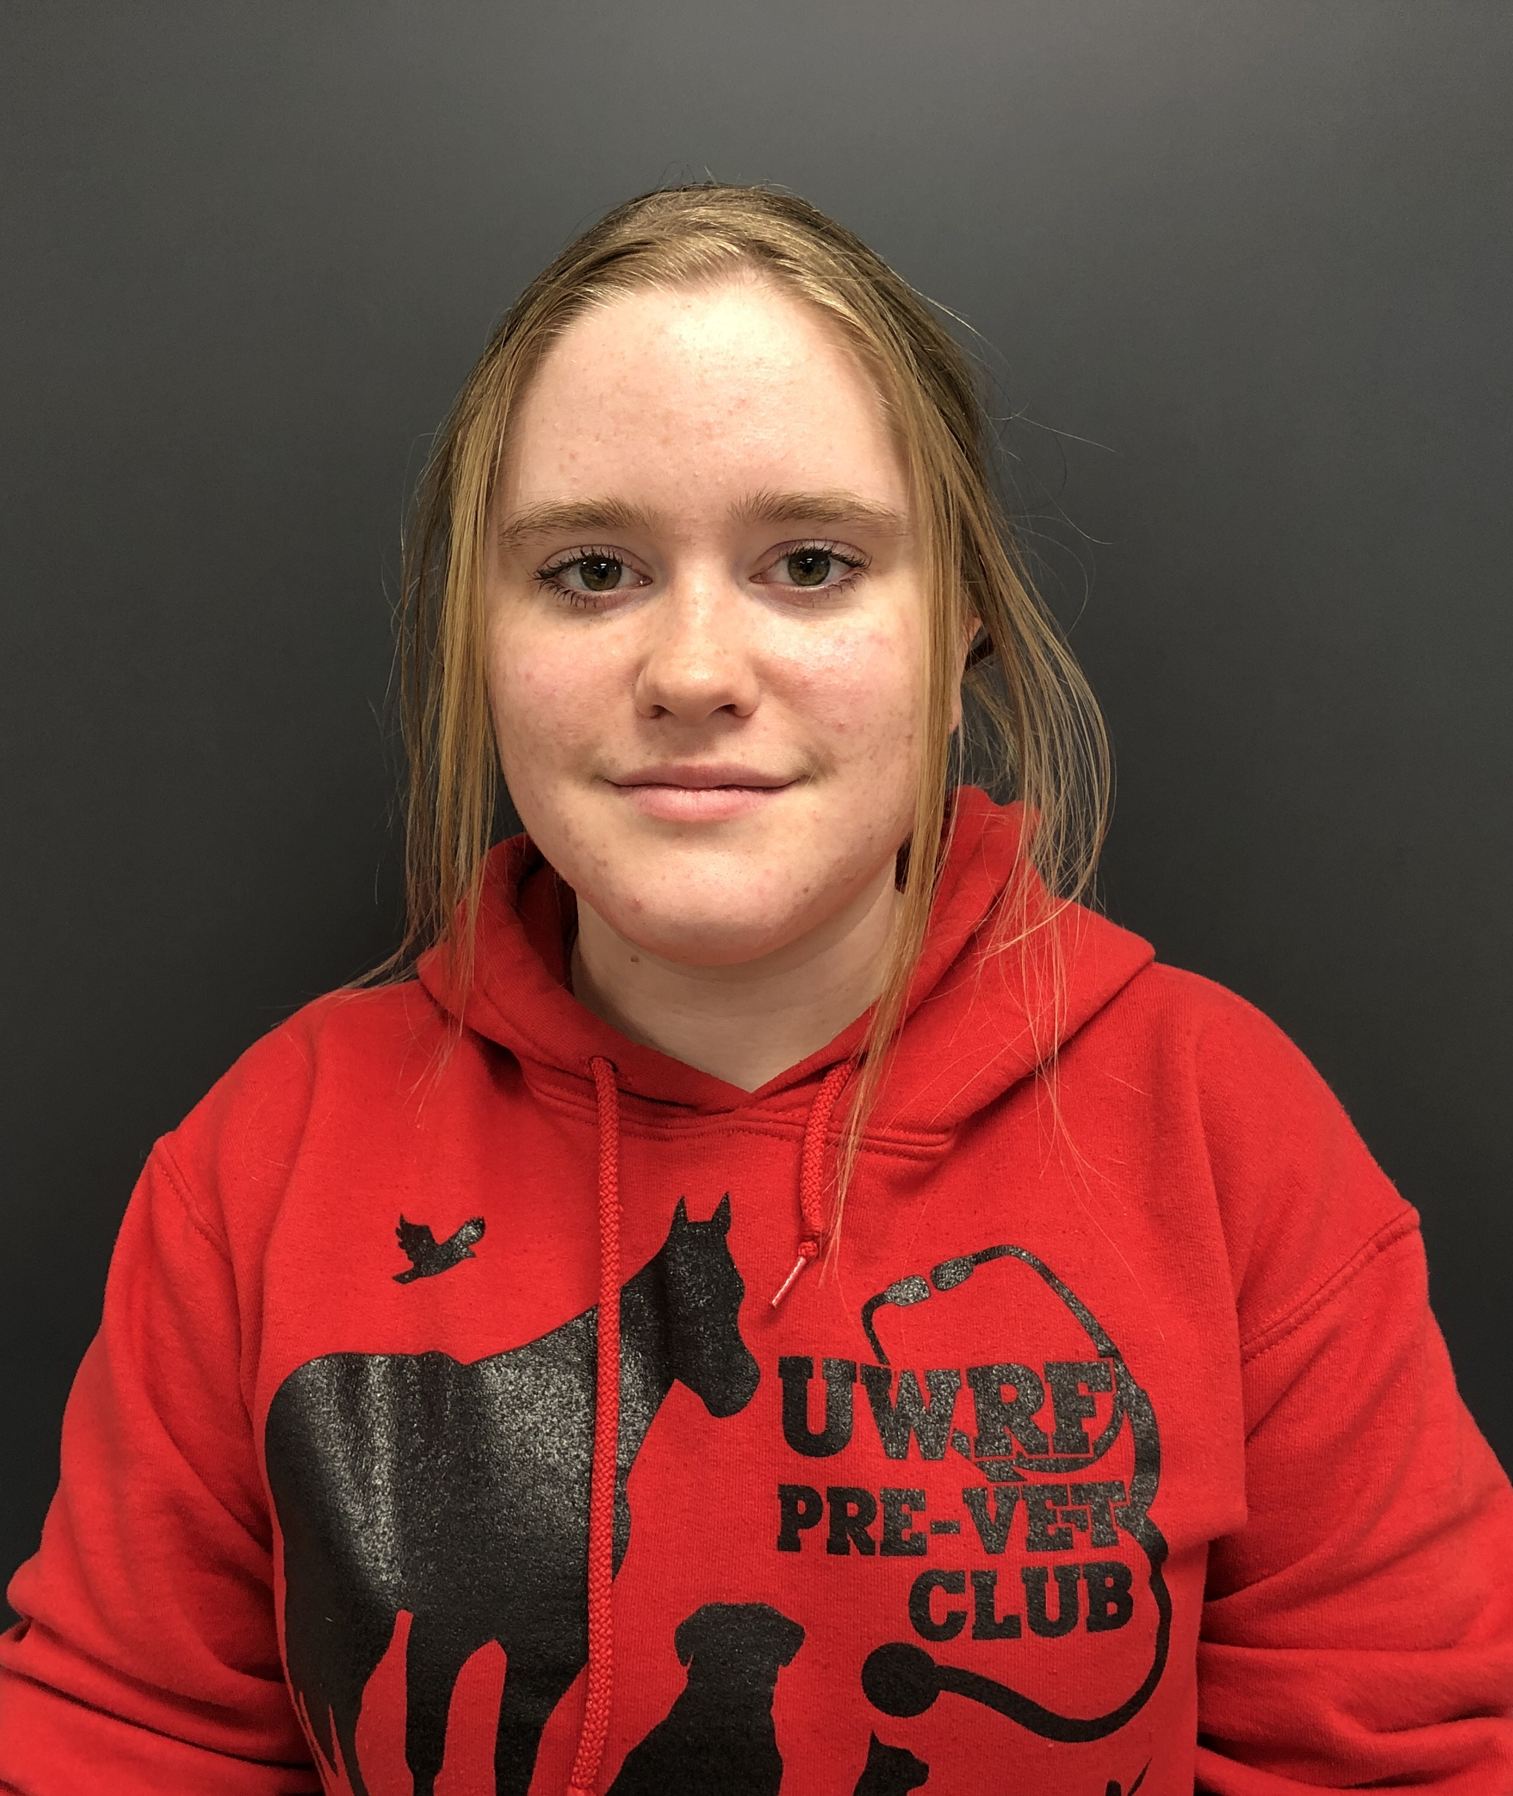
Elizabeth Zimmerman
Ger Moua
Genomic features of viruses isolated on an alternative host species
Elizabeth Zimmerman, Ger Moua, Karen Klyczek
We isolated phages on Microbacterium paraoxydans as well as the more commonly used host, Microbacterium foliorum. Two M. paraoxydans phage genomes were sequenced and analyzed. One of these phages, Cassita, is in cluster GB, which consists of four phages that were all isolated on M. paraoxydans. The cluster GB phages have Siphoviral morphology and genomes that are 59,253-62,439 kb with large direct terminal repeats (1350-1807 bp). These genomes have very little nucleotide similarity with other phages in the database. However, they share overall genome structure and several phams, including structural proteins and DNA modification enzymes, with cluster ED phages. The second phage sequenced, Fransoyer, is in cluster EG. There are two other M. paraoxydans phages in this cluster, SadLad and RubyRalph, and these three phages form a group that is more similar to each other (>85% gene content similarity) than to the other cluster EG phages isolated on M. foliorum (<60% gene content similarity). These phages have Siphoviral morphology and 61,880-62,801 bp genomes with 209-211 bp direct terminal repeats. We are conducting host range experiments to determine whether these M. paraoxydans phages can infect M. foliorum or other Microbacterium species.

