CONSIDER FOR TALK
2022 SEA Symposium Abstract
University of Ottawa
Ottawa
Corresponding Faculty Member: Adam Rudner (arudner@uottawa.ca)
Celine Fawagreh
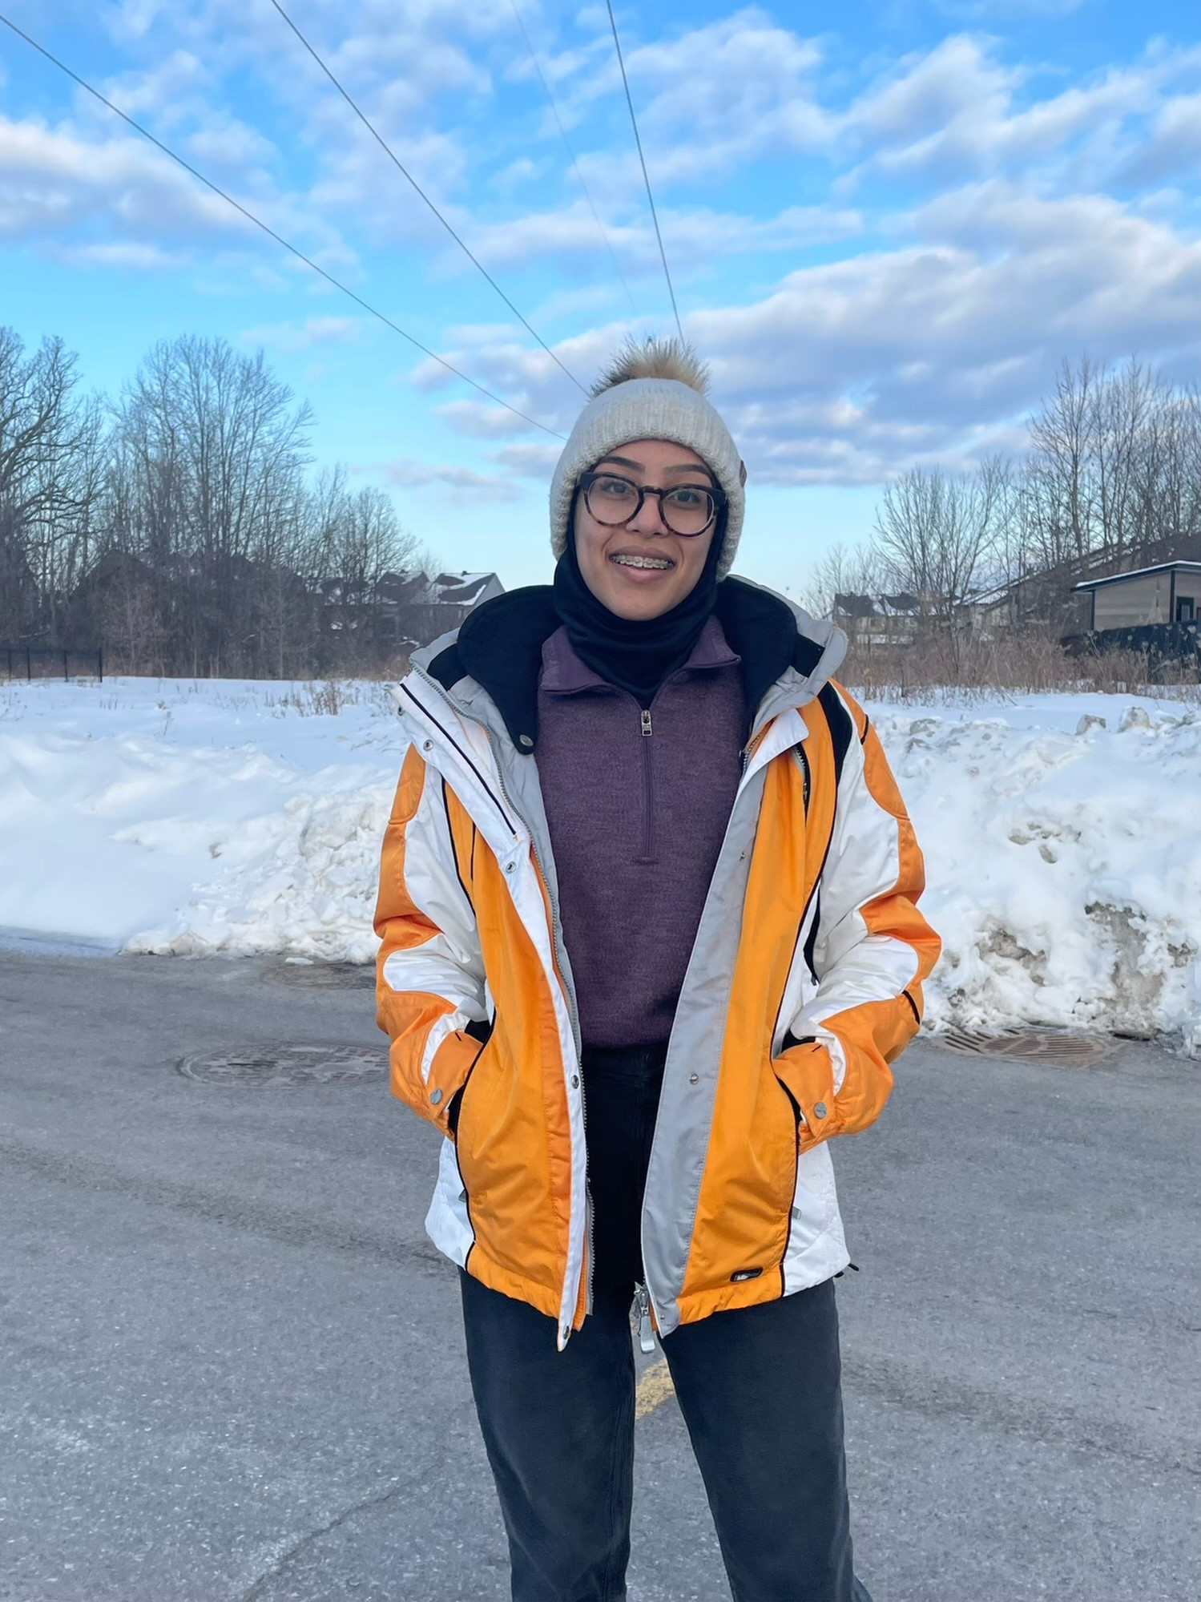
Laila Alfadhli
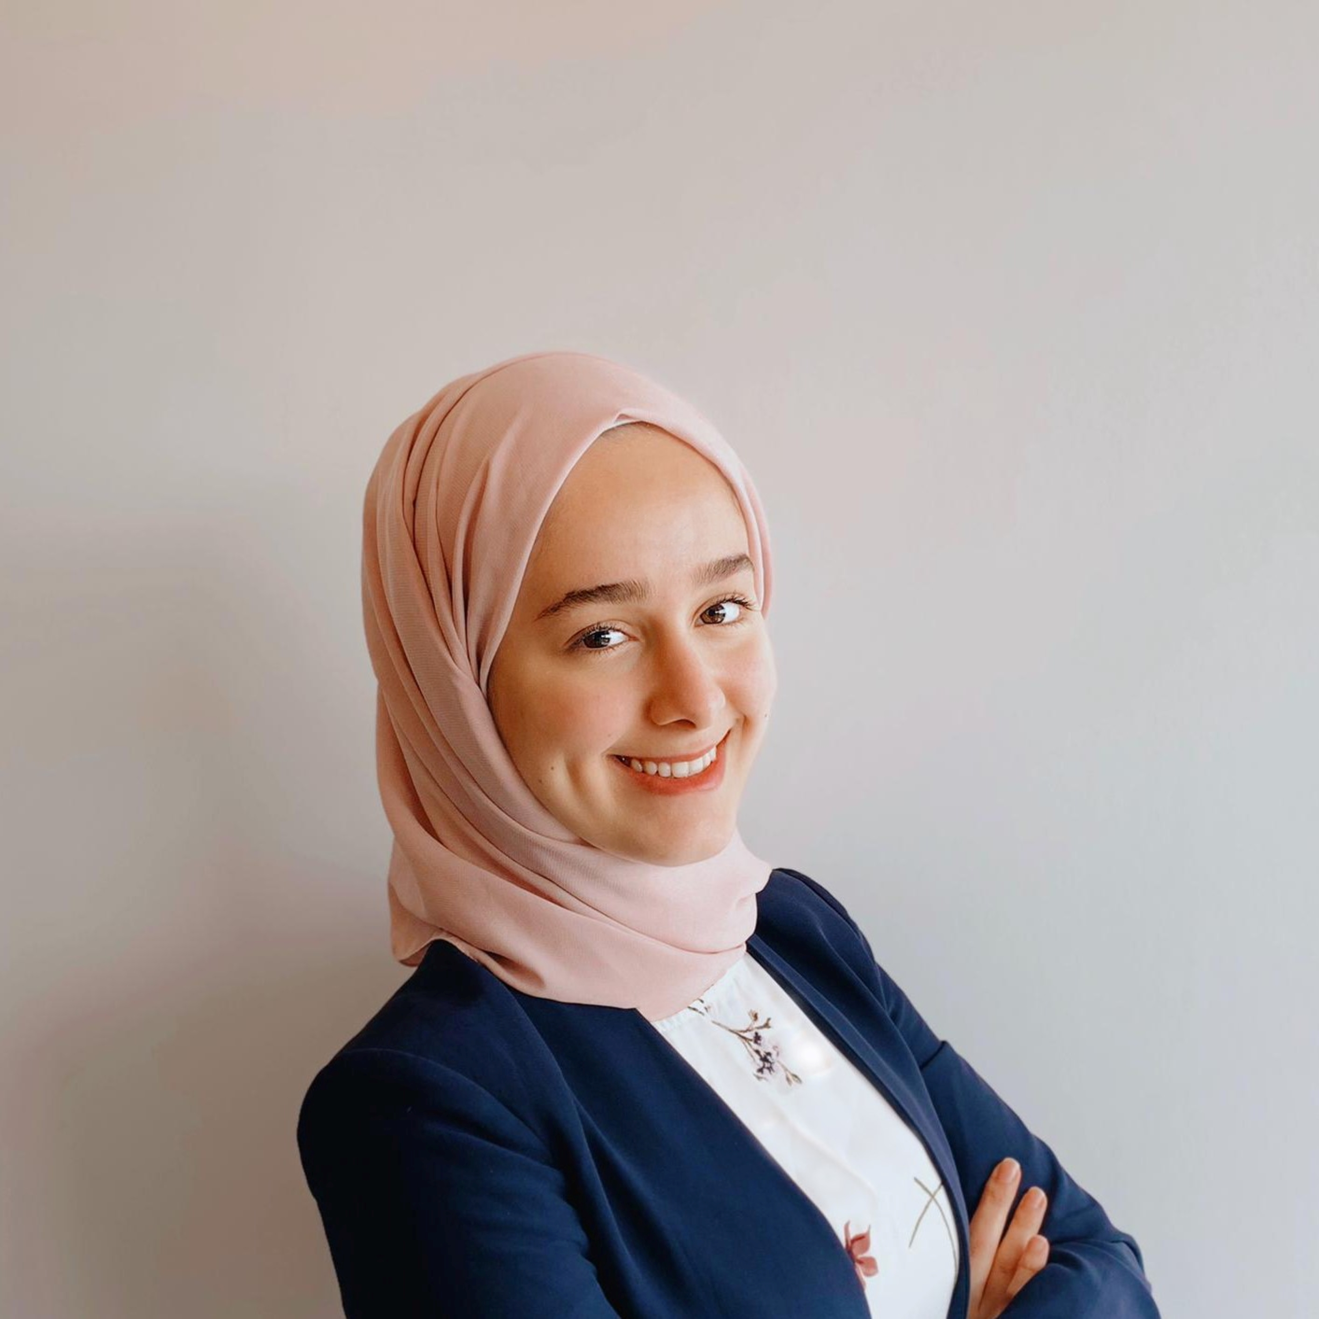
Leen Madani
Isolation and Characterization of Defense Escape Mutants (DEMs) in Crewmate and Warda Phages
Alicia Wu, Celine Fawagreh, Laila Alfadhli, Leen Madani, Naveed Shahzada, Rohan Ray, Salman Abdisalam, Ammar Alam, Zeynep Cildir, Katia Koziel Ly, Elizabeth C Williams, Adam D Rudner
Temperate bacteriophages, those that enter the lysogenic cycle, integrate their viral genome into the bacterial host chromosome to form a prophage. AZ cluster phages, which infect Arthrobacter hosts including Arthrobacter globiformis, are generally temperate and genetically diverse.
A prophage formed through lysogeny aids in the survival of the host bacteria through different mechanisms. One notable mechanism is the prophage-mediated defense system, which protects the bacterial host from secondary infection from other phages. Secondary phage infection can be closely related (homotypic defense) or distantly related (heterotypic defense). The homotypic defense system includes the use of repressor-mediated immunity, while the heterotypic defense involves an exclusion system that results in the synthesis of a protein that prevents injection of phage DNA upon infection.
The aim of this study is to isolate phage mutants able to escape the defense mechanism of the Amyev lysogen. We focused on isolating defense escape mutants of AZ cluster phages Crewmate and Warda which we have shown can partially infect the Amyev lysogen. The efficiency of plating (EOP) was calculated by comparing the infectivity of individually isolated putative Crewmate and Warda mutants against the Amyev lysogen and A. globiformis. The relative EOP of each mutant allows us to determine whether the phage’s ability to infect the Amyev lysogen is heritable and due to a genetic mutation, or is caused by other factors influencing defense escape, i.e., epigenetic changes.
We have isolated several mutant phages in both Crewmate and Warda which we believe contain genetic mutations that allow escape from the prophage-mediated defense system. We are currently amplifying the mutant phages, isolating genomic DNA and preparing sequencing libraries that will allow us to determine the precise genetic changes in the mutants. We anticipate that this study will reveal mechanistic details about the AZ cluster prophage-mediated defense system.

