DO NOT CONSIDER FOR TALK
2022 SEA Symposium Abstract
University of Lagos
Lagos
Corresponding Faculty Member: Imade Nsa (insa@unilag.edu.ng)
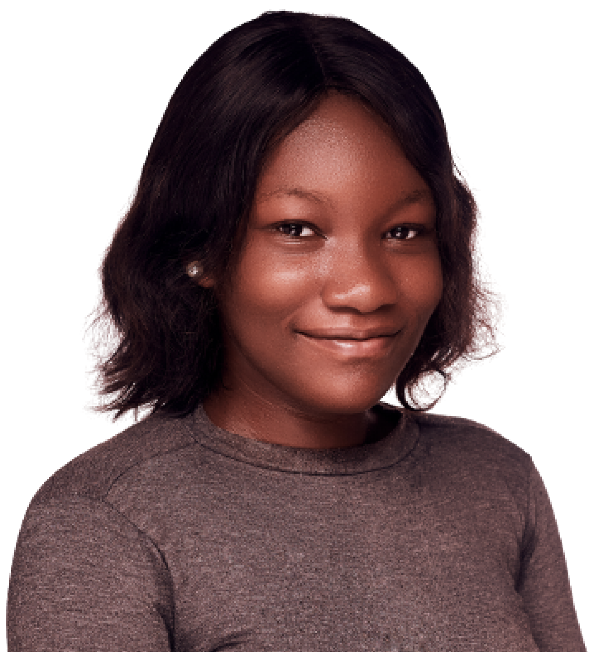
Abisola C Jegede
Genome Characterization of Phage Rockne
Abisola C Jegede, Ayodele J Oluwapelumi, Esther O Afuape, Amenze O Osadolor, Ameenat O Oloko, Olalekan A Mustapha, Eunice O Oluwalanke, Muhammed A Abubakar, Hakeemat M Quadri, Praise S Adeayo, Seun D Bamisaye, Ayodeji A Odunsi, Imade Y Nsa, Tenny O G Egwuatu, Ganiyo O Oyetibo, Matthew O Ilori
Rockne, a Subcluster F1 temperate phage was discovered by St. Ignatius High School, South Euclid, Ohio in 2012 from a soil sample by the enrichment method. Phage Rockne was sequenced at the Pittsburgh Bacteriophage Institute. It is a Siphoviridae with a genome length of 56704 bp and a GC content of 61.4%. Rockne is a temperate phage that forms lysogens. Following infection by a temperate phage, there are two possible outcomes, lytic growth or lysogeny. Rockne forms plaques that are averagely small in size and have turbid centers, due to the growth of lysogens. Its isolation host is Mycobaterium smegmatis mc2155. The programs used for annotation include DNA Master, phagesdb, NCBI BLAST, Phamerator, Starterator, GeneMark, GLIMMER and HHPred. DNA Master was remarkable in calling 104 genes using its auto-annotation feature whereas phagesdb and Phamerator called 107 genes. Comparison between DNA Master and phagesdb gene calls led to the addition of three (3) genes. The concluded annotation of Rockne unfolded 108 ORFs with 40 genes having known functions and 68 hypothetical proteins. Less than 5% were reverse genes and no tRNA was found. Rockne’s annotation showed a very strong resemblance to other temperate phages found in subcluster F1 such as Phage Drago and Phatniss. Several copies of minor tail proteins were found and the two copies of tail assembly chaperone caused by the frame shift mutation were merged as one. Rockne has several mosaic commonalities with other F1 phages which include: terminase small and large subunit, portal protein, capsid maturation protease, scaffolding protein, major capsid protein, head-to-tail adaptor, head-to-tail stopper, tail terminator, major tail subunit, tail assembly chaperone, tape measure protein, minor tail protein, helix-turn-helix DNA binding domain protein, lysin A, lysin B, DnaQ-like (DNA polymerase III subunit), tyrosine integrase, immunity repressor, CRO protein, anti-repressor. Start codons for phage genes encountered in Rockne were ATG (70.4), GTG (24.1) and TTG (5.5%). Tape measure protein is the longest gene with 3492 bp while genes 37 and 48 are the shortest, having 93 base pairs each. Gene 42 has the largest gap with 1461 base pairs. There were 40 overlapping genes, all in the forward direction. It has 99 forward genes and 5 reverse genes. Rockne’s annotation revealed a strong resemblance to phage PMC with a 94.81% similarity. They shared 100 phams including terminase subunit protein, portal protein, terminase large subunit. Scaffolding protein, major capsid protein, among others.

