CONSIDER FOR TALK

2022 SEA Symposium Abstract

University of Ottawa

Ottawa

Corresponding Faculty Member: Adam Rudner (arudner@uottawa.ca)

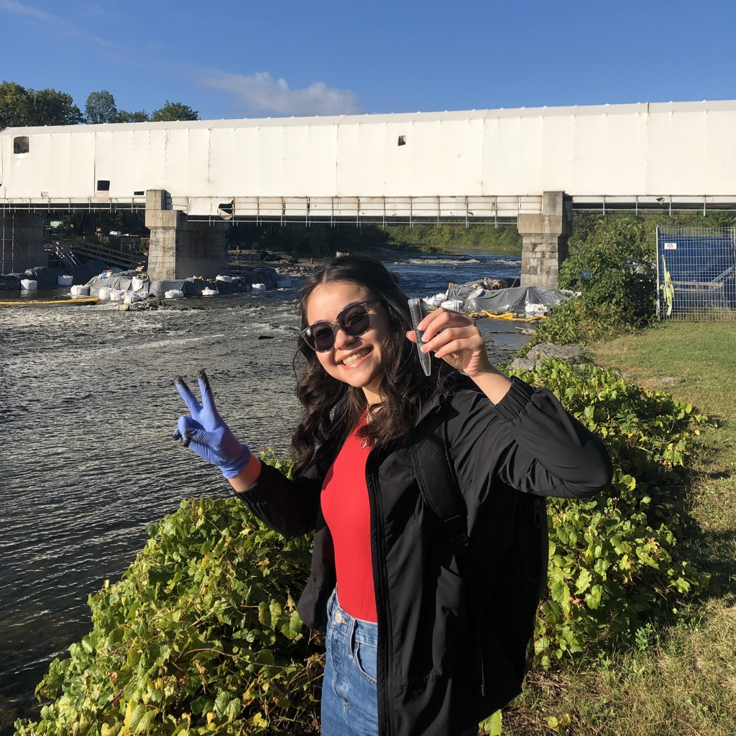

Katia Koziel Ly

Superinfection immunity of AZ cluster phages: Not so immune?

Katia Koziel Ly, Christelle Kwakedi, Sarah Lapolice, Ciara Heffernan, Kieran Furlong, Sabrina Grégoire, Rohan Ray, Maryam Abdelaal, Mawaia Elkbouli, Elizabeth C Williams, Adam D Rudner

When entering the lysogenic cycle, a bacteriophage injects its DNA into the bacterial genome and forms a prophage. Phages belonging to the same cluster are thought to have superinfection immunity, where a related phage is unable to infect the lysogen because of prophage-mediated defense. One known mechanism of superinfection immunity is the use of a repressor protein synthesized by the prophage that binds to and silences lytic genes to maintain the lysogen. If the injected DNA of another phage is similar enough to the initial phage, the repressor protein can bind this DNA and prevent superinfection. The aim of the present study is to create lysogens from AZ cluster phages as a first step in elucidating the mechanism underlying superinfection immunity in the AZ cluster.   
  
AZ cluster bacteriophages Amyev, Cassia, JohnDoe, Lizalica, ObiToo, Pixelle, Phrustrated, and Warda were isolated from soil in the Ottawa area between 2019-2021 by students in the SEA-PHAGES discovery lab. All phages infect *Arthrobacter globiformis* and belong to the siphoviridae family characterized by a long, noncontractile flexible tail and icosahedral head. We have successfully created lysogens of the phages Amyev, Cassia, JohnDoe, Lizalica, ObiToo, Phrustrated, Pixelle, and Warda. We are currently conducting infectivity assays within the AZ cluster to resolve the relationships between AZ cluster phages and lysogens. Our preliminary data suggests that Lizalica lysogens display strong superinfection immunity to other AZ cluster phages, while Amyev lysogens are partially infected by several AZ cluster phages. Since phages may develop mutations that allow them to escape immunity, these assays are revealing candidates for the study of defense escape mutants.