DO NOT CONSIDER FOR TALK

2022 SEA Symposium Abstract

University of Lagos

Lagos

Corresponding Faculty Member: Imade Nsa (insa@unilag.edu.ng)

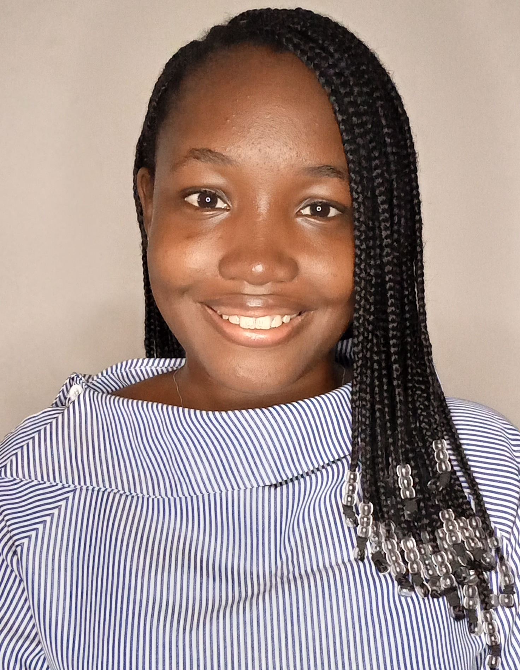

Victory C Okorie

Genome Annotation of Mycobacterium Phage McGee

Victory C Okorie, Rashidat O Abass, Dennis O Amadi, Oluwafemi A Kadiri, Zainab A Sekoni, Josephine O Oluwafemi, Abisoye F Olubajo, Temidayo M Makinwa, Solape O Olaiya, Tomilayo L Owoeye, Joshua E Ebitigha, Olasunkanmi Olaore, Ayodeji A Odunsi, Seun D Bamisaye, Ayomikun E Kade, Nwanneka M Akinyemi, Imade Y Nsa, Tenny O G . Egwuatu, Ganiyu O Oyetibo, Matthew O Ilori

McGee, a Myoviridae phage in the order Caudovirales, has a double-stranded DNA genome, contractile tail and is non-enveloped. It was isolated from an organic soil sample obtained from Manassas, VA about 3 inches deep using the direct isolation method at George Mason University. Phage McGee was sequenced at the Pittsburgh Bacteriophage Institute using the Illumina MiSeq platform. After genome assembly, McGee had a large genome size of 156,008 bp with a 64.6% GC content.   
McGee is assigned to Cluster C, Subcluster C1. Phages in this subcluster are generally lytic phages forming small, clear plaques on lawns of Mycobacterium smegmatis. Cluster C phages have 162 members, average bp length of 155,557, average GC of 64.7% and they infect hosts in the genus Mycobacterium. Programs including DNA Master, Phamerator, Starterator, Phagesdb, GeneMark, GLIMMER, GCS Tool, NCBI, HHPred were used for annotation and analysis. Auto-annotation of the genome showed 223 ORFS 30 tRNAs and no orpham genes. On complete annotation, there were 235 ORFS, of which 179 had no known functions (hypothetical proteins), 31 tRNAs and no orpham genes. 98.3% were forward genes while 1.7% were reverse genes. 63.8 % (167) of the start sites began with ATG, 29.8 % (51) with GTG and 6.4 % (5) with TTG. The longest and shortest genes in McGee are forward genes 98 and 191 with lengths of 4113 bp and 90 bp respectively. McGee’s comparison with other phages in subcluster C1 using the Gene Content Similarity tools revealed a strong resemblance to another lytic phage, Phage Ghost (formerly called DjDiddles) with a similarity of 95.01% and 219 shared phams. A closely related phage to McGee is another Sub-cluster C1 phage Blackbrain with which it shares a similarity of 93.04% and 214 phams. Using the GCS Tool, to compare McGee to other phages annotated by the University of Lagos, it was discovered that it was highly dissimilar to Arcanine, Boehler, Big3 and Kenmech with 2.25%, 2.17%, 2.3% and 2.28% similarity respectively. McGee shares 3 phams with McGee, Pound, Chuckly, Peterson and Rockne (1.75%, 2.83%, 2.97% and 2.74% similarity respectively), shares 4 phams with Hegedechwinu (2.66% similarity) while Ringer shared 2 phams with McGee. Some functional proteins coded for in McGee includes portal protein, tail assembly chaperone, HNH endonuclease, DNA primase, major capsid protein, DNA helicase, minor tail protein, lysin B, holin, lysin A, RNA ligase. McGee also had some host bacteria genes such as polynucleotide kinase, RF-1 peptide chain release factor.