CONSIDER FOR TALK

7th Annual SEA-PHAGES Symposium Abstract

University of Maine, Fort Kent

Fort Kent ME

Corresponding Faculty Member: Peter Nelson (peter.nelson@maine.edu)

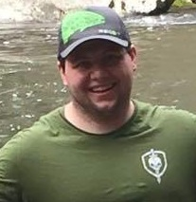

Zach Beal

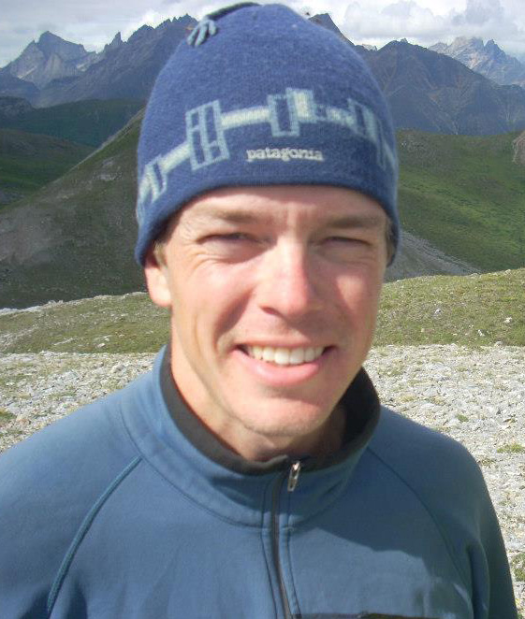

Peter R Nelson

Annotation of PeterPeter, a Cluster A Phage

Zach Beal, Jeremy Bishop, Isaac Alexander Caballero, Kaleigh Carroll\*, Bryce Carter, Colby Drexel-Harmon, Corey Henderson, Kate LaPlante\*, Jessica Laytart\*, Monique Mills\*, Jessica Walker, Shallee Page\*, Peter R Nelson

\* University of Maine, Machias, Machias ME

Students at the University of Maine-Fort Kent isolated and purified a novel organism, Mycobacteriophage PeterPeter, from a soil sample taken outside a University residence hall next to a dumpster. Students then analyzed PeterPeter’s 51,366 bp genome. PeterPeter’s genome has a GC content 63.9% and begins with a reverse gene. This is uncommon, with only 30% of A4 phages having this as a start. PeterPeter is a member of the largest cluster and the second largest subcluster of the A phages (subcluster A4).