DO NOT CONSIDER FOR TALK
2022 SEA Symposium Abstract
University of Lagos
Lagos
Corresponding Faculty Member: Imade Nsa (insa@unilag.edu.ng)
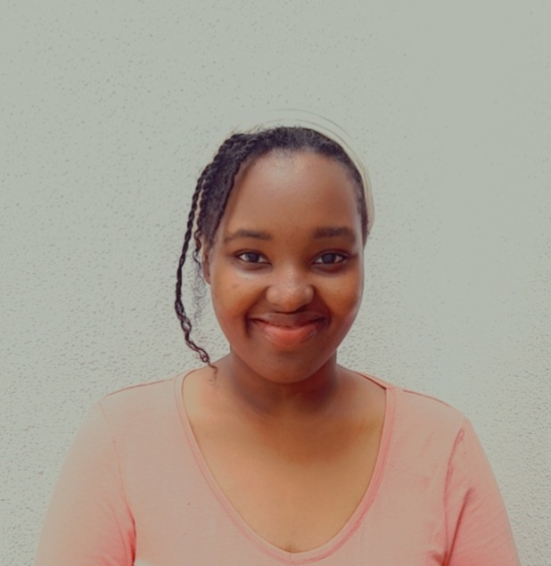
Hauwa J Kamselem
Kenmech, a Compost- Amended Soil Phage
Hauwa J Kamselem, Ezichukwu E Ejiofor, Adetutu G Akingbade, Adebimpe O Ademilola, Whaliat M Akinsola, Anthony A Akala, Yewande T Abina, Aisha A Akintola, Farouk O Sulaimon, Michael I Abulude, Victor O Olubiyo, Moyinoluwa E Akintobi, Ehivbuema A Iyamu, Samuel Stephen, Ayodeji A Odunsi, Imade Y Nsa, Tenny O G Egwuatu, Ganiyu O Oyetibo, Matthew O Ilori
Kenmech, a Mycobacterium phage discovered in 2020 at the University of Pittsburgh was isolated from compost-amended soil in Pittsburgh, PA. It belongs to the family Siphoviridae and it is a temperate phage displaying both lytic and lysogenic life cycles. The DNA extracted from Kenmech was sequenced at the Pittsburgh Bacteriophage Institute using Illumina MiSeq used to generate the reads. Its genome size is 52,470 bp with a GC content of 63.7 % and it belongs to Cluster A, Subcluster A1. The programs used for annotation include DNA Master, NCBI BLAST, Phamerator, Starterator, GLIMMER, GeneMark, Gene Content Similarity Tool, HHPred, TMHMM and SOSUI. DNA Master’s auto-annotation of Kenmech called 91 genes and 1 tRNA while Phages db/Phamerator called 93 genes. On completion of the manual annotation, of the 92 Open Reading Frames (ORFs), 58 % were reverse genes, 42 % were forward genes, and there was 1 tRNA. 57 % of the start codons of ORFs began with ATG, 32 % with GTG, and 11 % with TTG. Thirty-seven Kenmech ORFs had known functions including the scaffolding protein, lysin A, lysin B, tail terminator, tail assembly chaperone, portal protein, major capsid protein, HNH endonucleases, adjacent DNA primases etc. The longest gene, tape measure protein has a genome length of 2400 bp while the shortest gene of 96 bp had no annotated function. Important fixes included slippery tail assembly chaperone sequence, gene deletions and insertions. Kenmech’s annotation revealed a very strong resemblance to other temperate Sub cluster A1 phages, Dussy and Abbyshoes, also isolated by University of Pittsburgh. The Gene Content Similarity tool revealed that all 3 phages shared 84 phams while Kenmech and Abbyshoes had an additional pham, 11546. Two Phams (100452, 100694) found in both Dussy and Abbyshoes were not present in Kenmech. The least similar subcluster A1 to Kenmech is Froghopper with a GCS similarity of 66.89% and they share 58 phams. In comparison with other subcluster A1 phages annotated by our institution, Kenmech had a similarity of 76.51%,75.28%, 74.32% and 73.82% for Ringer, Arcanine, Big3 and Peterson respectively. Kenmech is dissimilar from the phages in other clusters we are annotating; sharing only lysin B and D-Ala-D-Ala carboxypeptidase with both McGee (Subcluster C1), and Rockne (Subcluster F1).

