DO NOT CONSIDER FOR TALK
2022 SEA Symposium Abstract
Salem State University
Salem MA
Corresponding Faculty Member: Amy Sprenkle (asprenkle@salemstate.edu)
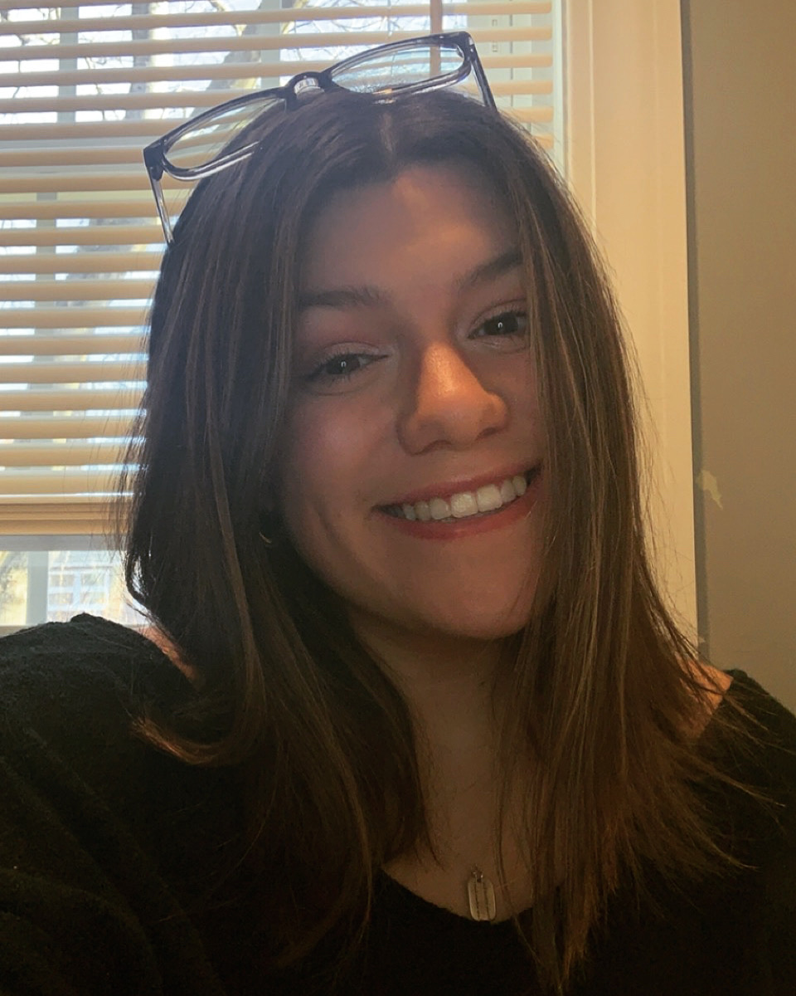
Lindsay Aubin
Discovery and Annotation of Microbacterium foliorum Actinobacteriophage Jemerald.
Lindsay Aubin, Bundy Benton, Nia Brown, Amy Colón, Cole Couture, Nomar Fernandez, Jarelle Garcia, Jeriel A Garcia, Danielle M Jean
Salem State was fortunate to be able to run the Phage Discovery semester of SEA-PHAGES in person in the Fall of 2021 under COVID-19 compliant protocols. Two actinobacterial hosts were used; Microbacterium foliorum and Gordonia rubripertincta. Student’s enriched soil samples yielded a number of phages on both hosts. We were able to amplify and purify only one Microbacterium foliorum phage as we had difficulty isolating enough DNA for sequencing from the Gordonia phage, but finally sent a DNA sample for full genome sequencing at the University of Pittsburgh. Microbacterium phage Jemerald is a lytic siphoviridae in cluster EA6 at 41099 base pairs in length and is a close relative of phage Juicer, which was sequenced and annotated last year and had been submitted for sequencing and archived in 2020. Jemerald was annotated using the Actinobacteriophage Database at phagesdb.org, Phamerator and PECAAN. Jemerald has a translational frameshift in the tail assembly chaperone upstream of the tape measure protein, and displays typical genome structure with structural proteins in the left arm of the genome and DNA synthesis and nucleotide modifying enzymes in the right. Plans for the end of the semester and summer are to troubleshoot the phage DNA isolation, as we had several high titer stocks, but were only able to isolate DNA from one phage lysate with help from HHMI.

