DO NOT CONSIDER FOR TALK
2022 SEA Symposium Abstract
James Madison University
Harrisonburg VA
Corresponding Faculty Member: Steven Cresawn (cresawsg@jmu.edu)
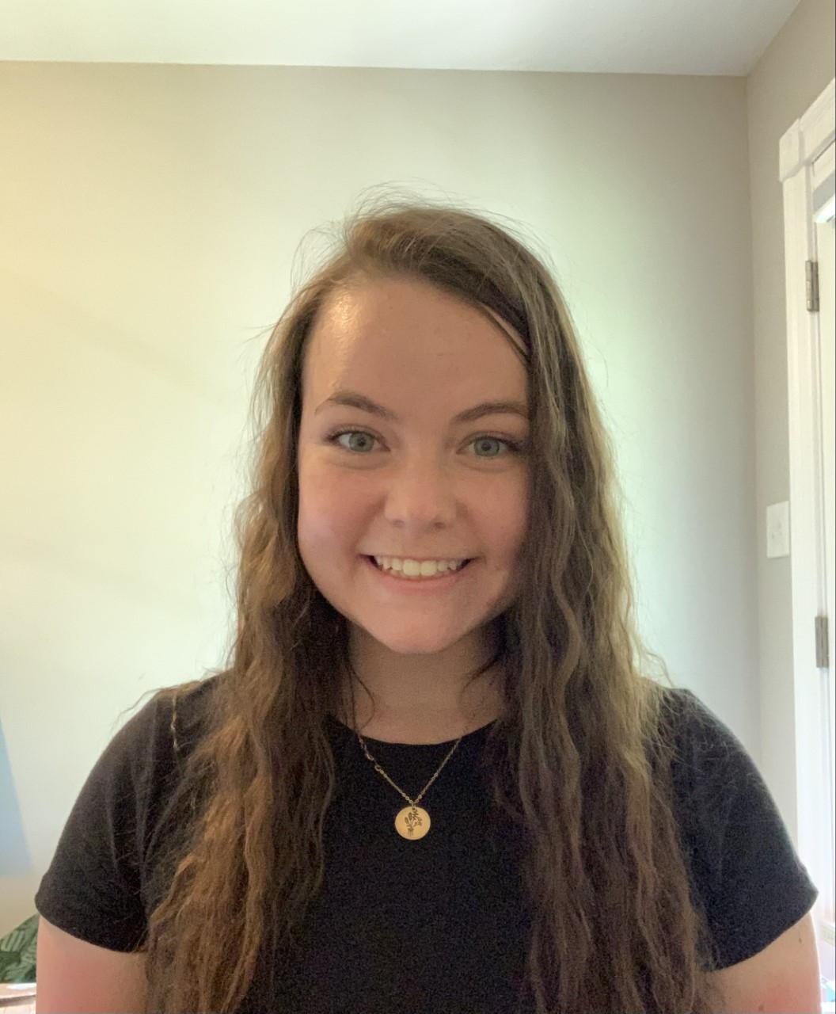
Madison Bendele
Morgan Burns
Erica Lam
Kateryna Marku
Taking a census: an overview of clusters, genomes, genes, and phamilies
Madison Bendele, Morgan Burns, Gabby Jackson, Nicholas Kolecki, Erica Lam, Kateryna Marku, Jack Orton, Ben Tanner, Steven Cresawn
Bacteriophages are recognized as the most abundant biological entities in the biosphere. Their ability to replicate within and ultimately lyse their host cell makes them useful in the fight against the growing problem of antibiotic-resistant bacteria. To learn more about how these bacteriophages function we can look at their genomes. Pittsburgh Bacteriophage Institute has sequenced 4,036 bacteriophage genomes; these can be easily accessed at PhagesDB.org. Our class explored the already annotated phage genomes on a population level. We considered the following classes of information: genomes, genes, clusters, and phamilies. To better understand the data set as a whole we asked questions like how many genes are present and what is the average number of genes per phamily? And more specifically, what percent of these genes are tRNAs, and for what percentage of the proteins in a phage's genome do we know the function? A summary of our methodology and findings will be presented.

