DO NOT CONSIDER FOR TALK
2022 SEA Symposium Abstract
University of California, Los Angeles
Los Angeles CA
Corresponding Faculty Member: Amanda Freise (afreise@ucla.edu)
Pablo D Esparza
Aditi Melkote
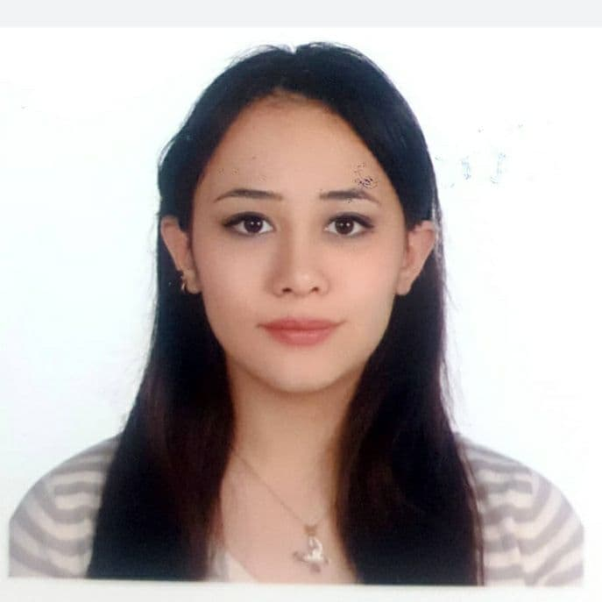
Kiana Niazmandi
Jayasuriya Senthilvelan
Comparative Genomic Analysis of Cluster FH Arthrobacter Phages
Pablo D Esparza, Aditi Melkote, Kiana Niazmandi, Jayasuriya Senthilvelan, Farrell Kasemsunt, Krisanavane Reddi, Ana Garcia Vedrenne, Amanda C Freise
Phages infecting Arthrobacter globiformis, a Gram-positive, aerobic soil bacterium responsible for creating usable nitrogen products for plants, are of great ecological importance. They drive soil microbial evolution by facilitating horizontal gene transfer between various strains of A. globiformis and potentially other soil bacteria. Despite their importance, literature on these phages is sparse and revolves around intercluster comparisons or characterizations of individual phages, resulting in a lack of intracluster genomic analyses. Studies of transcriptional regulation in these phages can shed light on how phages exploit host transcriptional machinery and provide a clearer picture of phage-host interactions. Hence, a study of intracluster genomic relationships and transcriptional regulation was performed on cluster FH, a small group of five recently discovered A. globiformis phages, with the goal of observing their unique characteristics and understanding their diversity. To accomplish this goal, we used various bioinformatic tools to perform genome-wide comparisons, identify variable regions, and pinpoint transcriptional regulatory sequences. These analyses showed that most cluster FH phages have a 3kb region containing unique, potentially recombinant tail proteins, suggesting differing host ranges across these phages and a genetic insertion event. We note that phage Bumble is different from other cluster FH phages and contains a lysin potentially derived from a co-infection event with another phage. Finally, a novel putative transcriptional regulatory element and three putative operons, two of which may be responsible for DNA-editing, were discovered. These findings highlight intracluster diversity in viral attachment proteins and elucidate mechanisms of transcriptional regulation in A. globiformis phages.

