DO NOT CONSIDER FOR TALK
2022 SEA Symposium Abstract
Northwestern College
Orange City IA
Corresponding Faculty Member: Sara Tolsma (stolsma@nwciowa.edu)
Michael B Anderson
Abigail M Clarke
Kip R Cullinan
Lindsey J Groen
Travis J Grover
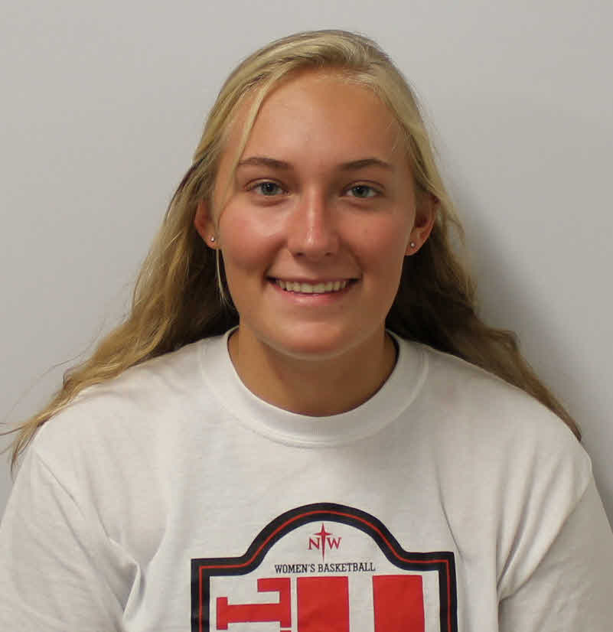
Kaytlyn E Keeler
Benjamin S Kingery
Jordyn L Kramer
Noah M Kryfka
Kaitlyn N McCraken
Emilien A Meray
Lane Mulder
Daniel Norquist
Mitchell J Oostra
Lauren Pavich
Dominick L Pickard
Mitchell T Rentschler
Annika G Stecker
Ashley N Van Egdom
Morgan C Veach
Elizabeth Y Heeg
Sara S Tolsma
Analysis of a Putative Promoter in Mycobacteriophage JacoRen57
Michael B Anderson, Abigail M Clarke, Kip R Cullinan, Lindsey J Groen, Travis J Grover, Kaytlyn E Keeler, Benjamin S Kingery, Jordyn L Kramer, Noah M Kryfka, Kaitlyn N McCraken, Emilien A Meray, Lane Mulder, Daniel Norquist, Mitchell J Oostra, Lauren Pavich, Dominick L Pickard, Mitchell T Rentschler, Annika G Stecker, Ashley N Van Egdom, Morgan C Veach, Elizabeth Y Heeg, Sara S Tolsma
JacoRen57 is a cluster AB mycobacteriophage that infects Mycobacterium smegmatis mc²155. We recently reported on the characterization of a putative promoter in JacoRen57 using an mCherry reporter construct. This promoter is present in a gap upstream of a gene that is present in all AB phages. In all cases, these are forward genes immediately following a long series of reverse genes. The genes are most frequently identified as RecA-like DNA recombinases but also as RepA by bioinformatics. To further analyze this putative promoter and gene product, we cloned the RecA-like DNA recombinase into an E. coli expression vector with a TVMV removable N-terminal His-tag. We expressed and purified the tagged protein and are using it to immunize Balb/c mice. We plan to use the antiserum to confirm RecA-like DNA recombinase expression patterns when JacoRen57 infects M. smegmatis.

