CONSIDER FOR TALK
2022 SEA Symposium Abstract
Carthage College
Kenosha WI
Corresponding Faculty Member: Deb Tobiason (dtobiason@carthage.edu)
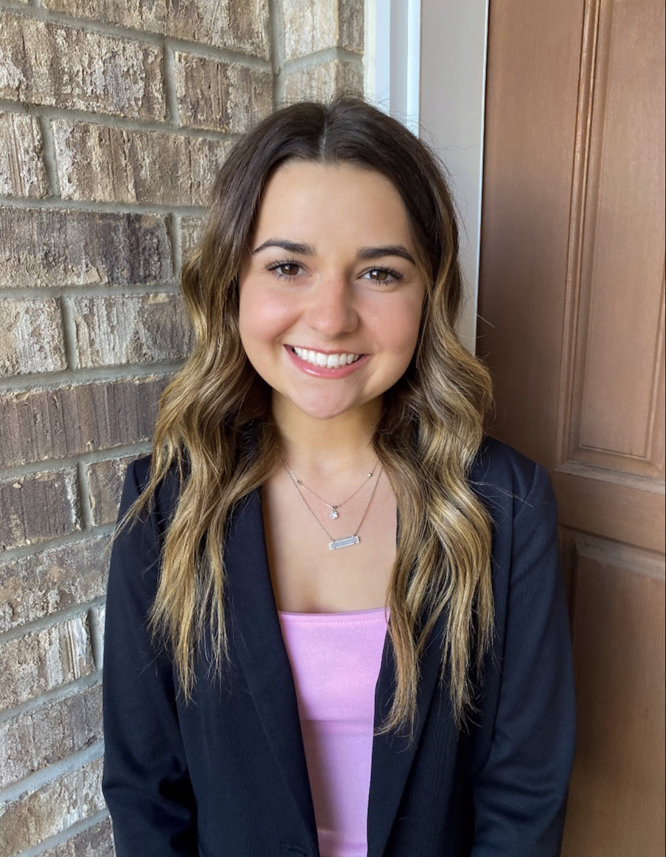
Allison Pacocha
Ella Pettinger
Investigating Microbacterium Cluster EB and EF phages- Johnathan and MortySmith
Allison Pacocha, Ella Pettinger, Ryan Del Alcazar, Hilda Gonzalez, Andrew Hallstrom, Ryan Henneman, Mackenzie Horutz, William Hutchins, Myles Krzewinski, Jessica Leo, Victoria Richter, Madison Schafer, John Vejvoda, David Vowels, Deborah Tobiason
Using the host Microbacterium foliorum, 20 phages were isolated at Carthage College in Fall 2021. Two of these phages, Johnathan and MortySmith were isolated from soil samples taken from the Carthage campus, which is located adjacent to Lake Michigan and has a river tributary running through campus providing unique conditions for exploring the soil microbial environment. Electron microscopy revealed that both phages are members of the siphoviridae family with long flexible tails. Genomic DNA sequencing revealed that both phages are lytic, which is also supported by their plaque morphology. Johnathan is a member of cluster EB phages, and its genome has defined ends while MortySmith is part of the cluster EF and has circularly permuted ends. Although both phages’ genomes have extensive similarity with other members of their cluster, distinct differences have been identified. During initial annotation of MortySmith, we have identified a possible small subunit terminase based on recent data added to the Protein Data Bank that was previously not called by other cluster EF phages. Once annotation is complete, further investigations will be performed via student-led independent projects to explore phylogenetic relationships and genomic information specific to our phages.

