DO NOT CONSIDER FOR TALK
2022 SEA Symposium Abstract
Culver-Stockton College
Canton MO
Corresponding Faculty Member: Esa Seegulam (mseegulam@culver.edu)
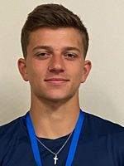
Zachary M Alday
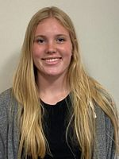
Ashleigh A Brawley
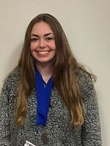
Jaden A Griffin
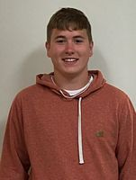
Nolton P Klingele
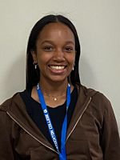
Caroline A Lindsay
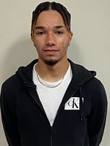
Nathan H Lopez
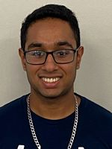
Millen B Patel
Isolation and Characterization of Mycobacteriophage Poompha
Zachary M Alday, Ashleigh A Brawley, Jaden A Griffin, Nolton P Klingele, Caroline A Lindsay, Nathan H Lopez, Millen B Patel, Muhammad E Seegulam
In this experiment we isolated and characterized Poompha, a novel bacteriophage from a soil sample taken from Carthage, Illinois. The bacterial host M. smegmatis mc2155 was used to amplify putative phages in the sample. After three rounds of purification to provide a homogenous phage sample, the purified phage was amplified, collected, titered, and its DNA was extracted and analyzed by gel electrophoresis for purity. The DNA was extracted and subjected to further analysis beginning with DNA sequencing. The Poompha genome was 50089 base pairs long and aligned with cluster A, subcluster A10. While the majority of the genes in the Poompha genome encode products of no known function, immunity suppressor, minor tail protein, scaffolding protein, capsid maturation protease, and portal protein were among the common gene products encoded by some of the 78 features identified. Additionally, 3 tRNA genes were identified. The programs used for annotation included DNA Master, Phamerator, Starterator, HHpred, NCBI BLAST and PECAAN.

