DO NOT CONSIDER FOR TALK

2022 SEA Symposium Abstract

University of Pittsburgh

Pittsburgh PA

Corresponding Faculty Member: Kristen Butela (kab340@pitt.edu)

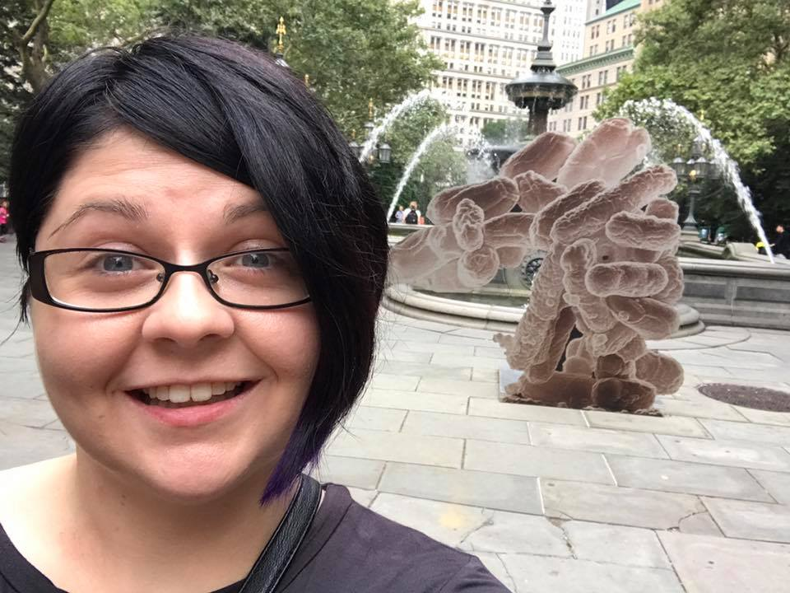

Kristen Butela

The genetic diversity of Gordonia phages may offer insights into the mechanisms that control viral host range

2021-22 Pitt SEA-PHAGES Students and Teaching Assistants, Ping An, Meredith Barbieri, Meghan Bechman, Dawn Bisi, Rebecca Bortz, Kristen Butela, Aimee Danley, Jennifer Grousd, Brenda Hammer, Amber LaPeruta, Ruth Orr, Kyle Parks, Scott Stuckman, Marcie Warner

The collection of over 20,000 actinobacteriophages, with 4000 of these being sequenced, can reveal insights into phage diversity and evolution. The 2021-2022 student cohort of phagehunters at the University of Pittsburgh isolated 95 phages from environmental samples using the host *Gordonia* *terrae* 3612, contributing to the overall total of over 2500 phages isolated on *Gordonia* hosts. The genomes of 13 of these phages were sequenced, adding to the existing collection of 634 sequenced *Gordonia* phages. These phage genomes are characteristically mosaic and span considerable genomic diversity, being assigned to 15 extant clusters (CS [6], CZ [4], DE [1], DN [1], DS [1]). Phages isolated during the 21-22 academic year differ in genome length ranging from 40,444 bp (OneDirection, Cluster DY) to 114,198 bp (BlueNGold, Cluster DS), and G+C% content, ranging from 53.2% (BlueNGold, Cluster DS) to 67.4% (Shivanishola, Cluster DE; G. terrae is 67.8%). We joined a group of 10 other SEA-PHAGES schools in a collaboration to investigate the ability of the *Gordonia* phages isolated this year to infect several additional strains other than *G. terrae* (in order of nucleotide similarity to *G. terrae*: *G. lacunae*, *G. westfalica*, and *G. rubripertincta)* in order to investigate how the genetic content of these phages may influence host range.