DO NOT CONSIDER FOR TALK
2022 SEA Symposium Abstract
University of Southern California
Los Angeles CA
Corresponding Faculty Member: Christa Bancroft (cbancrof@usc.edu)
Juan Miguel Bugayong
Aileen Cha
Keran Chen
Carlyn Hamel
Ryan Johnson
Joseph Kim
James Kim
Andrew Levy
Kenneth Nguyen
Luc Pham
Anusha Sapre
Aidan Scanlon
Brandon Ye
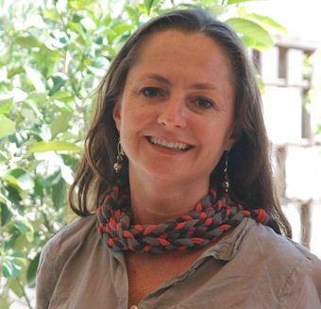
Raffaella Ghittoni
Christa Bancroft
Isolation and Analysis of Cluster AS1 and FA phage TaylorSipht and GlobiWarming
Juan Miguel Bugayong, Aileen Cha, Keran Chen, Carlyn Hamel, Ryan Johnson, Joseph Kim, James Kim, Andrew Levy, Kenneth Nguyen, Luc Pham, Anusha Sapre, Aidan Scanlon, Brandon Ye, Raffaella Ghittoni, Christa Bancroft
Bacteriophages, or phages, are viruses found in abundance around the world that infect various bacterial host species in order to replicate. Our lab section isolated sixteen different phage during Fall semester 2021 from the local area in Los Angeles in host Arthrobacter Globiformis. This group of phage included phage GlobiWarming and TaylorSipht, which we were able to most fully analyze. After isolating, purifying, and amplifying the bacteriophages, their structures were examined through Transmission Electron Microscopy (TEM) images. Through this process, it was determined that these phages are of Siphoviridae morphology, meaning they have non-enveloped capsule heads and have long, non-contractile tails. The phages’ genomic DNA was extracted and sequenced, establishing that were both temperate and part of the FA and AS (AS1 subcluster) clusters, respectively. The length of the GlobiWarming genome is 42,961 base pairs with 65% GC-content, while TaylorSipht contains 39,051 base pairs with 68.4% CG-content and approximately 74 and 64 predicted genes in each, respectively. We are using the software programs DNA Master, Starterator, Phamerator, GeneMark, Glimmer, Phagesdb BLAST, and BLAST to predict the presence of protein-encoding open reading frames (ORFs) and assign each a start codon. Using HHpred, NCBI BLAST and Synteny, we are attempting to deduce the function of each gene to find its importance in the genome. During our primary analysis, we have found a few ORFs called in the auto-annotation that are likely not “real” protein coding genes, and thus will be deleted. Additionally, we have found some regions in both GlobiWarming and TaylorSipht’s genomes that most closely relate to ORFs from other phage families, such as AY, FB and AM phage for GlobiWarming and EC, DO, and AY phage for TaylorSipht. We we will use Dot Plot analysis with representative genomes from these other phage families to see how closely they are related to GlobiWarming and TaylorSipht in these specific regions and in the genome overall. GlobiWarming also has at least 5 Orphams in its genome and it will be interesting to further analyze these genes to see their relatedness to other organisms and where they might have originated. The information that we have accumulated, and are currently working on, through our annotations can hopefully be used by others in the future as they predict the same aspects of their genome.

