DO NOT CONSIDER FOR TALK
2022 SEA Symposium Abstract
Howard University
Washington DC
Corresponding Faculty Member: Mary A Ayuk (mary.ayuk@howard.edu)
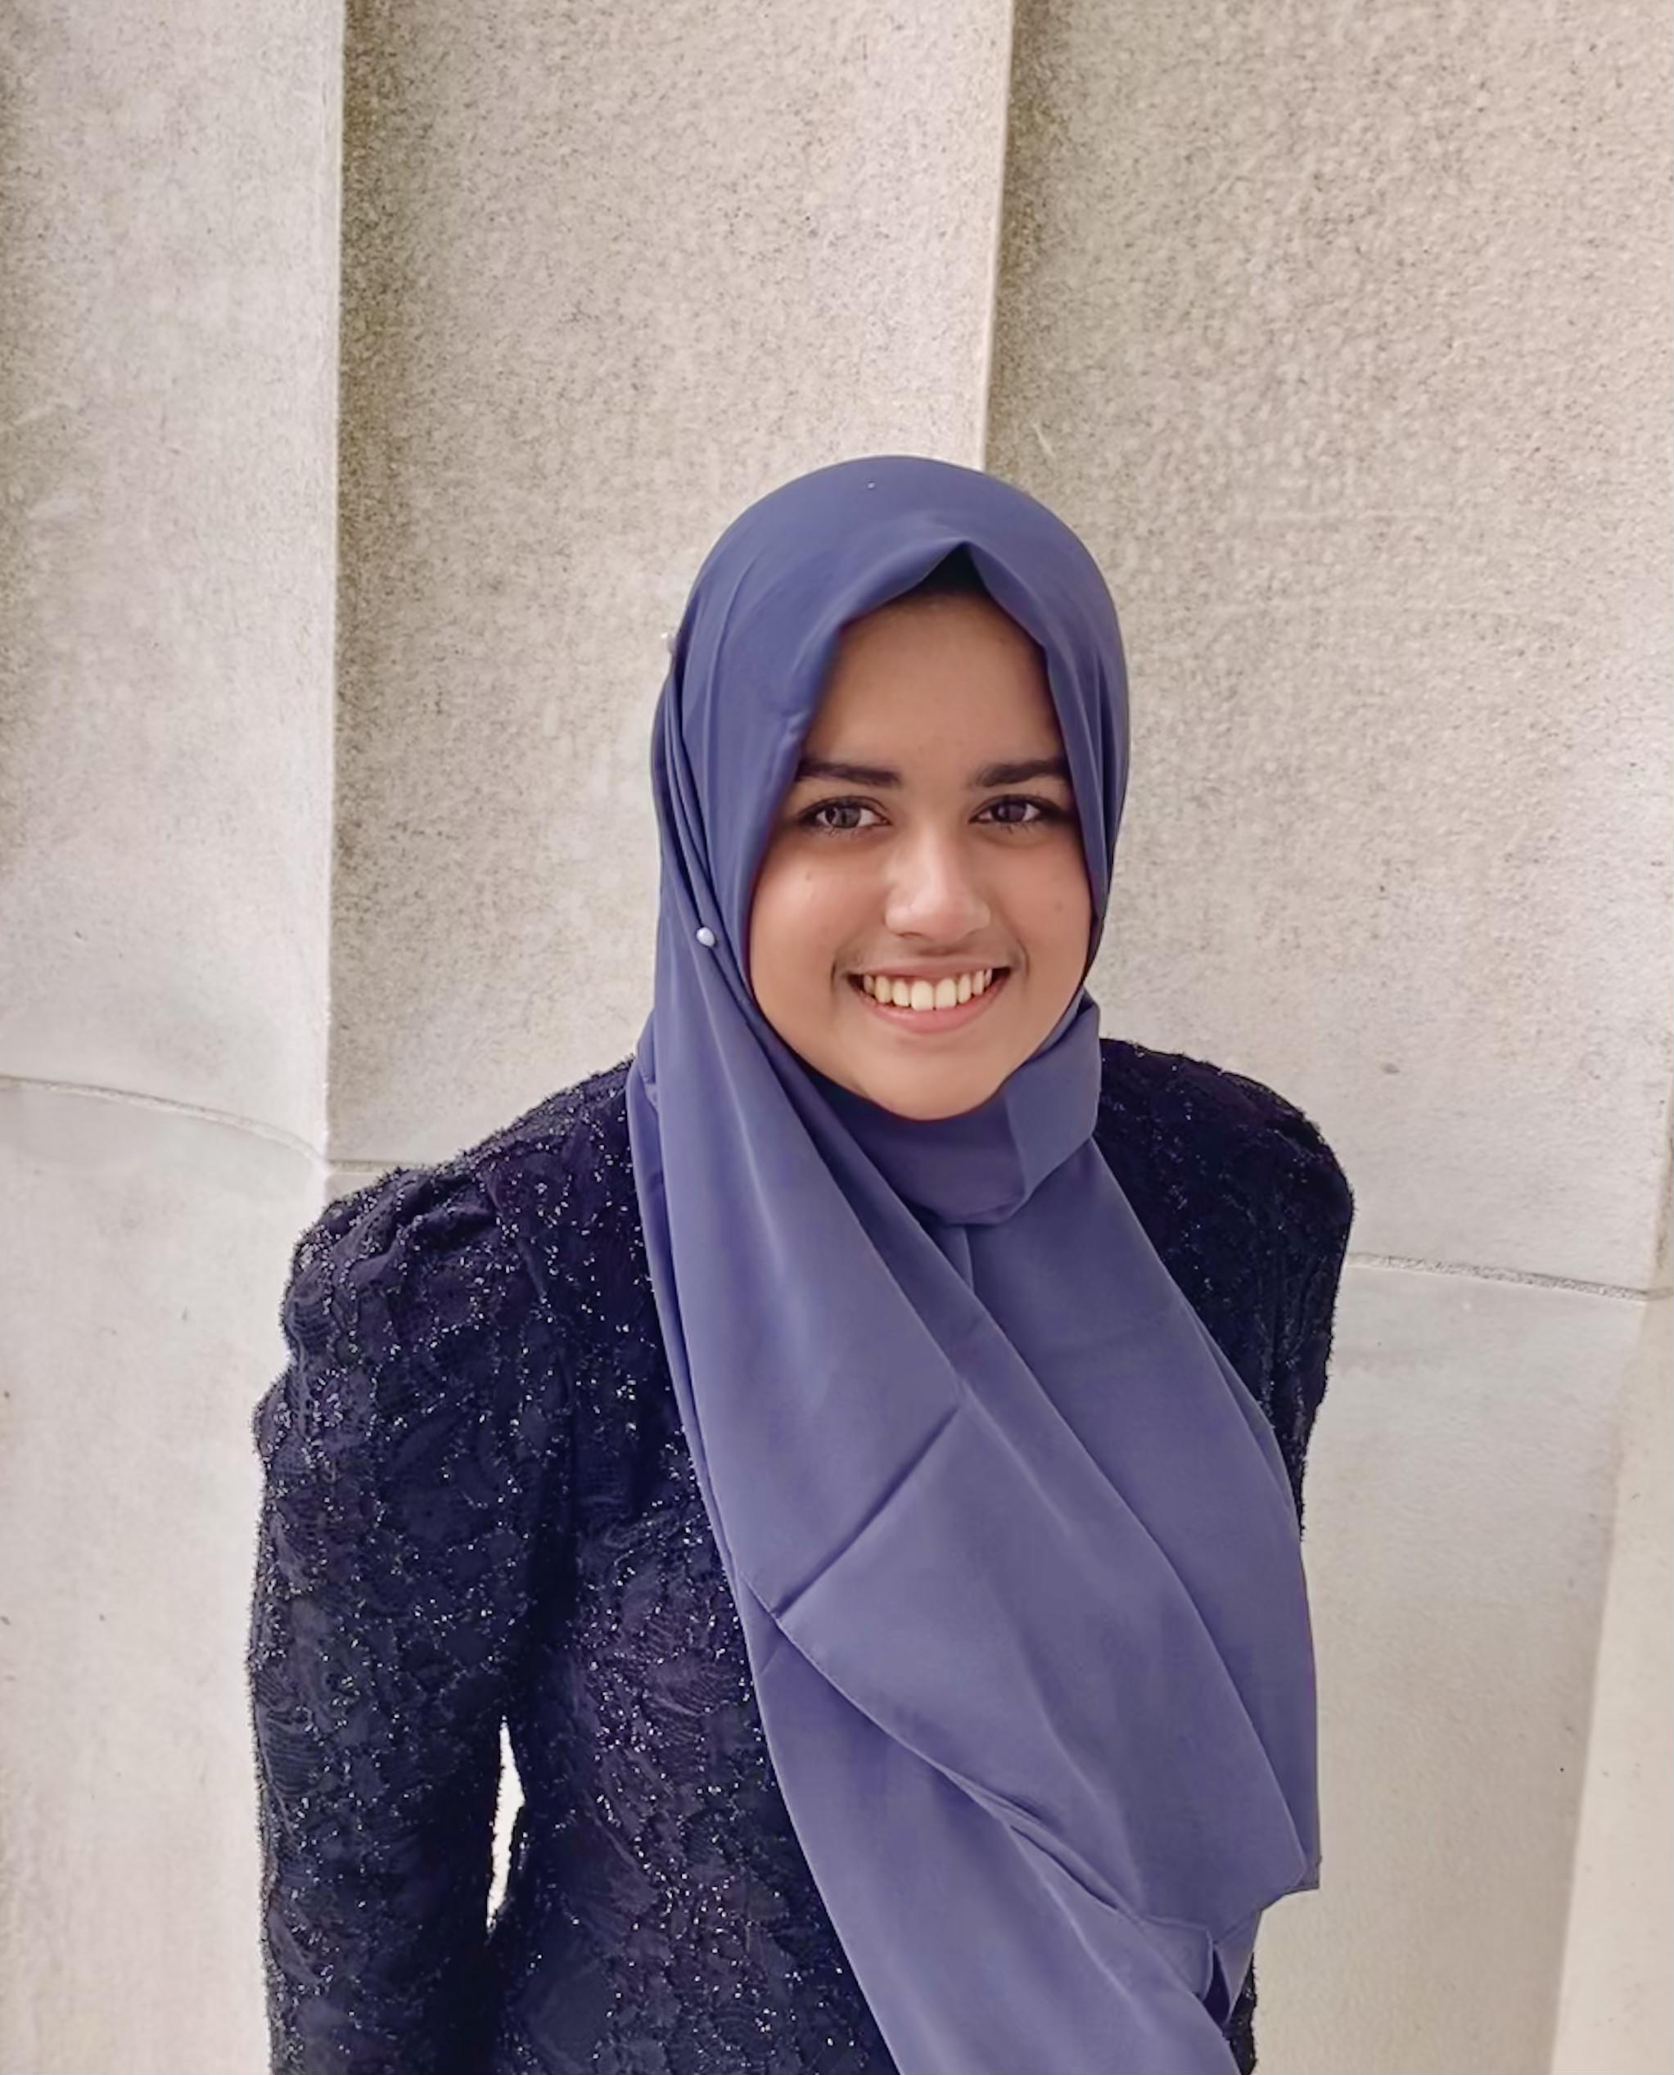
Akila N Islam
Bria G Holton-Oswald
Isolation and Characterization of Phages Briakila, Soile and Toni Isolated from the Howard University campus
Akila N Islam, Bria G Holton-Oswald, Melissa J Campbell, Morgan R Henderson, Lauryn . Craig, Micah . Watkins, Kemuel C Clarke, Haley J Roberts, Madison M Moore, Mary A Ayuk, Courtney J Robinson
Bacteriophages, or phages, may be utilized to study viral ecology, epidemiology, and enhance the development of therapeutics. In the current study, enrichment and direct culturing methods, using the host Mycobacterium smegmatis mc2 155, were used to elucidate phage diversity in soil samples collected from the campus of Howard University. Over 15 phages were purified using standard isolation protocols during the 2021-2022 academic year. Here we will address three of them: Briakila, Soile and Toni. Following isolation of the phages, lysates were generated, and DNA was extracted. The genomes were sequenced at the Pittsburgh Bacteriophage Institute, on the MiSeq platform (Illumina Sequencing). This revealed that the phages belonged to cluster B, with two belonging to subcluster B1 (Soile and Toni), and one belonging to B3 (Briakila). Soile is longer than ~60% of other sequenced members of B1 with a length of 69097, while Toni is closer to average length (68,581bp) with a length of 68,784 bp.. The G+C content for both genomes was consistent with the average for the subcluster. With 69,166 bp, Briaklia’s genome is slightly longer than the average B3 genome (68,787bp), and G+C content was consistent with the average for the B3. Annotation of the genomes is currently underway. Additionally, all other phages that were not sequenced phages in the 20221-2022 collection are undergoing assays to determine patterns of phage sensitivity/insensitivity—immunity using wildtype M. smegmatis mc2 155 and lysogens generated from the HU-PHAGES collection.
Key words: Mycobacteriophages, Soil, Mycobacterium smegmatis, Siphoviridae

