DO NOT CONSIDER FOR TALK
2022 SEA Symposium Abstract
Worcester Polytechnic Institute
Worcester MA
Corresponding Faculty Member: JoAnn Whitefleet-Smith (jaws@wpi.edu)
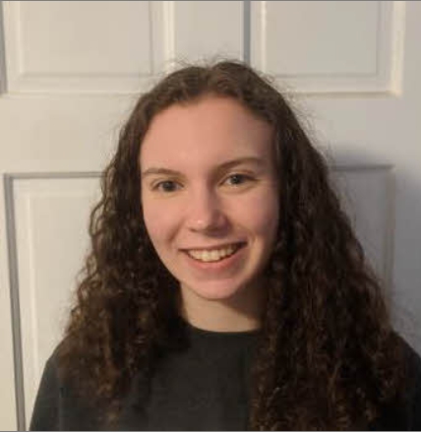
Emmaline Raven
Bioinformatics Analysis of the Ruthiejr_draft genome Sequence Switch Segment
Emmaline Raven, Madelaine Freitas, Marine Herman, Elizabeth Lemay, Dylan Mackisey, Daniel Mbusa, Hope Hutchinson, Jagruthi Maroju, Hannah Gilmore
A local nucleotide blast was performed to search for phage genomes similar to Ruthiejr_draft. The results showed an apparent sequence switch: most of the genome had significant similarity to the other K4 genomes, but no significant similarity (with the exception of Juliette) in the switch segment from 22-26 Kbp. In contrast, some cluster N and P1 genomes showed significant similarity to Ruthiejr_draft, but only in the switch segment. One analysis found a correlation between the location of phage isolation and which segment of Ruthiejr_draft the genome was similar to. Phylogenetic analysis of the six genes contained in the switch segment compared to close relatives of Ruthiejr_draft found that, as hypothesized, the Juliette genome was its closest phylogenetic relative. These also revealed possible points of horizontal gene transfer. Finally, an analysis of sequential and structural information on the proteins with unknown function and similar proteins in other phages led to predictions of the functions for gp 28, 30, and 31. For each analysis respectively, future research could examine more phages from different clusters, using laboratory techniques to study protein expression, and integrate laboratory and phylogenetic analysis to further support function predictions.

