DO NOT CONSIDER FOR TALK
2022 SEA Symposium Abstract
Northwestern College
Orange City IA
Corresponding Faculty Member: Sara Tolsma (stolsma@nwciowa.edu)
Annika Stecker
Steven Van Meeteren
Gracelyn Wager
Abigail Clarke
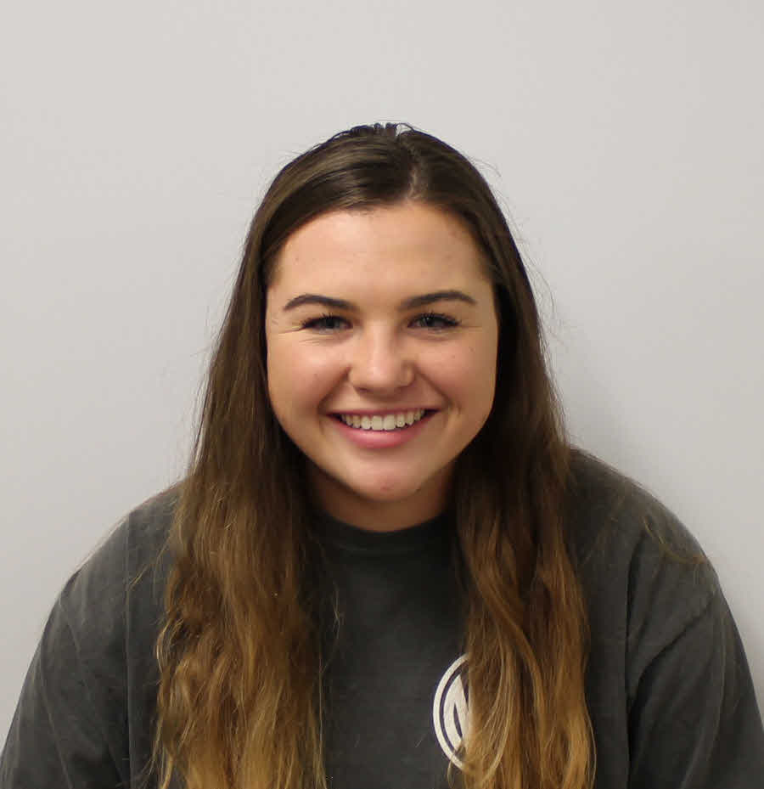
Jordyn Kramer
Lauren Pavich
Krista Starr
Kaarina Van Berkum
Ashley Van Egdom
Emily Schmidt
Sara S Tolsma
Exploring Gene Functions and Phage-Host Protein Interactions in Mycobacteriophage Island3
Annika Stecker, Steven Van Meeteren, Gracelyn Wager, Abigail Clarke, Jordyn Kramer, Lauren Pavich, Krista Starr, Kaarina Van Berkum, Ashley Van Egdom, Emily Schmidt, Sara S Tolsma
Island3 is an I1 mycobacteriophage that infects Mycobacterium smegmatis mc²155. It has a total of 76 protein coding genes, but only 17 of these genes have functions assigned by bioinformatics. To discover the functions of the additional genes, we cloned 72 of Island3’s genes and are assaying each gene product for two functions when expressed in the host M. smegmatis: the ability to reduce growth of the host (cytotoxicity) and the ability to protect the host from infection by Island3 or another phage (defense). So far, we have assayed more than 60 of Island3’s genes and found 14 genes that exhibited cytotoxicity but none that exhibited definitive defense against phage infection. We are currently analyzing the remaining genes for cytotoxicity and defense. In addition, we are moving forward with bacterial two-hybrid assays on two of the genes that exhibited cytotoxicity, seeking to identify host proteins that interact with the cytotoxic phage gene products in an attempt to understand the mechanism of cytotoxicity.

