DO NOT CONSIDER FOR TALK
2022 SEA Symposium Abstract
Iowa State University
Ames IA
Corresponding Faculty Member: Nick Peters (ntpeters@iastate.edu)
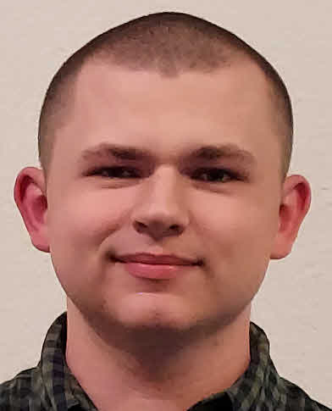
Alex M Bray
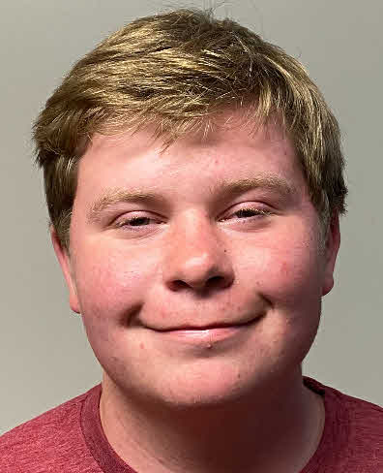
Cole Chittenden
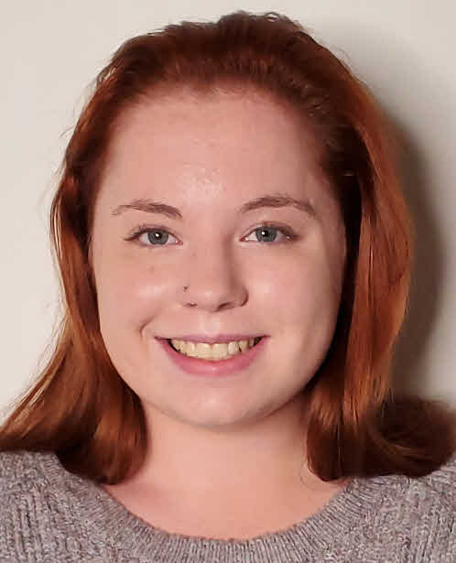
Brooklyn F Elwood
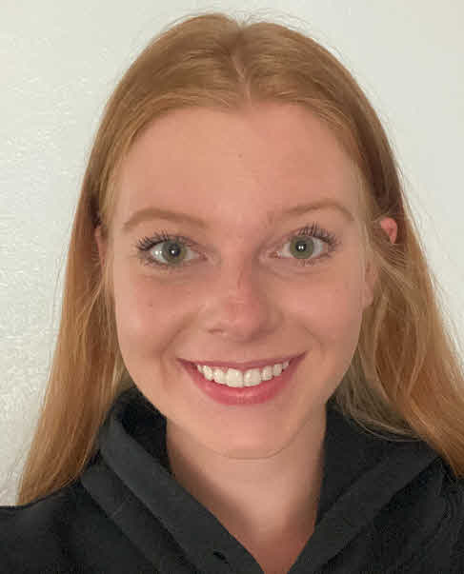
Isabell K Kreel
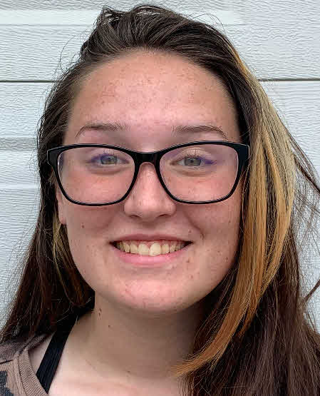
Haley R MacBurney
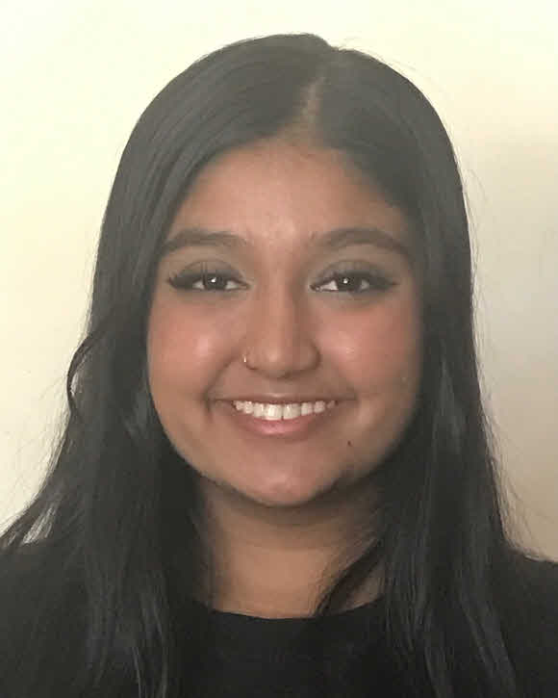
Tejasvini K Malli
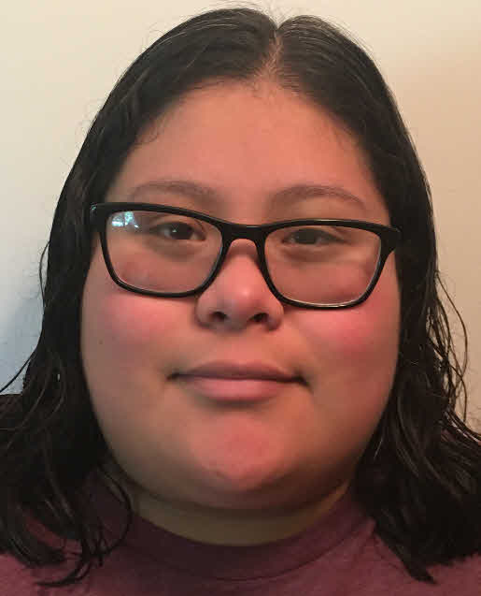
Johanna P Medrano
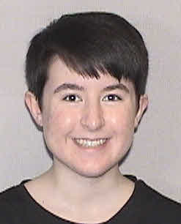
Haley E Roach
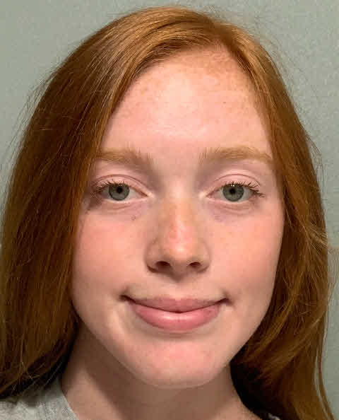
Chloe M Schaffer
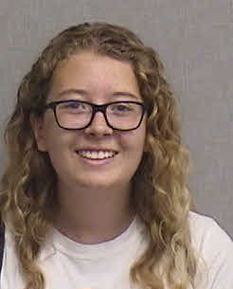
Kennedi Steburg
Ena Stojanovic
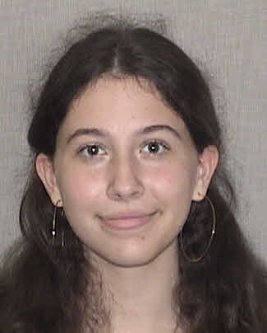
Emily G Twombley
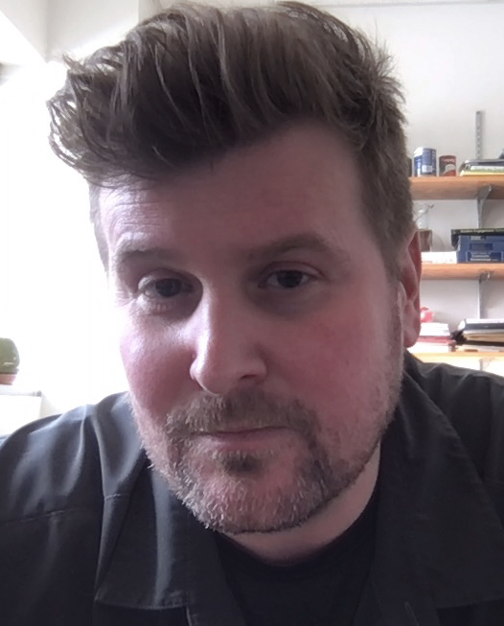
Nick T Peters
Challenges and Successes Annotating StevieWelch
Alex M Bray, Cole Chittenden, Brooklyn F Elwood, Isabell K Kreel, Haley R MacBurney, Tejasvini K Malli, Johanna P Medrano, Haley E Roach, Chloe M Schaffer, Kennedi Steburg, Ena Stojanovic, Emily G Twombley, Nick T Peters
StevieWelch is a phage that infects Microbacterium foliorum. It was isolated and purified in the fall of 2021 near Iowa State University. The goals of our bioinformatics project this spring were to successfully annotate StevieWelch and make an “Annotation Quick-Start Guide” written by students in the class. We decided to work in three groups of four people per group and divide the genome into three sections of approximately 40 genes per section. Each group then used a combination of DNA master and PECAAN to help guide the annotation process. We employed a shared excel file to do our preliminary annotations and make notes about each gene. Our next step was to trade our annotations with the other groups. We will ultimately have one full annotation per group and two audits per group to crosscheck our work. Then we will finalize our annotation of StevieWelch in PECAAN and build our “Annotation Quick-Start Guide.” The guide will serve as a resource to help other students get acclimated to the bioinformatics process and highlight where we had struggles and explain how to overcome them.

