CONSIDER FOR TALK

2022 SEA Symposium Abstract

University of North Georgia

Dahlonega GA

Corresponding Faculty Member: Alison Kanak (alison.kanak@ung.edu)

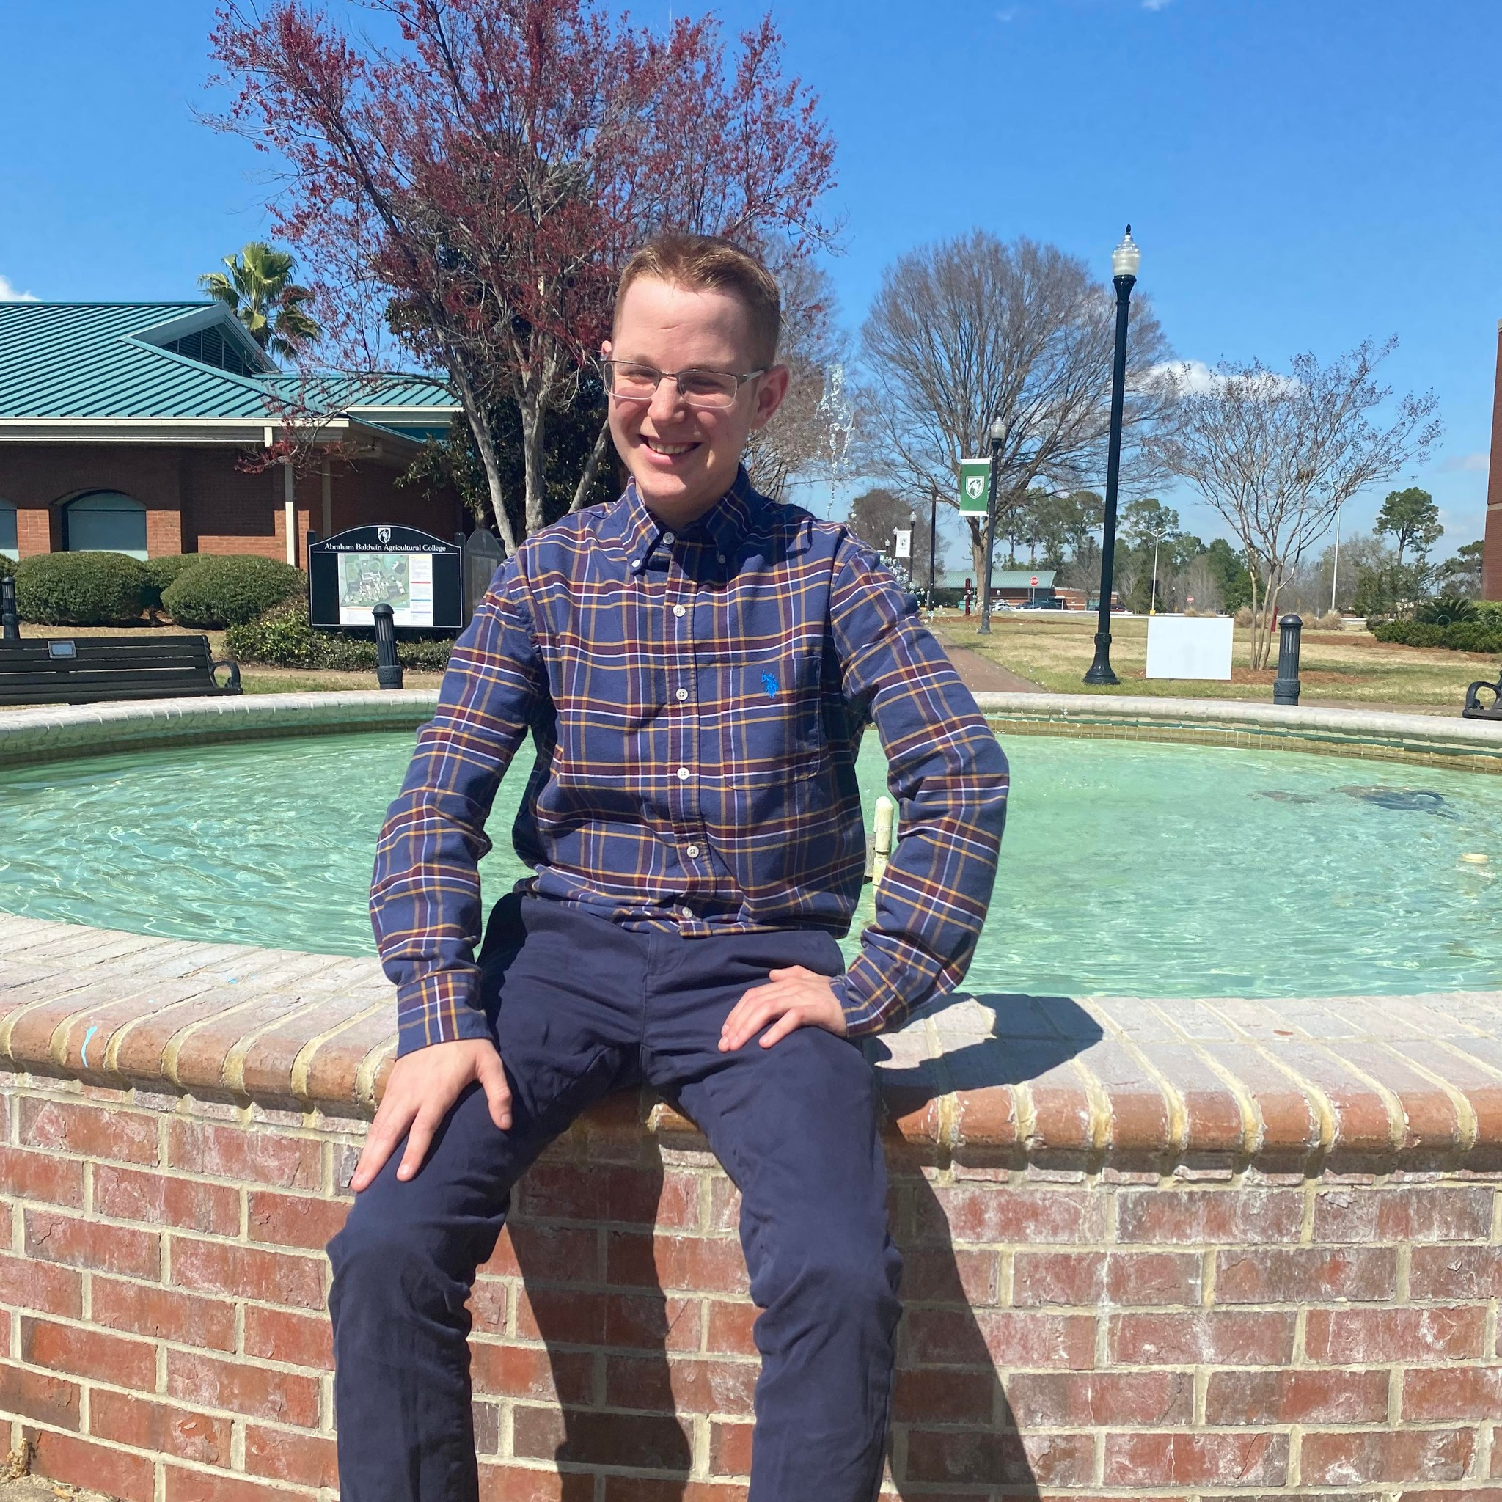

Jared Oenick

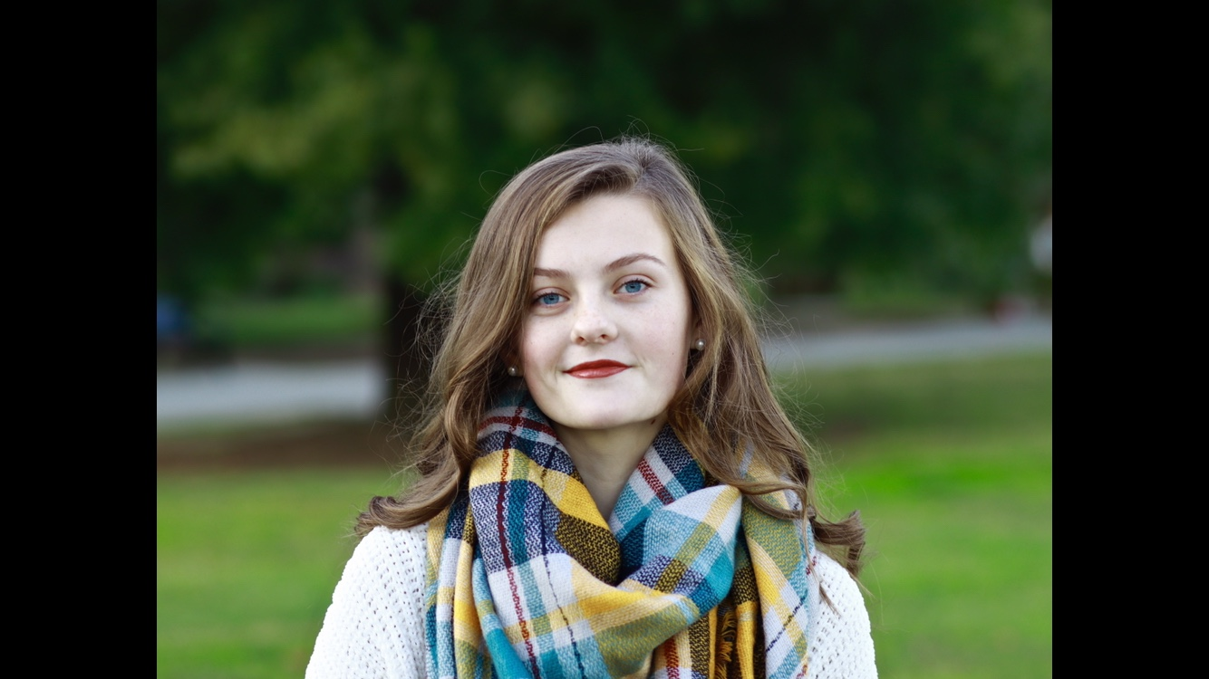

Kendall Carr

Novel Technique for the Isolation of Bacteriophage from Environmental Samples

Jared Oenick, Kendall Carr, Ryan Shanks, Alison Kanak

Bacteriophage (phage) are viruses that infect bacteria and are proposed to be the most copious organism on the planet. Study of phage leads to insights into novel therapeutics of antibiotic-resistant bacterial infections, as well as the development of molecular tools such as the CRISPR/Cas9 system. To further knowledge of phage biology, it is beneficial to isolate, identify, and study novel phage and their properties. Current phage isolation strategies rely on prolonged processing and luck, identifying single isolates at a time. Therefore, the establishment of a protocol with a higher throughput will enable scientists to isolate more phage in a shorter timeframe as it enables scanning more samples simultaneously. This allows the time for successfully isolating phage to be greatly reduced and increases the probability of isolation as well as further studies of phage identified. It is known that high bacterial cell density correlates to living cells and low density equates to dying cells. When treating bacteria with phage, a decrease in cell density indicates the presence of phage due to the death of bacterial cells. Our work has demonstrated that it is possible to use a 96-well plate and measurements of cell density to detect phage presence in very small aliquots of environmental filtrates. Furthermore, we have used this method to isolate novel phage with a total incubation time of only 15 hours using standard photometric assays and equipment. Future studies will analyze the accuracy of this assay with multiple bacterial hosts. The methodological approach described and developed here will be shared with the scientific community for improvement of phage isolation and study.