CONSIDER FOR TALK
2021 SEA Faculty Meeting Abstract
University of Pittsburgh
Pittsburgh PA
Corresponding Faculty Member: Kristen Butela (kab340@pitt.edu)
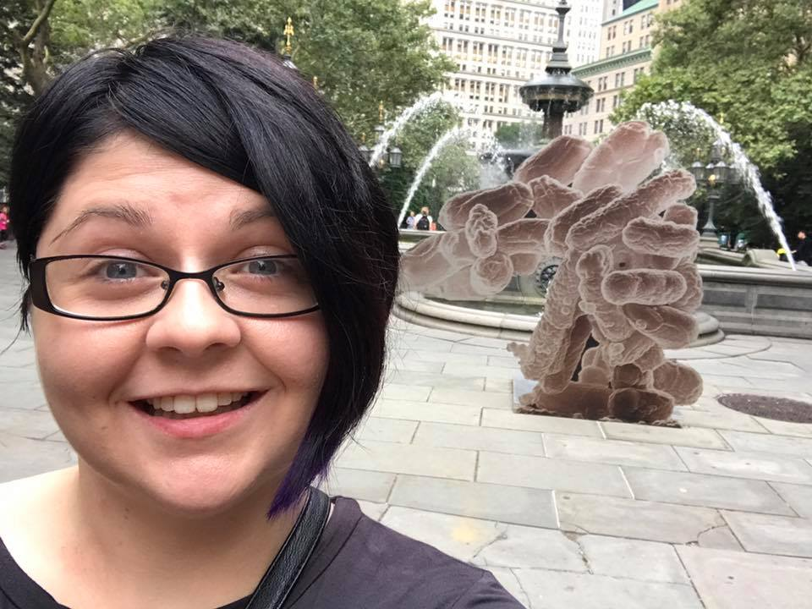
Kristen Butela
QUBES Resource: Generating High-Quality Genome Annotations
Kristen Butela, Hui-Min Chung*, Lee Hughes**, Denise L Monti***
* University of West Florida, Pensacola FL
** University of North Texas, Denton TX
*** Howard Hughes Medical Institute, Chevy Chase MD
In the HHMI SEA-PHAGES courses, students isolate, characterize, and annotate the genomes of Actinobacteriophages in order to gain insight into viral diversity and evolution. Bacteriophages are ideal model systems for undergraduate students to study viral diversity and evolution due to their relative ease of culture in the laboratory setting and small genome size (<250 kb), making full genome sequencing fairly rapid and inexpensive. During the Bioinformatics portion of the two-semester SEA-PHAGES course, students use a series of bioinformatic programs and databases to manually refine auto-annotations of Actinobacteriophage genomes in order to improve gene calling and detect nuances in the genome. Annotation of these genomes provides students with an opportunity to participate in authentic research while learning genetics, bioinformatics, proteomics, and data science. The Bioinformatics course culminates in the submission of student-curated high-quality bacteriophage genome annotations to GenBank.To ensure the best quality annotation is achieved by the end of the term, it is important to establish early best practices for data acquisition, interpretation, and note-keeping. The submission of a high-quality annotation starts with the student’s work. By providing students with tools to accurately and completely interpret the data from prediction programs, faculty should receive a nearly complete genome annotation by the end of the term thereby minimizing the time faculty spend checking annotations prior to GenBank submission. We have developed a series of student and faculty resources to support annotation efforts to ensure that high quality phage genome annotations are produced by students in the HHMI SEA-PHAGES courses.

