DO NOT CONSIDER FOR TALK
2021 SEA Faculty Meeting Abstract
College of St. Scholastica
Duluth MN
Corresponding Faculty Member: Daniel Westholm (dwesthol@css.edu)
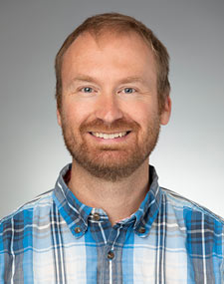
Daniel E Westholm
Arrowsmith in the classroom: using the Pulitzer Prize winning novel to explore phage therapy and pandemic clinical trials
Daniel E Westholm
In 2018, I presented a talk at the SEA-PHAGES symposium evaluating the accuracy and ethics of the phage biology and research in Sinclair Lewis’s 1925 Pulitzer prize winning novel Arrowsmith. Since then, I have incorporated a discussion of select chapters of this book into Bacteriophage Genomics. Students are assigned readings covering the discovery of bacteriophage and their use in a phage therapy trial during a plague outbreak on the fictitious island of St. Huberts. In this poster, I will discuss how these book events are used by students to explore the discovery of bacteriophage, historical and theoretical applications of phage therapy, the use of control groups in drug and vaccine trials during an epidemic, and how data is ethically published. These assignments have developing increased relevance due to the COVID-19 pandemic.

