DO NOT CONSIDER FOR TALK
2021 SEA Faculty Meeting Abstract
University of Pittsburgh
Pittsburgh PA
Corresponding Faculty Member: Beckie Bortz (rlb6@pitt.edu)
Ellen Wisner
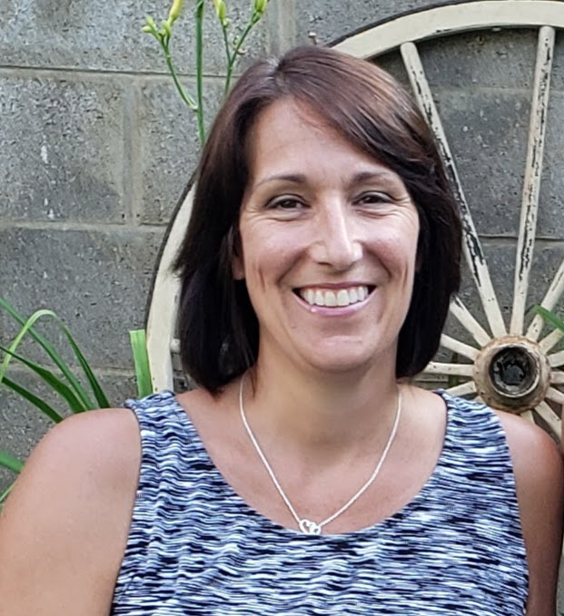
Rebecca Bortz
Teaching Gene Prediction Programs
Ellen Wisner*, Rebecca Bortz, Kirk Andrews**, William Davis***, Lee Hughes****
* University of North Carolina at Charlotte, Charlotte NC
** Gonzaga University, Spokane WA
*** Washington State University, Pullman WA
**** University of North Texas, Denton TX
The proper use of computational resources to interpret data retrieved from large datasets is a skill that is required in nearly every area of research in the modern life sciences. As degree programs guide their students to develop as scientists, we want them to be able to think critically as they evaluate data and output from computer programs and not just engage in “black box” approaches to using the information obtained through bioinformatics. This involves applying relevant foundational biological concepts, understanding (even at a rudimentary level) the underlying principles of how computational programs function, and being able to evaluate computational outputs in the context of the research question being asked.
The field of modern genomics is built upon a foundation of big data and the use of computational resources. This poster presentation will overview the teaching materials from the “Understanding Gene Prediction Programs” QUBES resource. These are aimed at helping students apply the key biological concepts underlying gene prediction to understand how gene prediction programs work, as well as how to analyze and apply the output of gene prediction/analysis programs. This resource also includes an activity that allows students to reflect on their engagement with big data and computational output.
In practice, several of the developers used the materials in the past year in remote instructional environments and found the resource helpful for course organization and student understanding. While the resource materials may be used in their entirety, instructors may also mix and match sections to fit their teaching needs. These materials may require novice instructors to view background material linked in the teaching resource document.

