DO NOT CONSIDER FOR TALK
2021 SEA Symposium Abstract
Southern Connecticut State University
New Haven CT
Corresponding Faculty Member: Nicholas Edgington (EdgingtonN1@SouthernCT.edu)
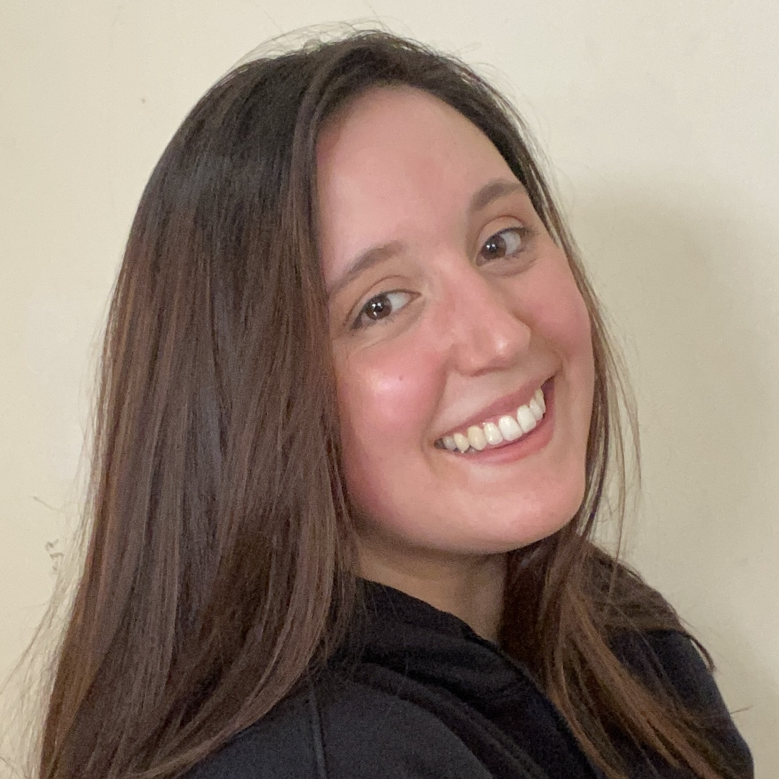
Isabelle L Lucarelli
Erica A Sellers
All in 'Z' family: Annotation and analysis of two new Cluster AZ members from SCSU
Isabelle L Lucarelli, Erica A Sellers, Jamie Outlaw, Joshua S Tolokan, Mark J Nowak, Brianna C Baldwin, Camila G Ramos, Yadinitza Torres, Stefan Uka, Simon Uka, Amber E Fearnley, Patrick D Legrand, Jacklyn Ramos-Arvelo, Daniel J Skelly, Celine C Hall-Campbell, Nicholas P Edgington
Phage hunting for Arthrobacter globiformis bacteriophages on the campus of Southern Connecticut State University has lead to the discovery of four closely related Cluster AZ members, Elezi, Niobe, Asa16, and Nitro. The phages in this cluster are all likely temperate and have an average genome length of 43,557 bp. We will discuss the some of the interesting features of these genomes that were identified during the annotation of these genomes, as well as discuss several of the predicted gene products which includes a potential TA system, a minor tail pham, and two HNH endonuclease phams.

