CONSIDER FOR TALK
2021 SEA Symposium Abstract
Saint Joseph's University
Philadelphia PA
Corresponding Faculty Member: Julia Lee-Soety (jlee04@sju.edu)
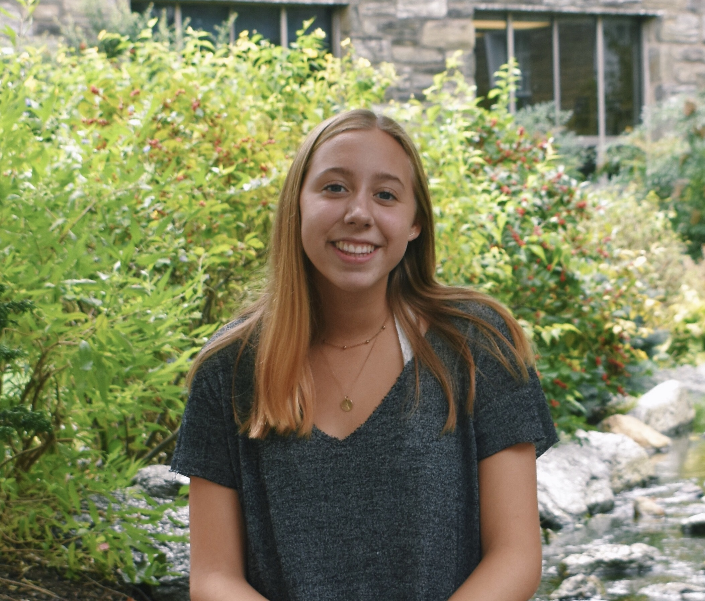
Anne Winkler
Mycobacteriophages in the B1 cluster discovered at and around Saint Joseph’s University.
Anne Winkler, Aidan Conry-Murray, Kara Moulton, Shane Patil, Isabella Patterne, Bernadette Bergman, Elizabeth Binder, Joshua Blackley, Rachel Brown, Katherine Commale, Emily Costello, Talyor Cromer, Jasmine Davila, Olivia Desanto, Mary Agnus Dunn, Deborah Duong, Sophia Feingold, Kayla Flanders, Mary Frattara, Tate Fryczynski, Leya Givvines, Dana Glavin, Reid Hartman, Anthony Holvick, Julia Iacovella, Katherine Koestler, Caroline Kominick, Andy Lam, Sharon Mashkovich, Jordan McCarthy, Corinne Merlino, Alexa Mihaita, Thientrinh Nguyen, Danielle Niblock, Isabella Paoli, Cecilia Petruconis, Skye Rodriguez, Isabella Stefanic, Jenna Stoneroad, Deanna Struss, Caren Teague, Fabinan Tort-Umpierre, Arianna Varano, Alexandra Vlahovic, John Braverman, Christina King-Smith, Julia Lee-Soety
Between 2018 and 2020, six distinct bacteriophages that infect Mycobacterium smegmatis were discovered on and around the campus of Saint Joseph’s University by two cohorts of students participating in the SEA-PHAGES program. Phages Burr, Cher, Inchworm, Magic8, Mcshane, and Bluephacebaby all exhibited the siphoviridae morphotype, produced clear plaques ranging 1-4mm in diameter, were lytic, and classified in the B1 cluster. Inchworm was sequenced at North Carolina State University Genomic Sciences Laboratory; all others were sequenced at the Pittsburgh Bacteriophage Institute. Genome lengths ranged between 68,899bp (Bluephacebaby) and 68,929bp (Mcshane). The GC contents ranged between 66.3 – 66.5%. While Phages Burr and Mcshane were the most similar, differing only by 854nt and sharing 98.76% identity, Cher and Magic8 were the most dissimilar by 3,182nt and shared 95.42% identity. We annotated 96 protein-coding genes in Magic8, 101 in Bluephacebaby, 102 in Cher, 103 in Inchworm, and 104 in Burr and Mcshane. Overall, majority of the genes that encoded proteins with known or putative function were comparable across all six genomes and have consistent synteny. Inchworm and Magic8 have an additional HNH endonuclease not found in the others. Cher and Bluephacebaby have gp55 (pham 48464) and Inchworm is unique with gp47 (pham 22987) not shared with the others. Cher also has gp66 and gp67 (phams 42832 and 21871) that were not identified on the others.

