CONSIDER FOR TALK
2021 SEA Symposium Abstract
Drexel University
Philadelphia PA
Corresponding Faculty Member: Susan Gurney (smrw@st-andrews.ac.uk)
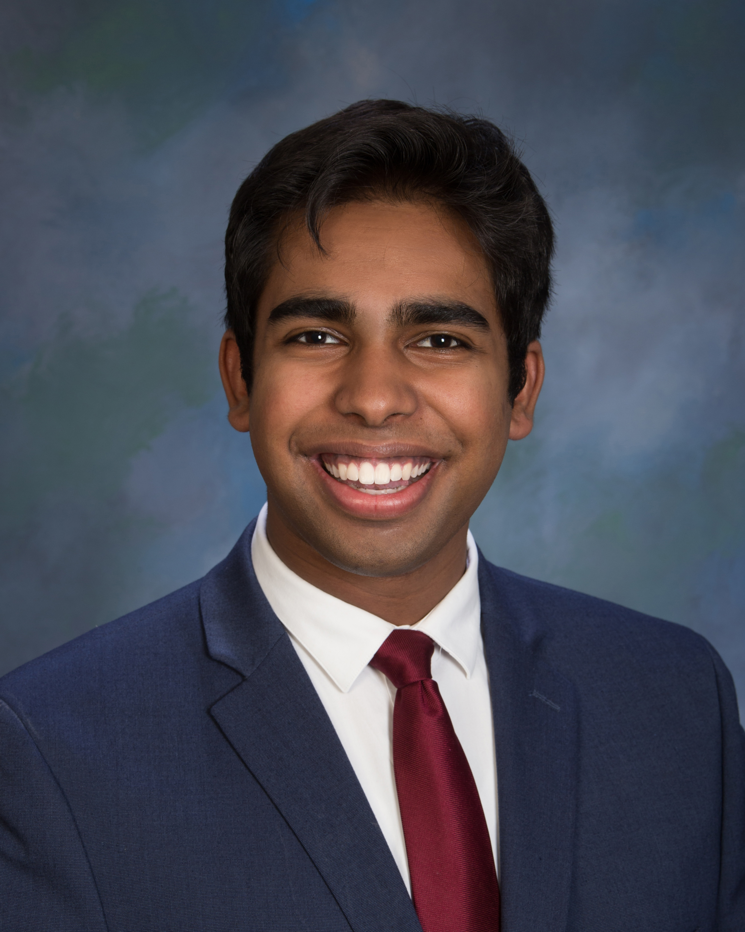
Vivek J Babu
Isolation and characterization of Microbacterium phages through a virtual lab experience
Tara F Al-Saleem, Aneri U Amin, Rudra B Amin, Sana R Amin, Vivek J Babu, Siean Benson, John Beshara, Yajat Bungatavula, Rohan V Dasari, Emma D Ducceschi, Krishi Dudhia, Sally Ehlers, Jared A Featherston, Carol G Gerges, Gabrielle L Greco, Auburn M Hackney, Megan A Hua, Skander Leroux, Graham G Lewis, Kelsey P Lucenius, Vedasri A Madala, Max F Maser, Rachel D Miller, Michael B Minkovsky, Steven R Muller, Bisher O Nasir, Graeme F Newcombe, Max V Olstad, Shreya V Palacherla, Rishika Pasula, Deep S Patel, Nisha Patel, Preet P Patel, Virali S Patel, Kareena Patel, Alesha B Philip, Diana G Pimentel-Lomeli, William L Rainow, Shyam Saravanan, Manali Shah, Manan S Shah, Yashvi Shah, Krisha S Shah, Aashraya Singiri, Dylan A Smoot, Serena J Sohmen, Shaheen Soltani, Albert Tang, Alexander J Vallarta, Soumya Vavilala, Anhelina V Volchok, Samuel R Zion, Brett M Condon, Susan M Gurney
In the Fall of 2020, Drexel University students isolated 6 bacteriophages from soil samples using Microbacterium foliorum NRRL B-24224 as a host. Soil was collected from locations around Pennsylvania and New Jersey. Due to the Pandemic, lab classed were held entirely virtually; students were provided protocols and supporting materials ahead of each class period, and were expected to direct instructors in the lab on how to isolate, purify, and characterize their phages. Instructors answered questions, and challenged student reasoning, but did not correct students’ erroneous instructions, simulating an authentic student experience in the lab. Results were posted on BBLearn for students to access, then interpreted in small groups before being discussed as a class. With student-led direction, Microbacterium phage BarBear was isolated using the direct isolation technique and sequenced by the Pittsburgh Bacteriophage Institute. BarBear produced lytic plaques and is expected to have siphovridae morphology. BarBear is an EE cluster phage , which have very short genomes; BarBear is 17,445bp in length, with only 25 genes in total. BarBear is genetically very similar to other phages within the EE cluster, which show little diversity. For annotation purposes 4 phages were adopted, including phage StagePhright. Microbacterium phage StagePhright was isolated from soil collected on Drexel’s campus in 2019. It has a podoviridae morphology and is a member of the EK2 cluster. Phage StagePhright’s genome is 54,442bp in length, and is made up of 55 genes including one notable gene which is 13,470bp in length. This gene is present in all phages within the EK2 cluster and is not found outside of the cluster; currently its function is unknown. Genetically StagePhright is very similar to other EK2 cluster phages isolated and characterized by Drexel University (phages Phedro, Pharky and Phractured). To increase engagement in the annotation process, the three sections of SEA-PHAGES competed for the “Phage Cup”. Each section annotated phage StagePhright individually, working in groups initially then performing quality control within their section. The annotation notes were then exchanged between the sections for critique. Point deductions were made for incorrect calls and deviations from the annotation template. Points were also awarded for activities promoting community within the sections. At the end of the term the points were tallied and each sections’ accomplishments were celebrated.

