DO NOT CONSIDER FOR TALK
2021 SEA Symposium Abstract
Gonzaga University
Spokane WA
Corresponding Faculty Member: Ann-Scott Ettinger (ettingera@gonzaga.edu)
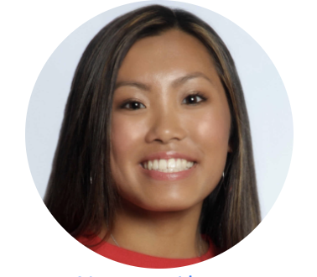
Alyssa Nguyen
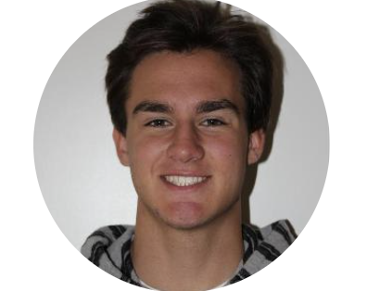
Jeffrey Lubisich
Mycobacteriophage SoSeph: Which K5 Cluster phages are the closest relatives?
Alyssa Nguyen, Jeffrey Lubisich, Joseph Lee, Sophia Barrows, Ann-Scott Ettinger
This project highlights the genome annotation of Cluster K5 mycobacteriophage SoSeph and the determination of close relatives. We intend to focus on unique areas in the genome, especially as compared to other K5 phage, to determine phylogenetic relationships. SoSeph was discovered in a soil sample on the campus of Gonzaga University (47.668056 N, 117.403611 W) from enriched soil samples using Mycocbacterium smegmatis mc2 155 as the host. SoSeph has a genome length of 61,968 bp, 95-96 protein-coding genes (still under evaluation), and a GC content of 65%. As of 3/15/21 there are only 17 K5 phage listed on Phagesdb.org and none have been previously discovered at Gonzaga University. Preliminary data using NCBI/Phagesdb Blastp and Phamerator indicate the largest segment of similarity is to K5 phage OkiRoe (~ 20,000 bp alignment, 97 % Identity) and that genomes are very similar across Cluster K5 phage until gene 70 (~51000bp) . Variability between the most similar K5 phages (OkiRoe, Leston, Paola, etc.) begins around 51000 bp and few functions are annotated in all K5 phage after this point. Prior to Gene 70 in SoSeph, another difference observed is Gene 52 (Pham 1108) of SoSeph is not present in OkiRoe or Paola. Preliminary Blastp analysis was done on the sequence of Gene 52 and it matched 100% to phage Waterfoul (identities: 54/54) and the second was Psycho at 85% (43/54). Further investigation into how Waterfoul is related to SoSeph evolutionarily is planned using ClustalW. Are SoSeph and Waterfoul most similar at Gene 52 alone or other areas? We plan to investigate phylogenetic relationships using ClustalW and other programs to learn more about evolutionary relationships of this newly discovered K5 phage SoSeph before the SEA-Phages Symposium.

